**db2**

| **db2** | **SNRdB_Heart**  **_Sound** | **RMSE_Heart**  **_Sound** | **PRD_Heart_Sound** | **CC_Heart**  **_Sound** |
| --- | --- | --- | --- | --- |
| Level 2 | 23.6806 dB | 0.0001068 | 6.5459% | 0.95945 |
| Level 3 | 24.6274 dB | 9.7141e-05 | 5.8699% | 0.9669 |
| Level 4 | 24.6526 dB | 9.5453e-05 | 5.8529% | 0.96811 |
| Level 5 | 24.7985 dB | 9.3825e-05 | 5.7554% | 0.96915 |
| Level 6 | 26.2702 dB | 7.9202e-05 | 4.8584% | 0.97804 |
| Level 7 | 26.4246 dB | 7.8919e-05 | 4.7728% | 0.97821 |

**(1) db2 LEVEL 2**

(a) db2 LEVEL 2 ARCHITECTURE

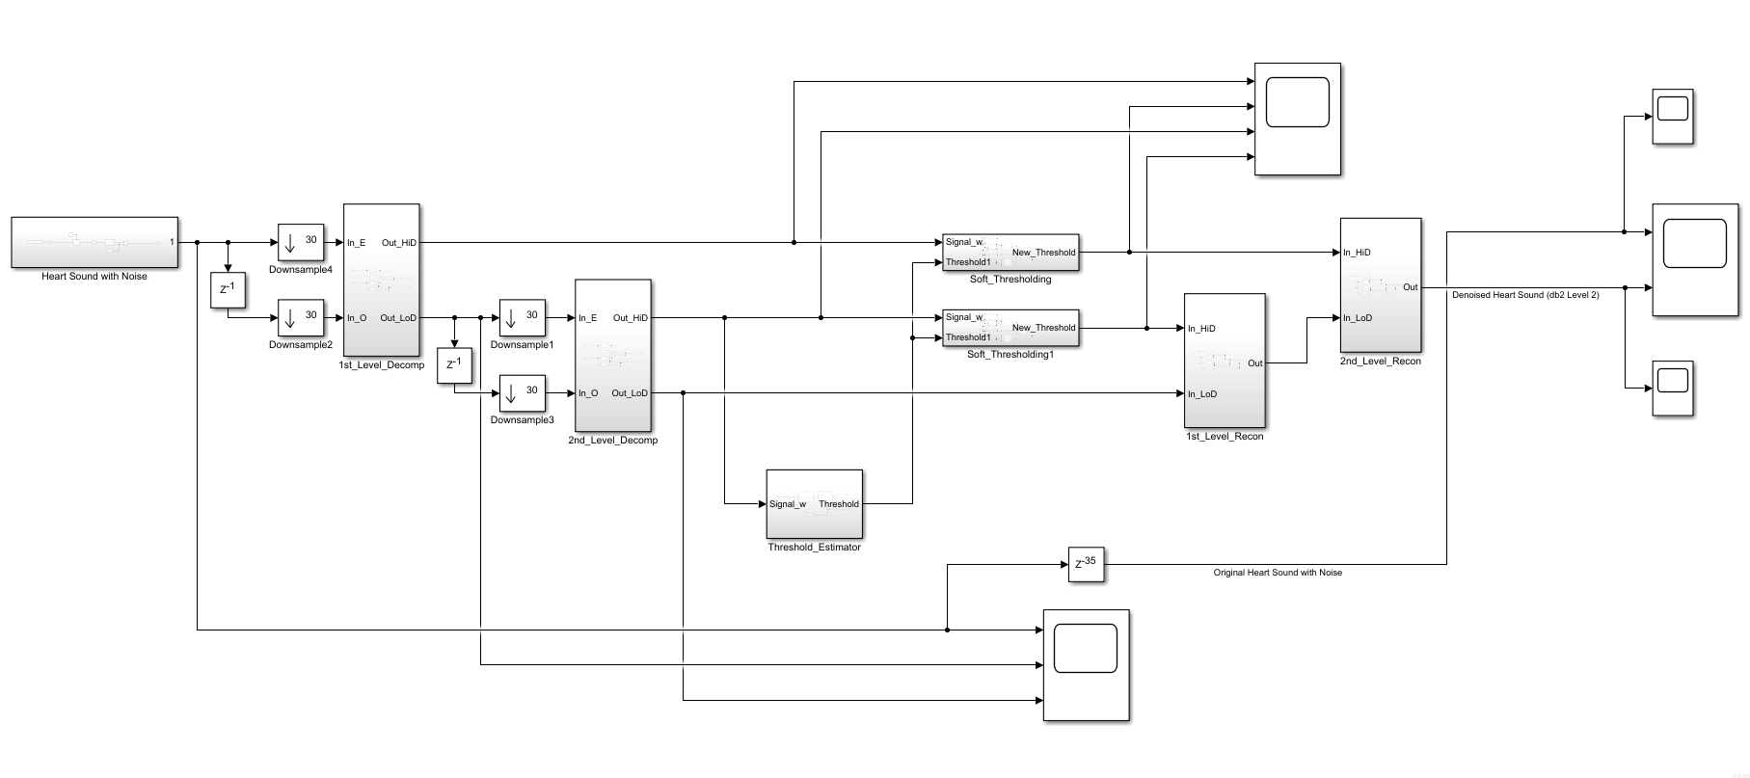

(b) db2 LEVEL 2 SIMULATION RESULT

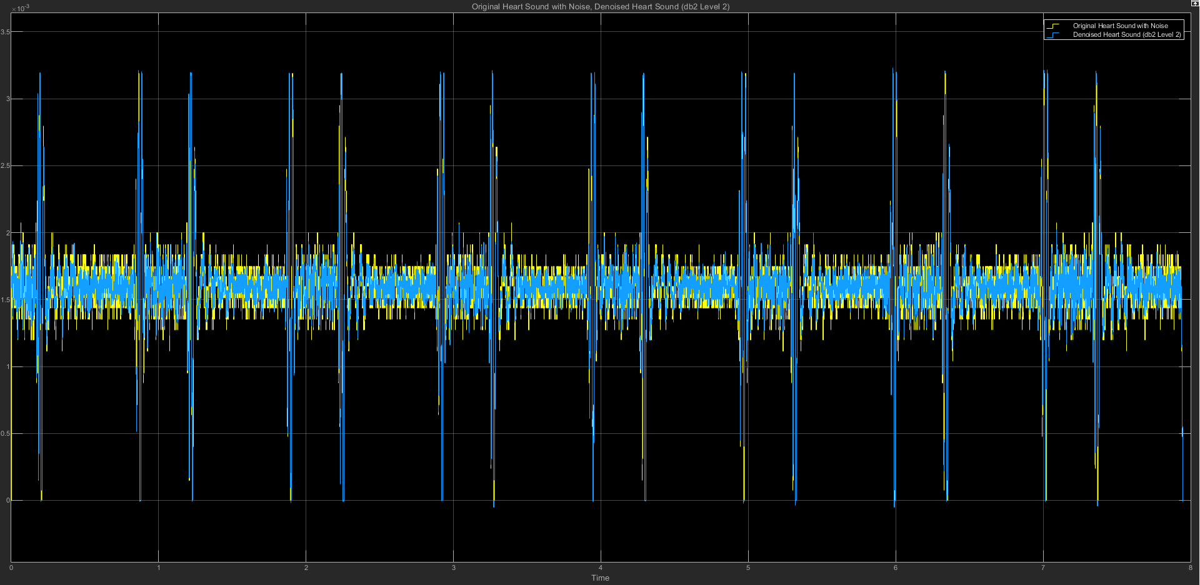

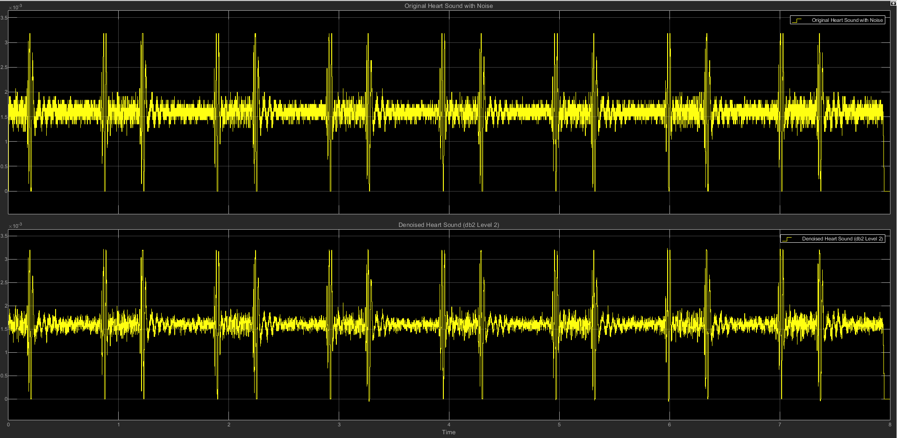

(c) db2 LEVEL 2 STATISTICS RESULT

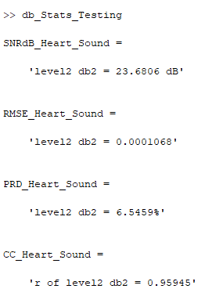

(d) db2 LEVEL 2 SCATTER PLOT RESULT

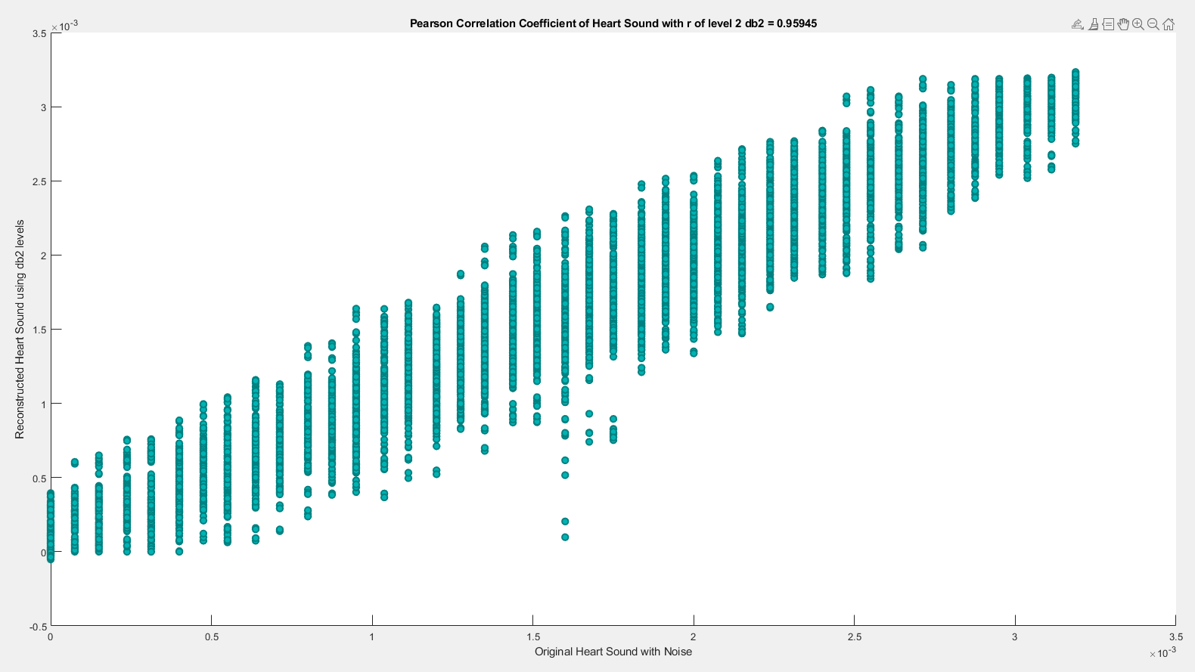

**(2) db2 LEVEL 3**

(a) db2 LEVEL 3 ARCHITECTURE

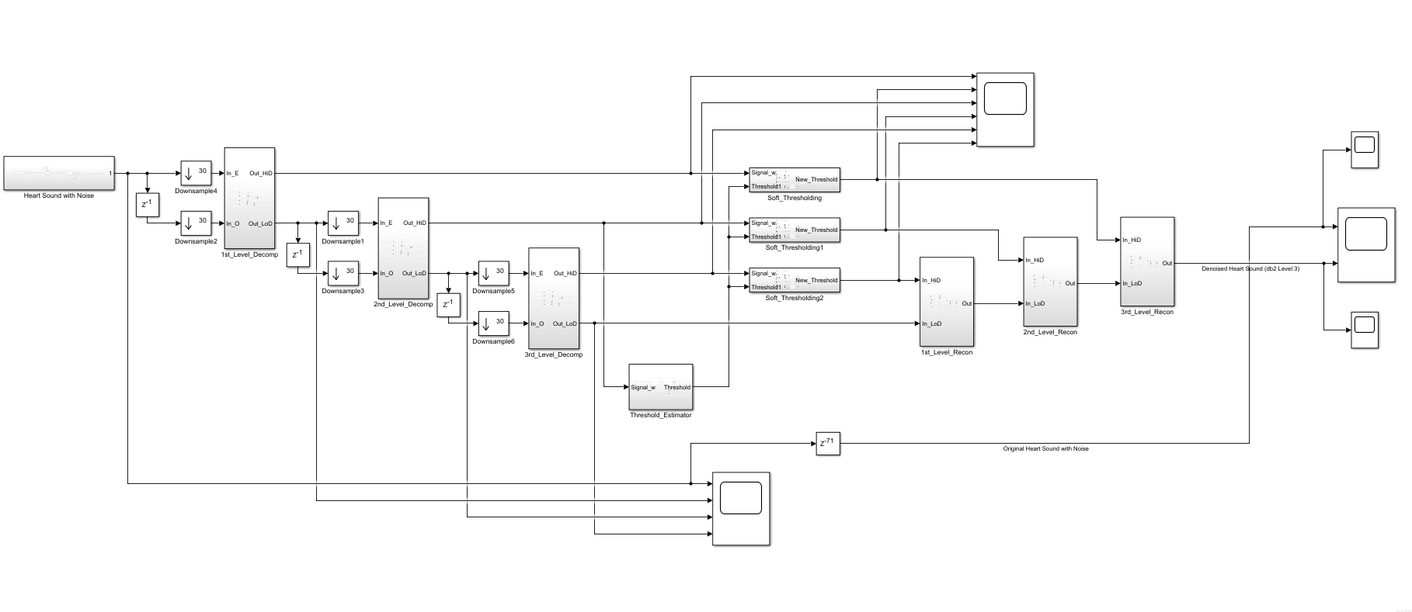

(b) db2 LEVEL 3 SIMULATION RESULT

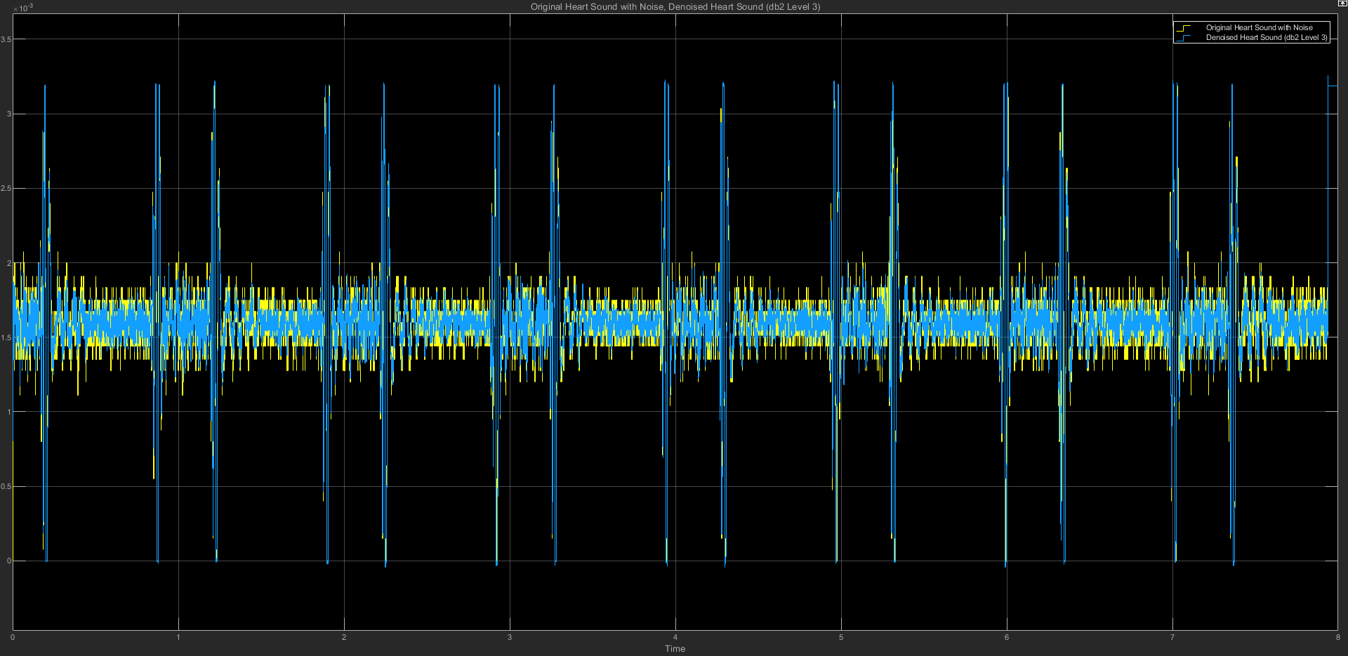

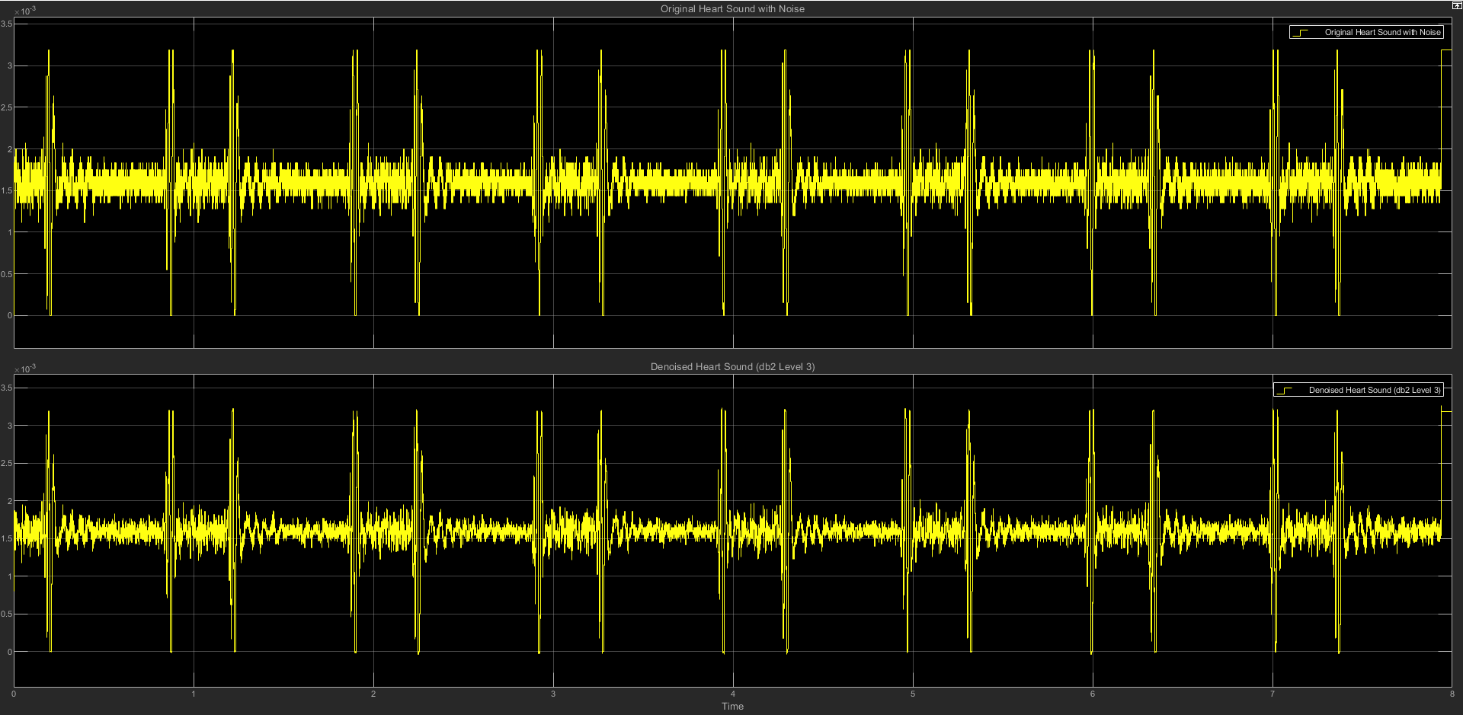

(c) db2 LEVEL 3 STATISTICS RESULT

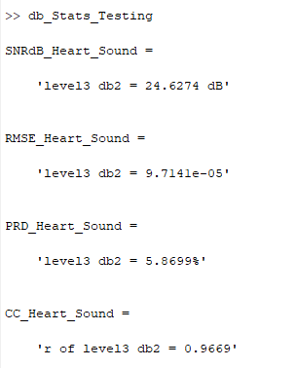

(d) db2 LEVEL 3 SCATTER PLOT RESULT

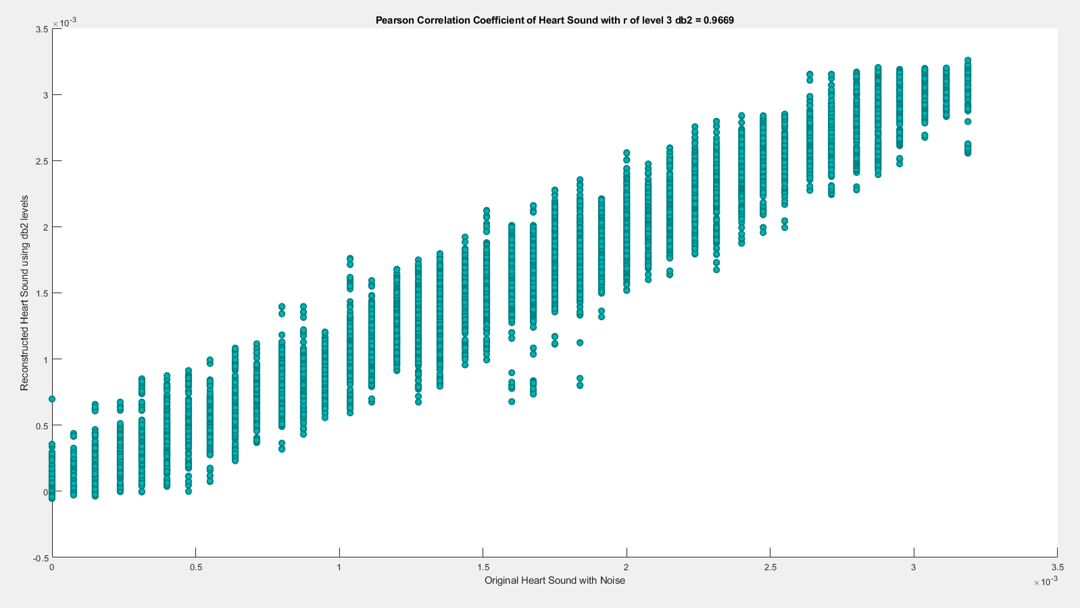

**(3) db2 LEVEL 4**

(a) db2 LEVEL 4 ARCHITECTURE

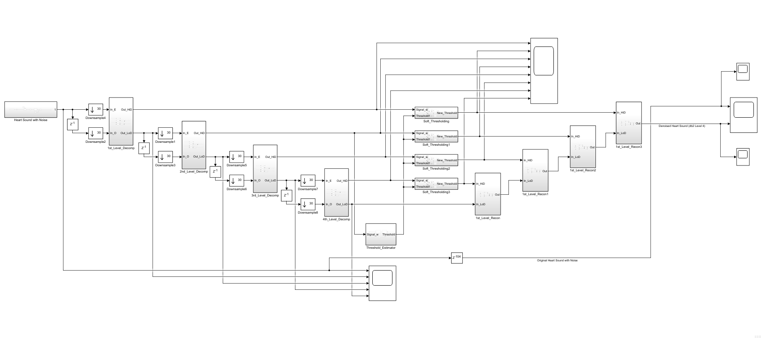

(b) db2 LEVEL 4 SIMULATION RESULT

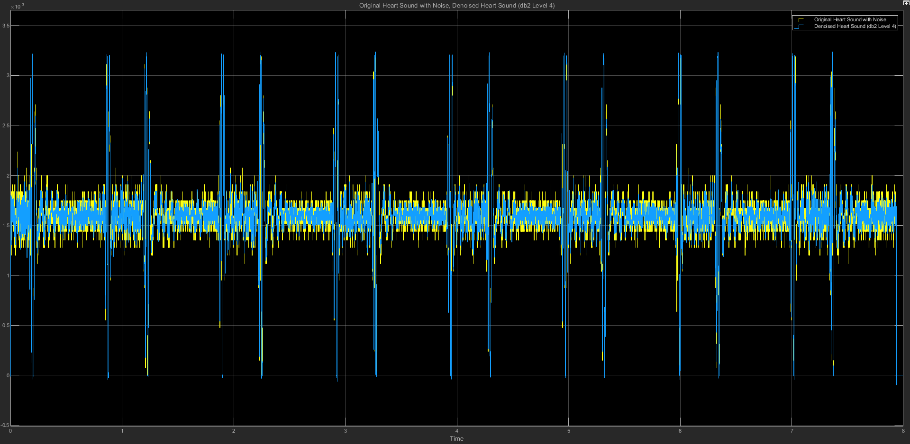

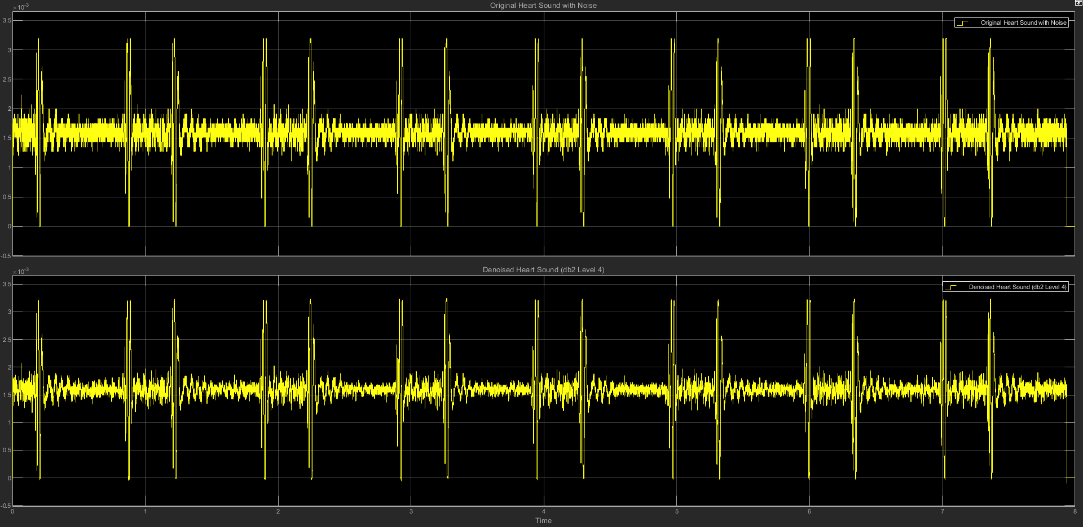

(c) db2 LEVEL 4 STATISTICS RESULT

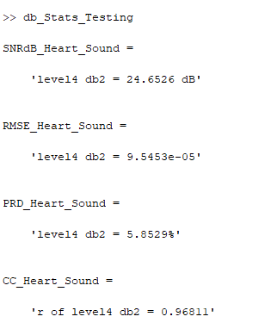

(d) db2 LEVEL 4 SCATTER PLOT RESULT

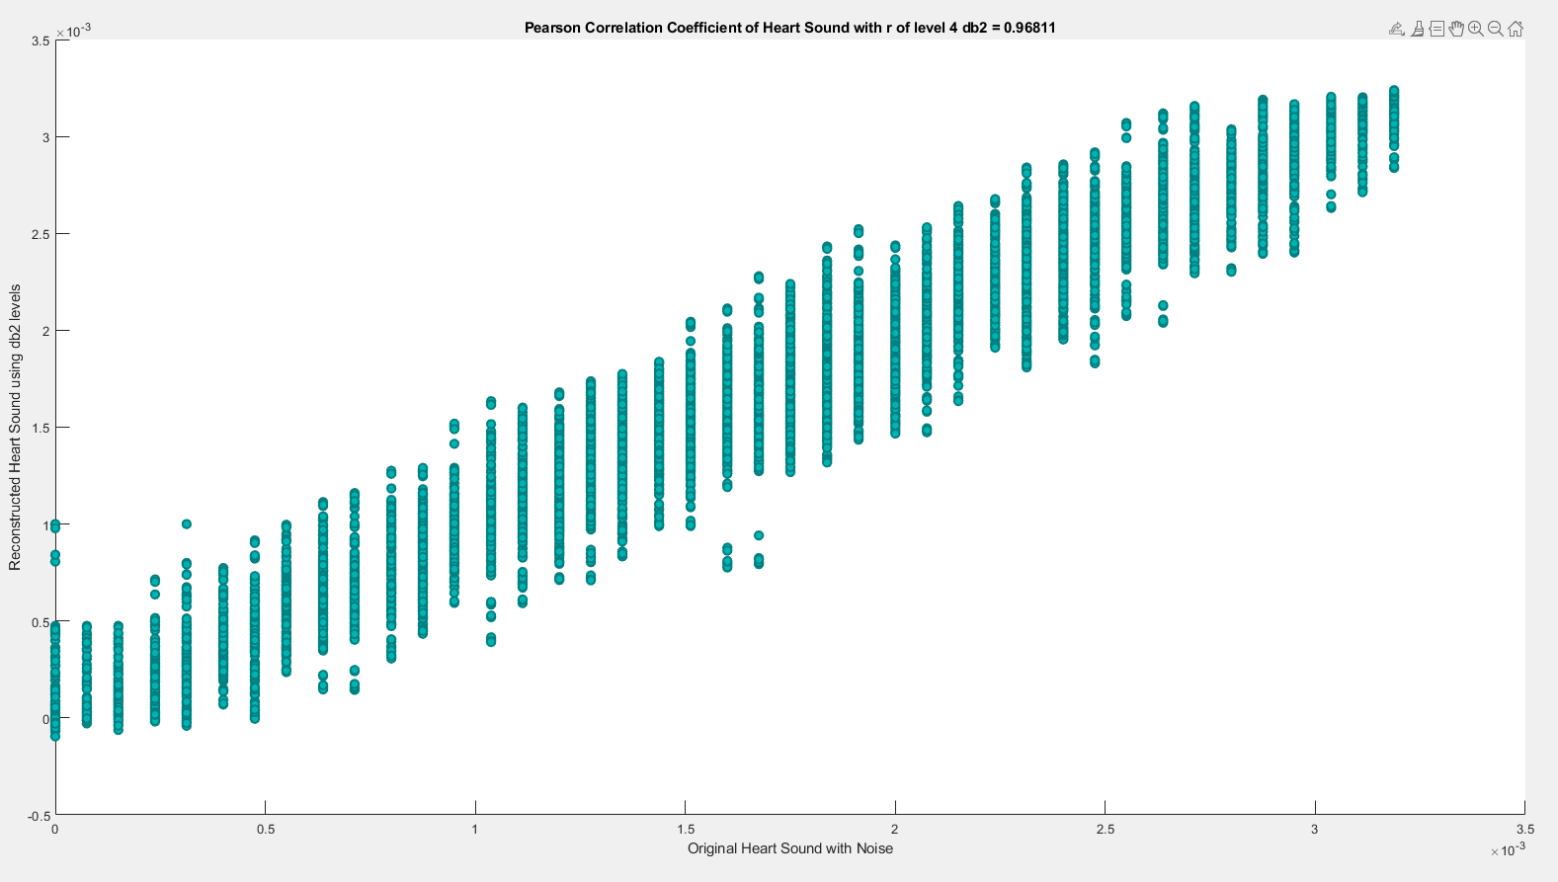

**(4) db2 LEVEL 5**

(a) db2 LEVEL 5 ARCHITECTURE

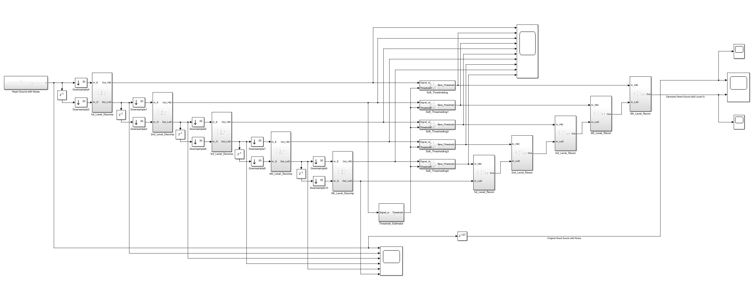

(b) db2 LEVEL 5 SIMULATION RESULT

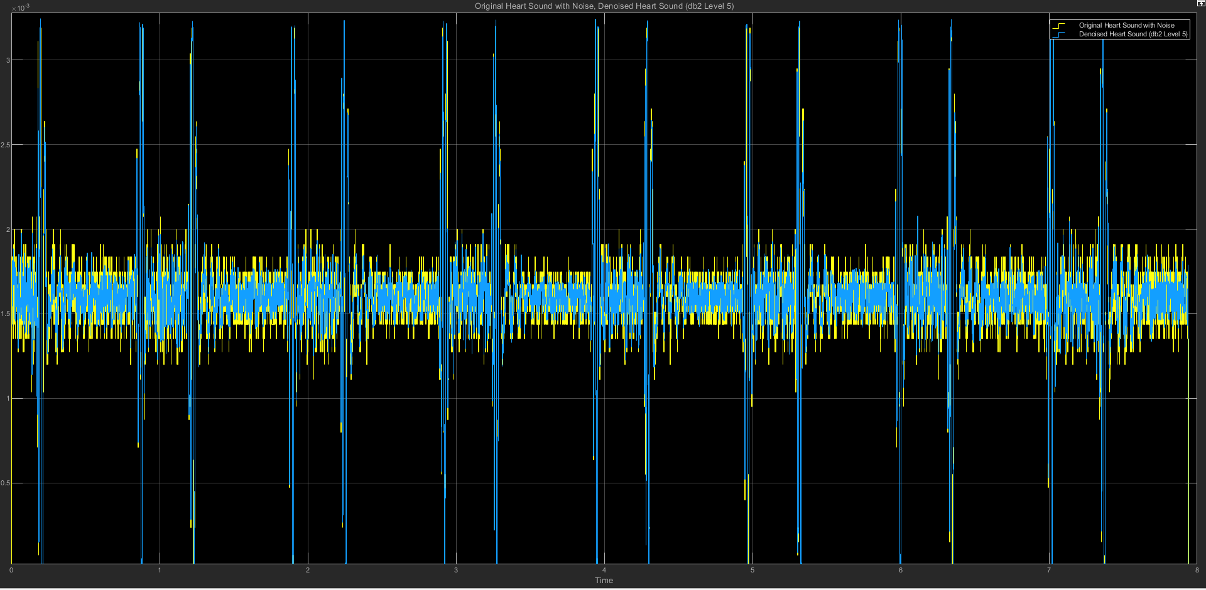

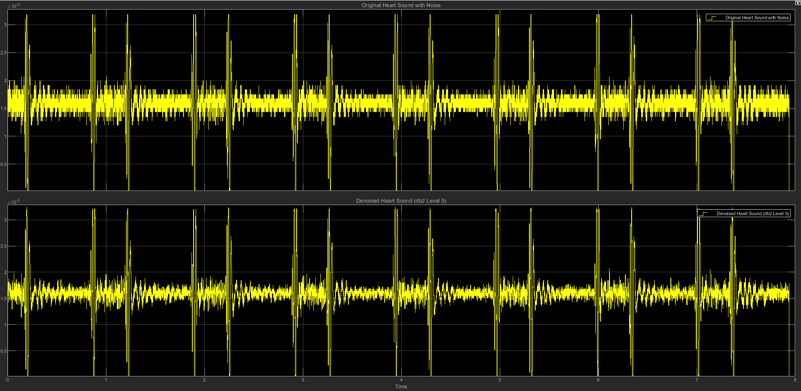

(c) db2 LEVEL 5 STATISTICS RESULT

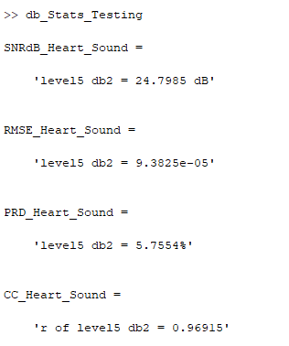

(d) db2 LEVEL 5 SCATTER PLOT RESULT

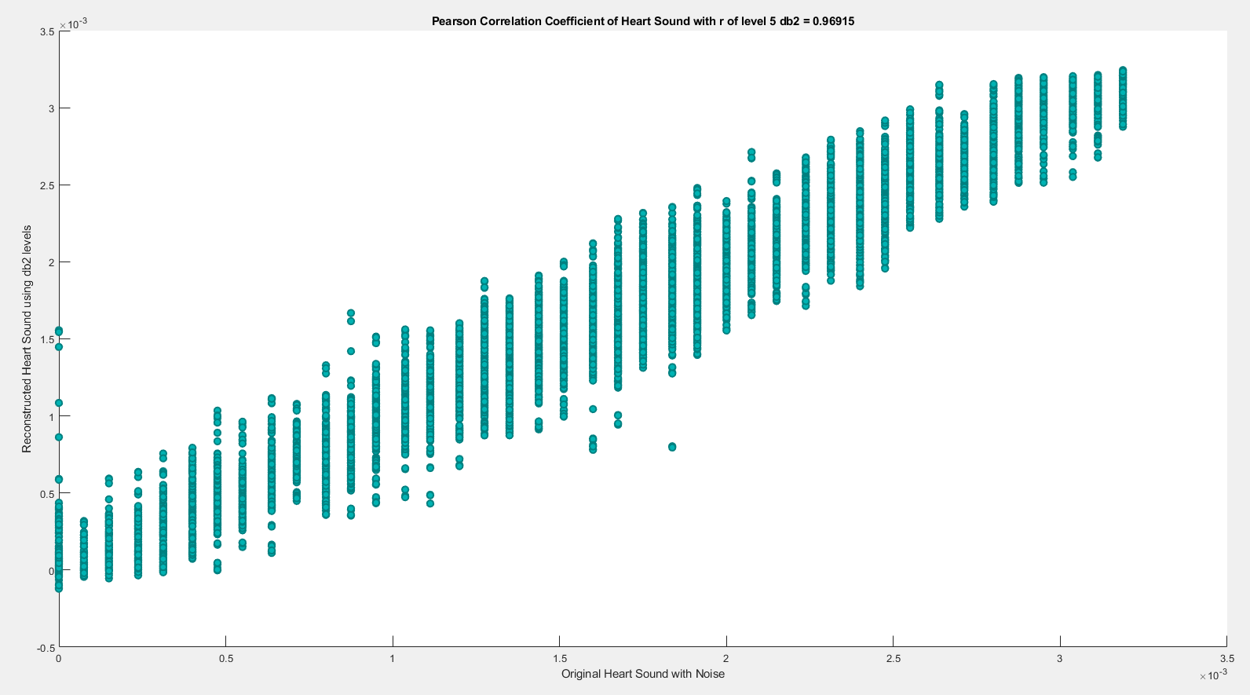

**(5) db2 LEVEL 6**

(a) db2 LEVEL 6 ARCHITECTURE

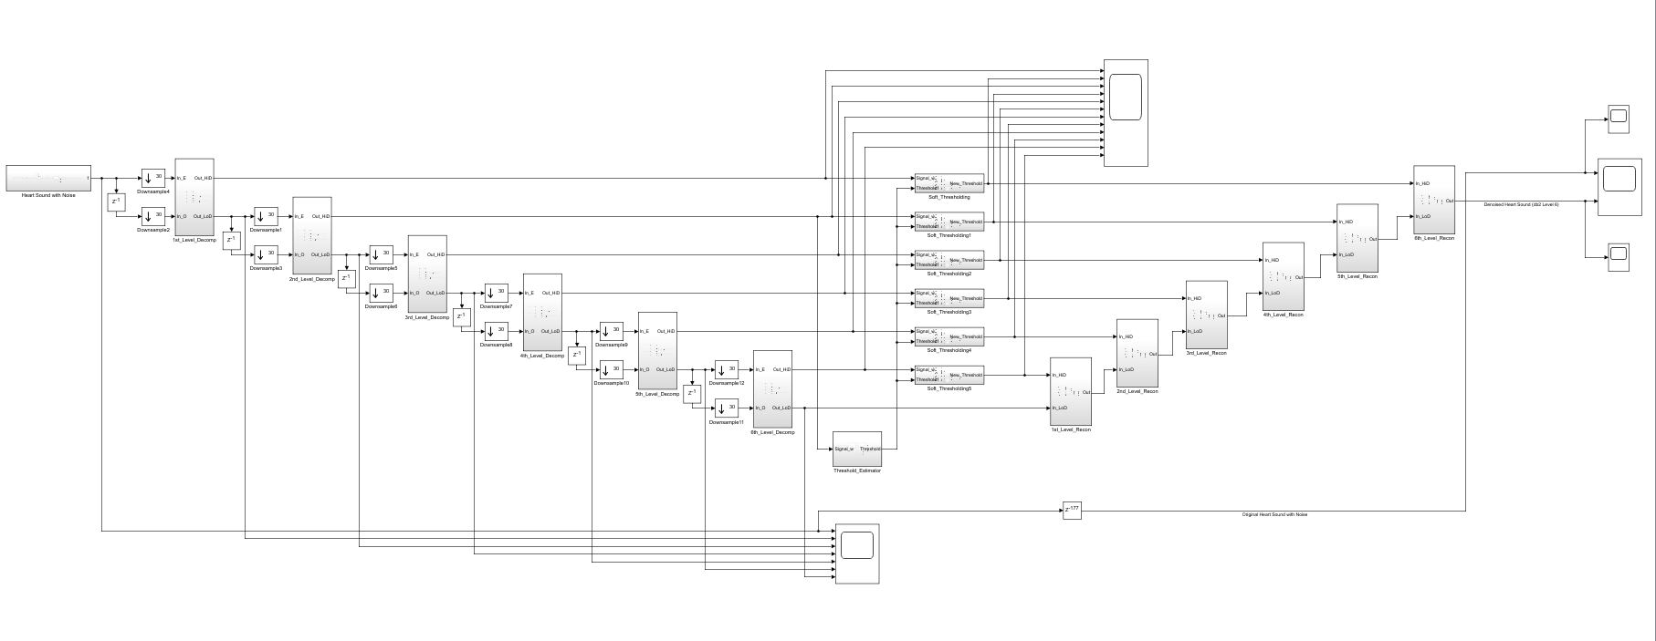

(b) db2 LEVEL 6 SIMULATION RESULT

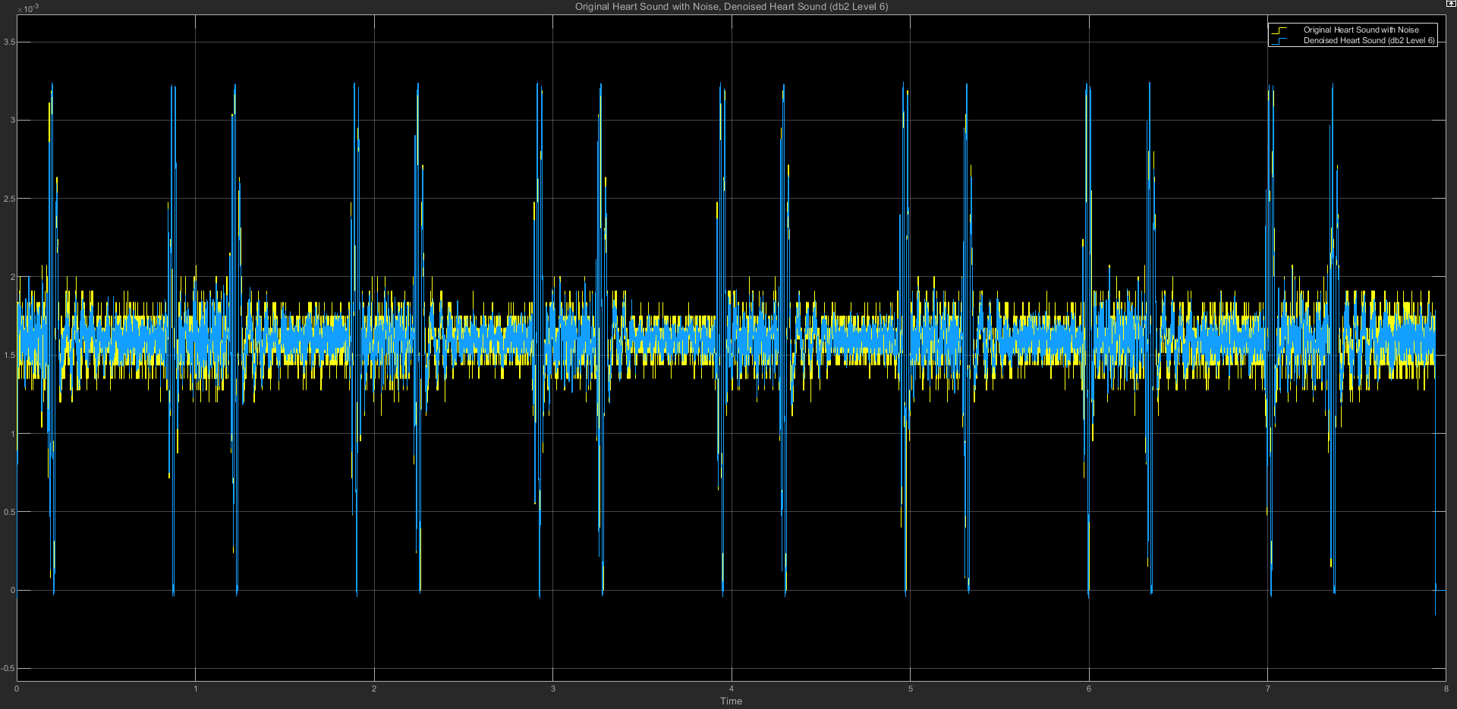

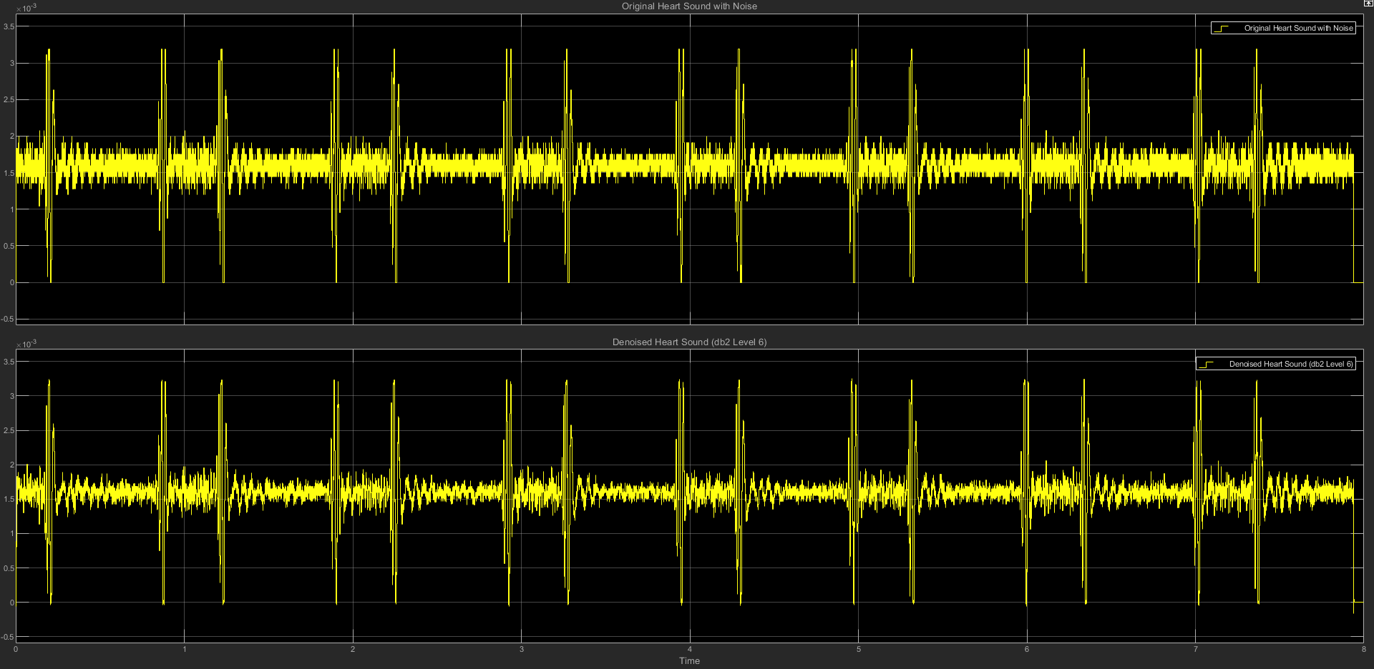

(c) db2 LEVEL 6 STATISTICS RESULT

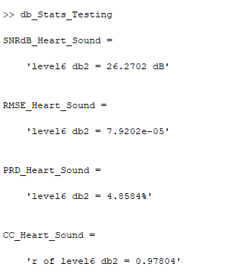

(d) db2 LEVEL 6 SCATTER PLOT RESULT

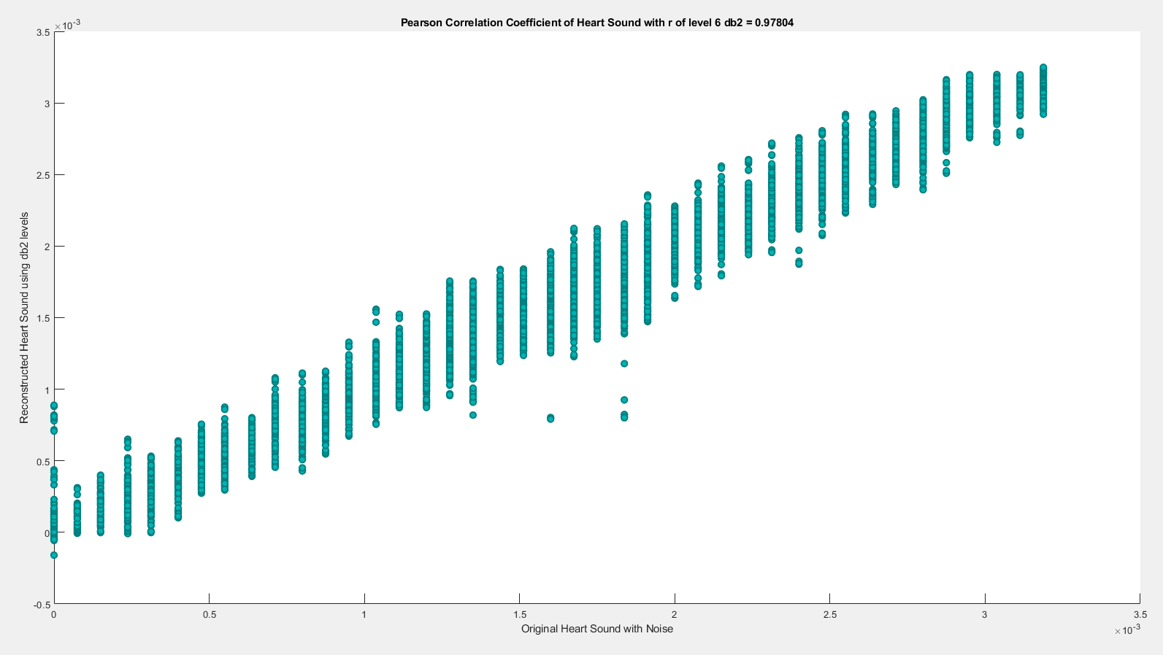

**(6) db2 LEVEL 7**

(a) db2 LEVEL 7 ARCHITECTURE

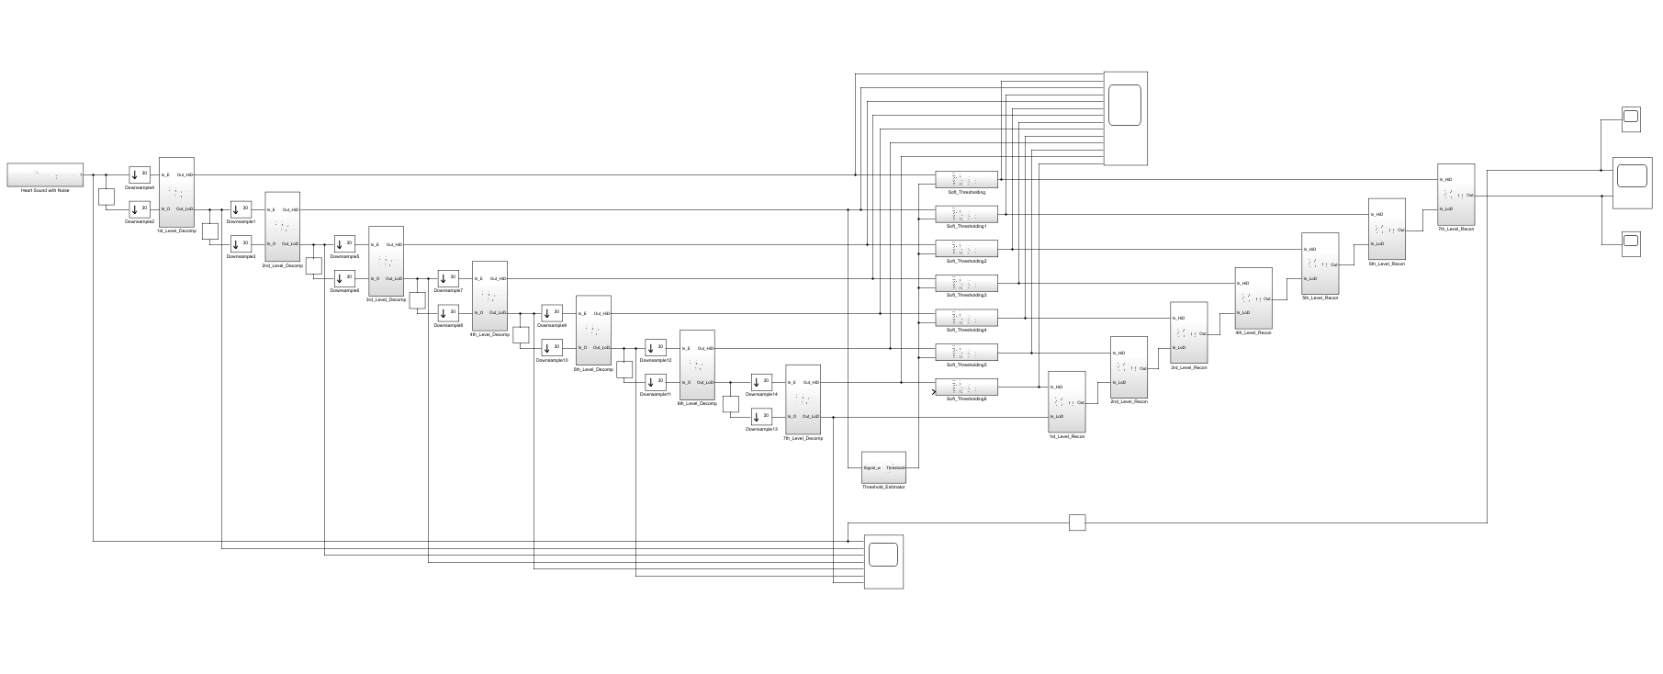

(b) db2 LEVEL 7 SIMULATION RESULT

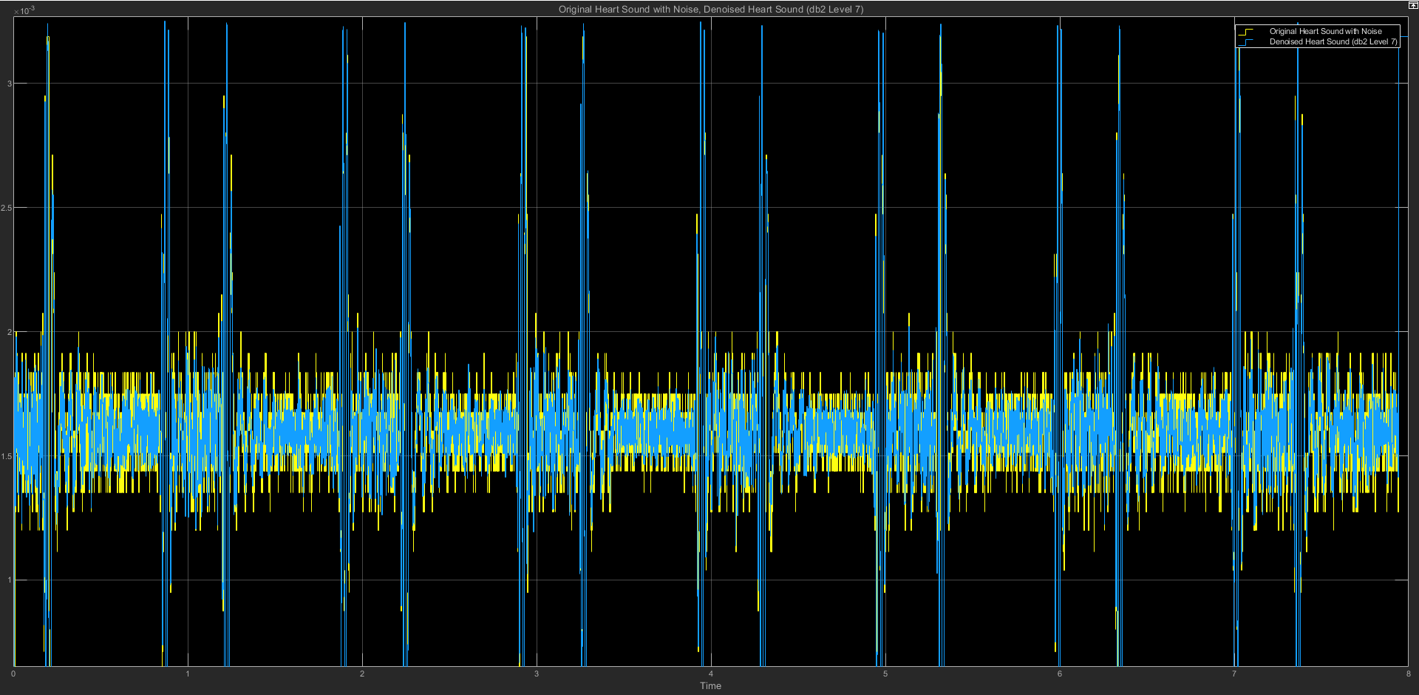

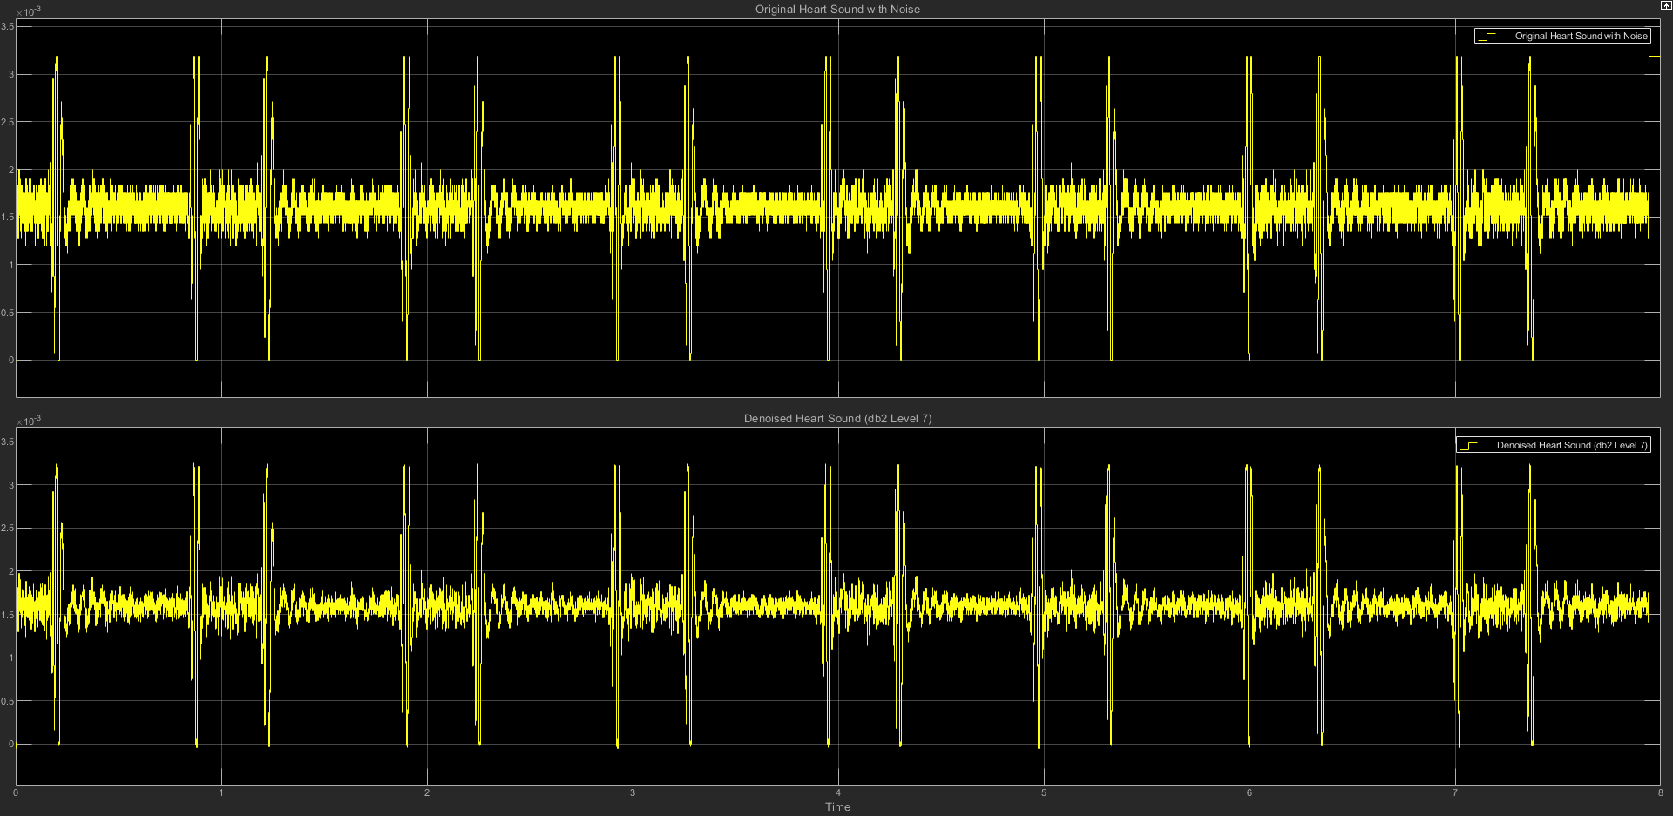

(c) db2 LEVEL 7 STATISTICS RESULT

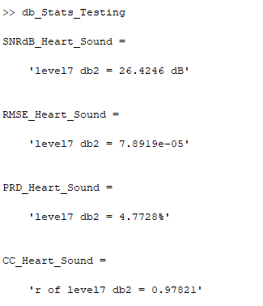

(d) db2 LEVEL 7 SCATTER PLOT RESULT

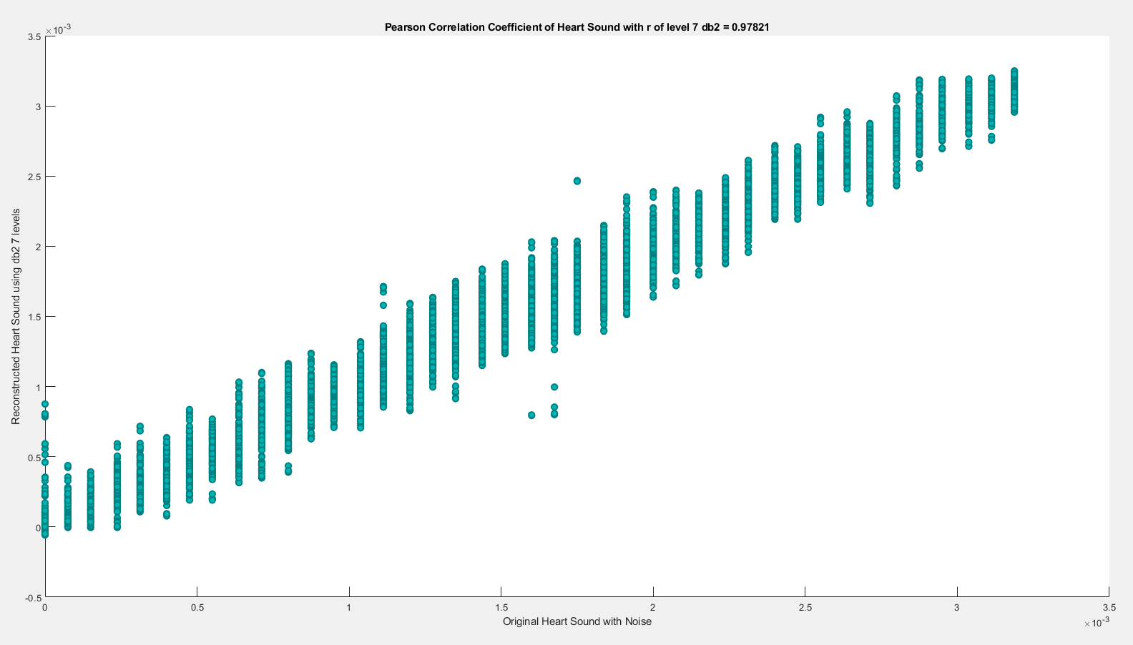

==================================================================

**db3**

| **db3** | **SNRdB_Heart**  **_Sound** | **RMSE_Heart**  **_Sound** | **PRD_Heart_Sound** | **CC_Heart**  **_Sound** |
| --- | --- | --- | --- | --- |
| Level 2 | 23.7353 dB | 0.00010763 | 6.5048% | 0.95946 |
| Level 3 | 24.1873 dB | 0.00010215 | 6.175% | 0.96349 |
| Level 4 | 24.9547 dB | 9.3505e-05 | 5.6528% | 0.96933 |
| Level 5 | 25.751 dB | 8.4114e-05 | 5.1576% | 0.97526 |
| Level 6 | 26.092 dB | 8.0843e-05 | 4.9591% | 0.97712 |
| Level 7 | 26.2782 dB | 8.0237e-05 | 4.8539% | 0.97752 |

**(1) db3 LEVEL 2**

(a) db3 LEVEL 2 ARCHITECTURE

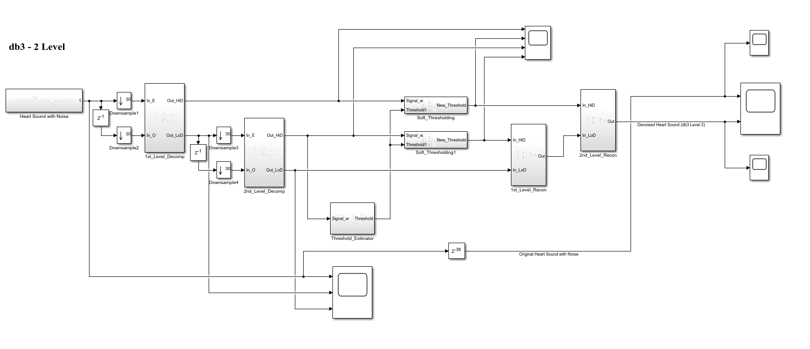

(b) db3 LEVEL 2 SIMULATION RESULT

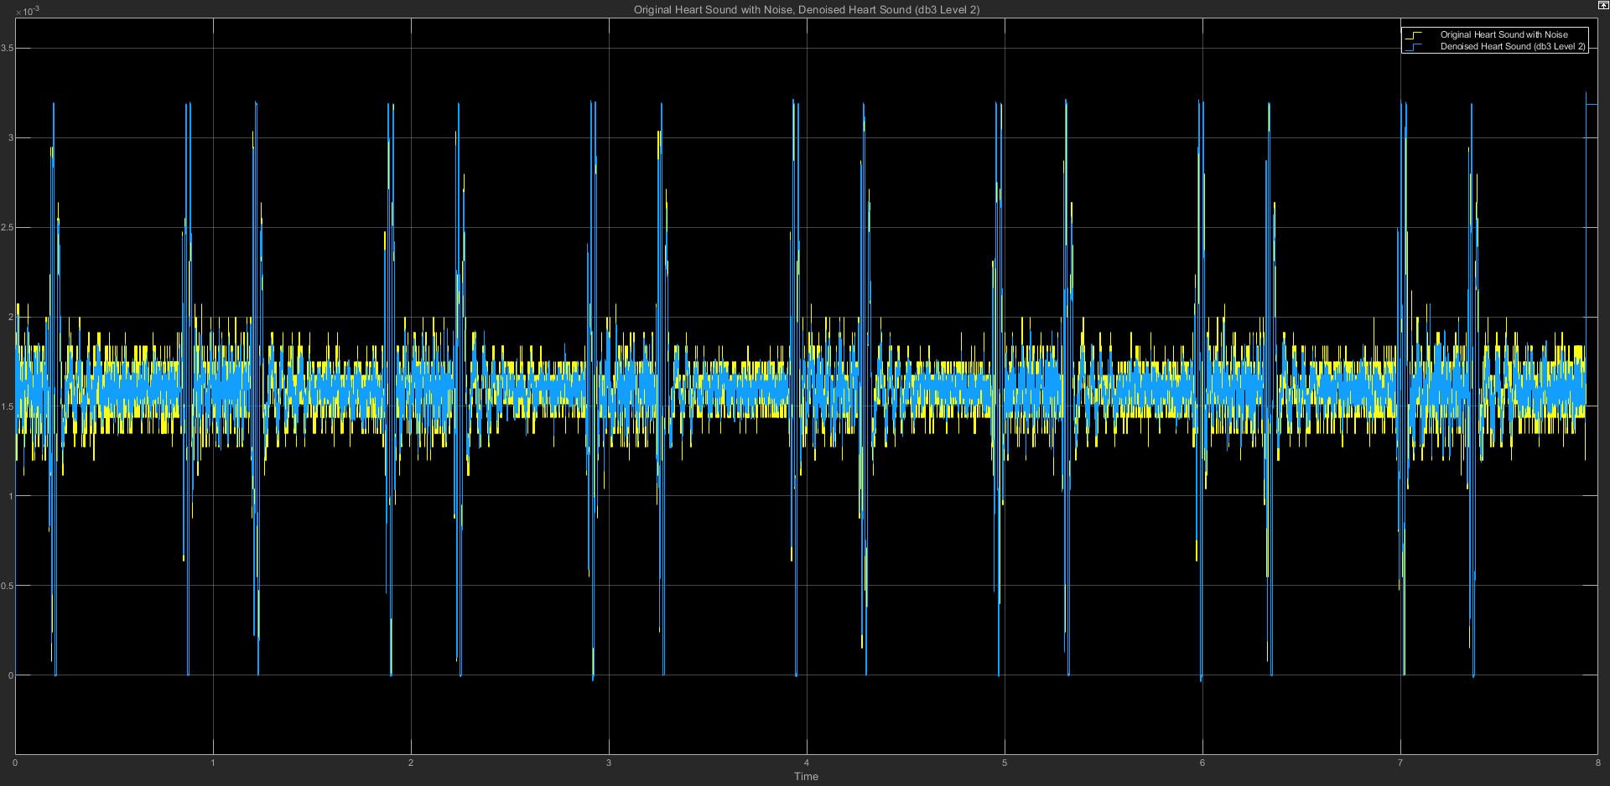

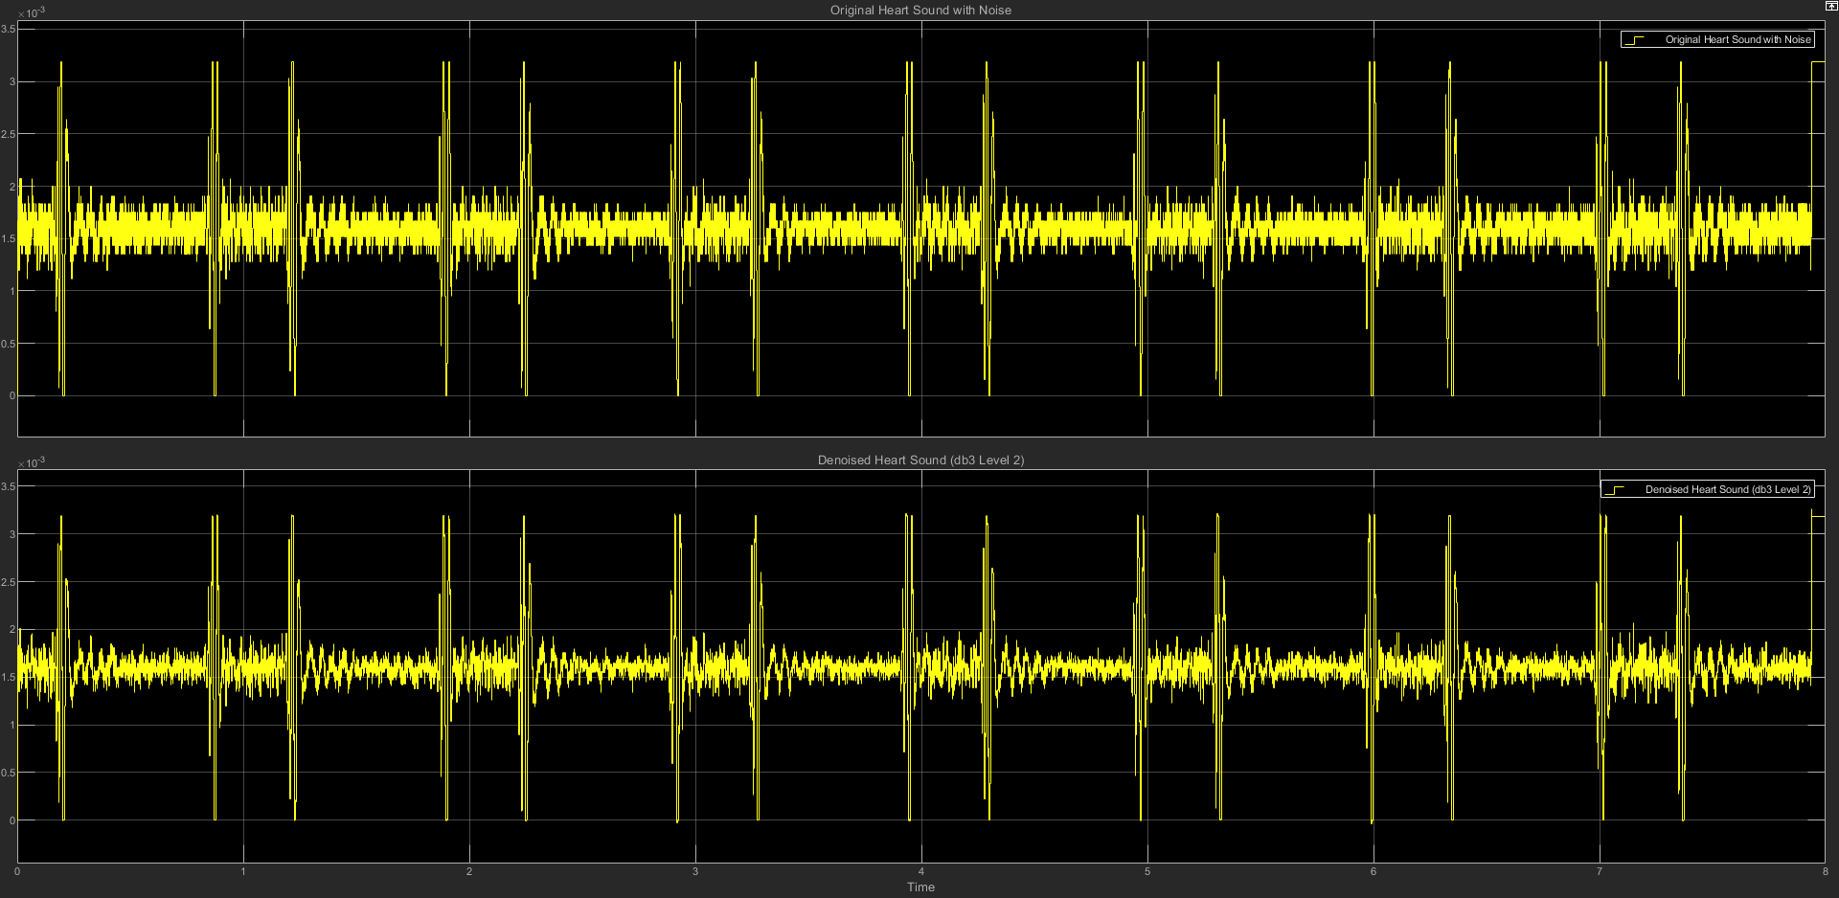

(c) db3 LEVEL 2 STATISTICS RESULT

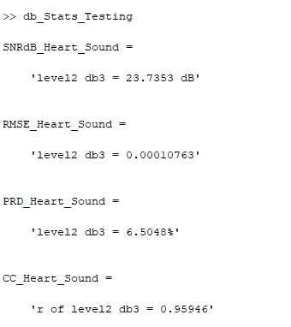

(d) db3 LEVEL 2 SCATTER PLOT RESULT

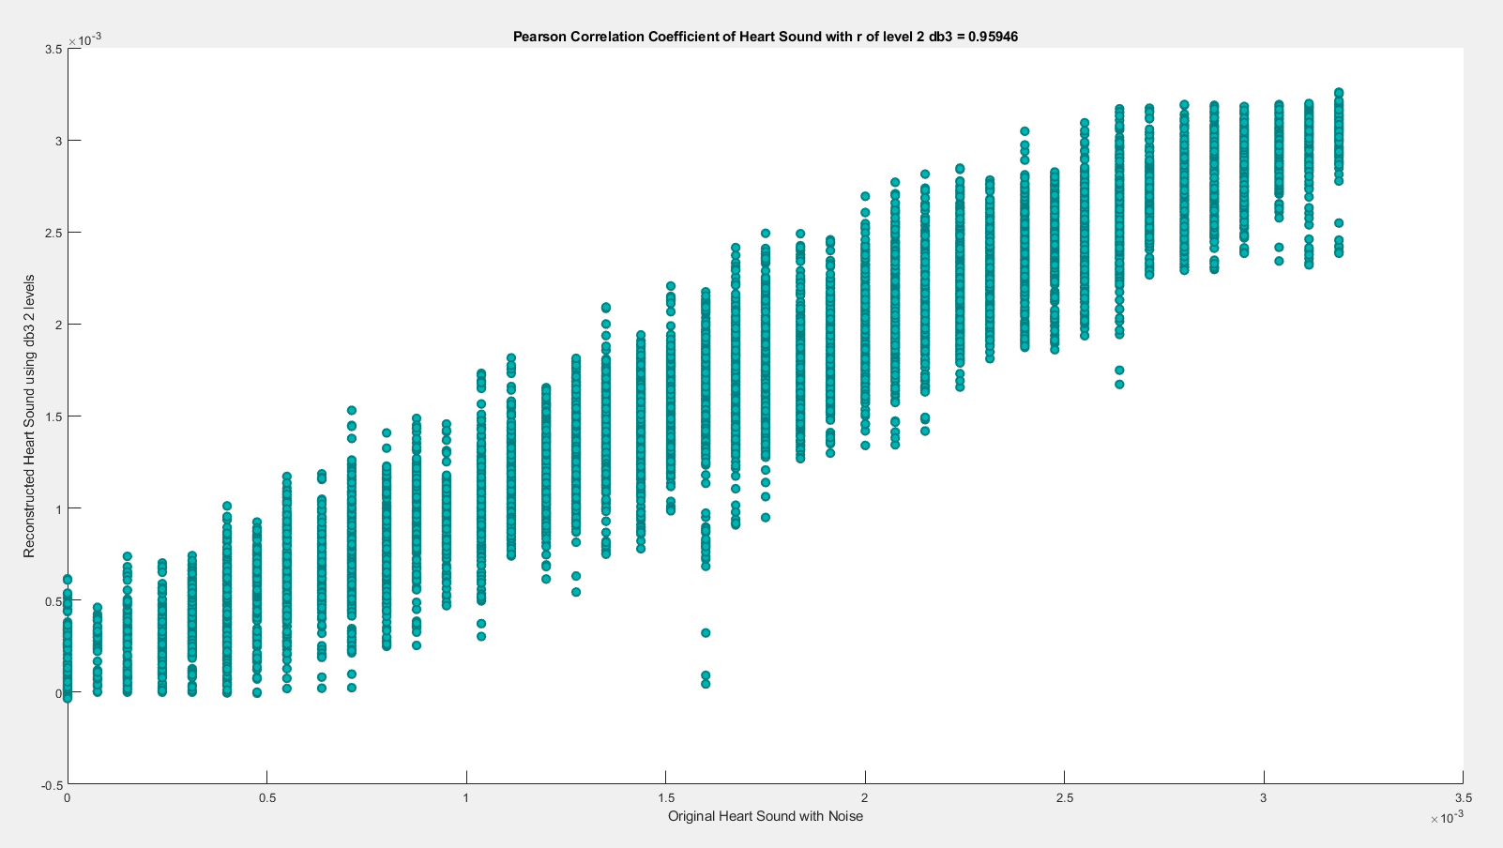

**(2) db3 LEVEL 3**

(a) db3 LEVEL 3 ARCHITECTURE

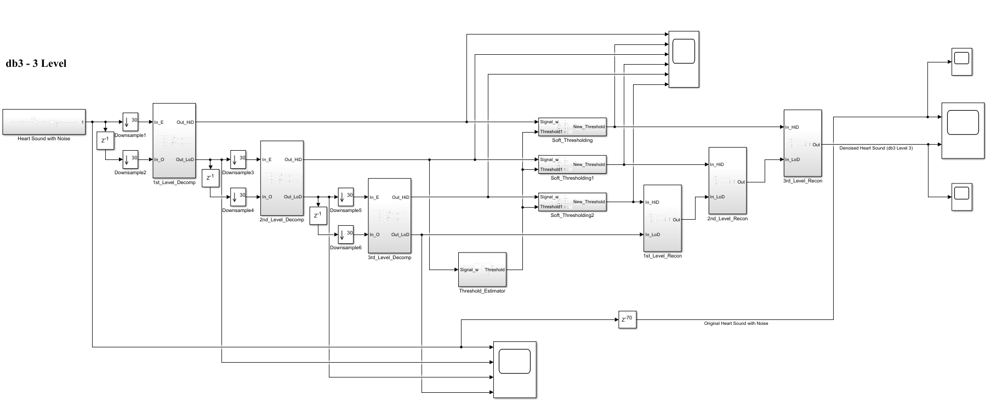

(b) db3 LEVEL 3 SIMULATION RESULT

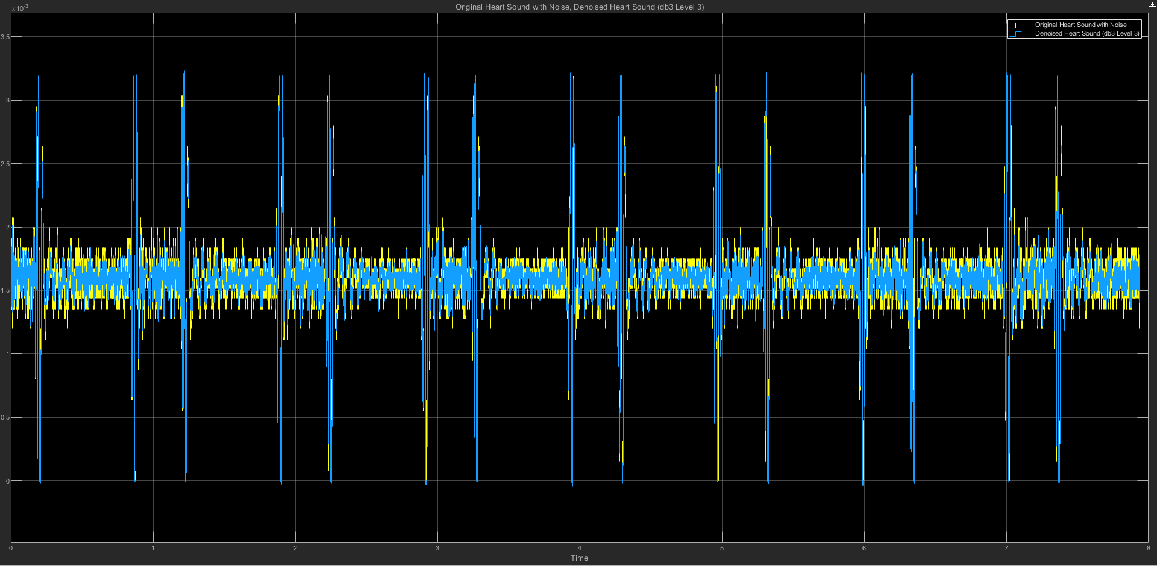

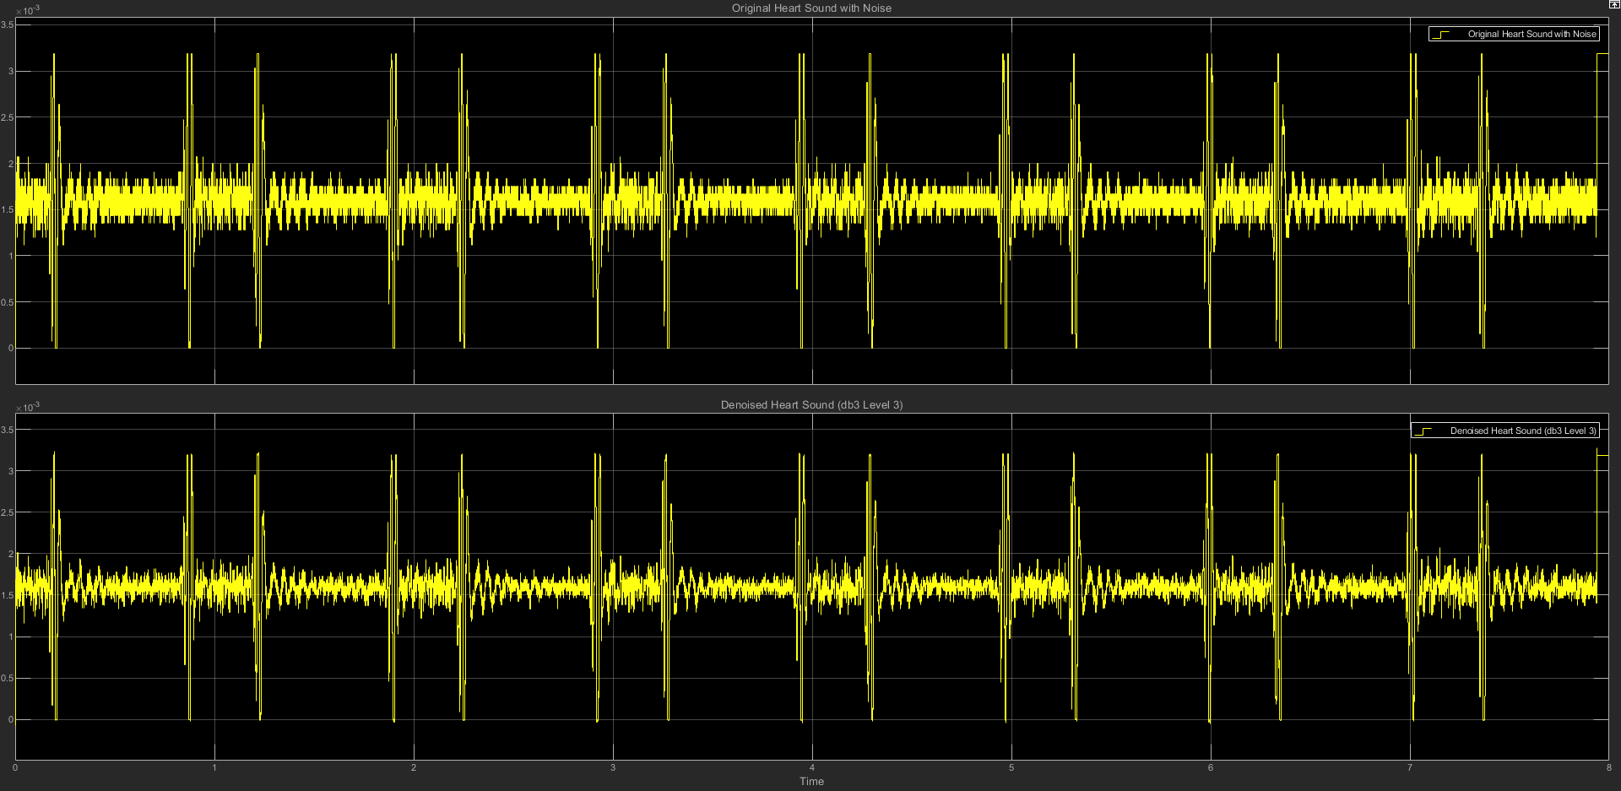

(c) db3 LEVEL 3 STATISTICS RESULT

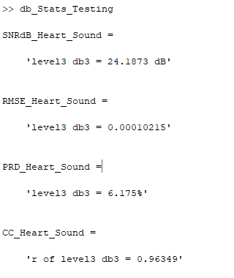

(d) db3 LEVEL 3 SCATTER PLOT RESULT

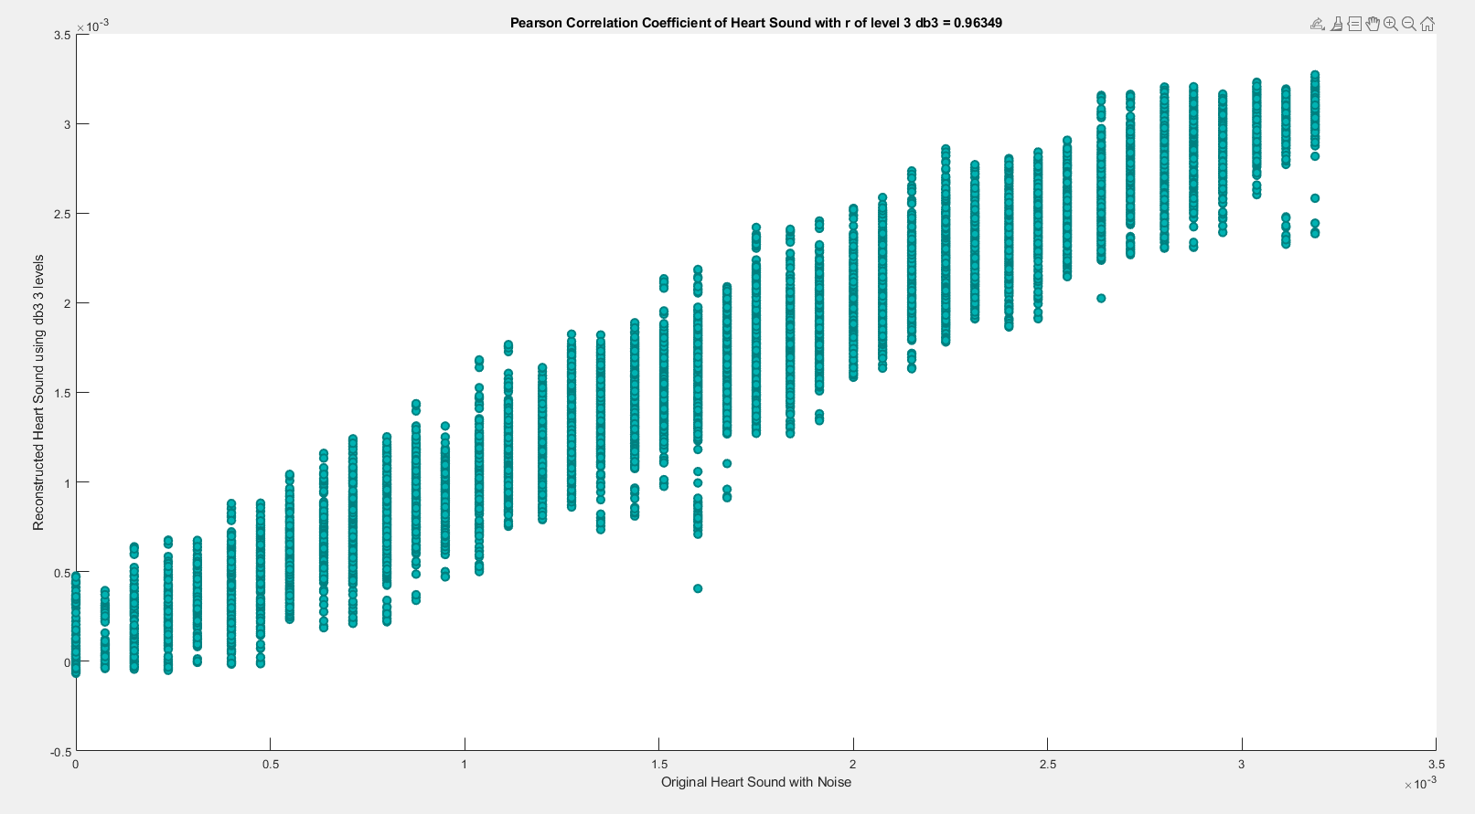

**(3) db3 LEVEL 4**

(a) db3 LEVEL 4 ARCHITECTURE

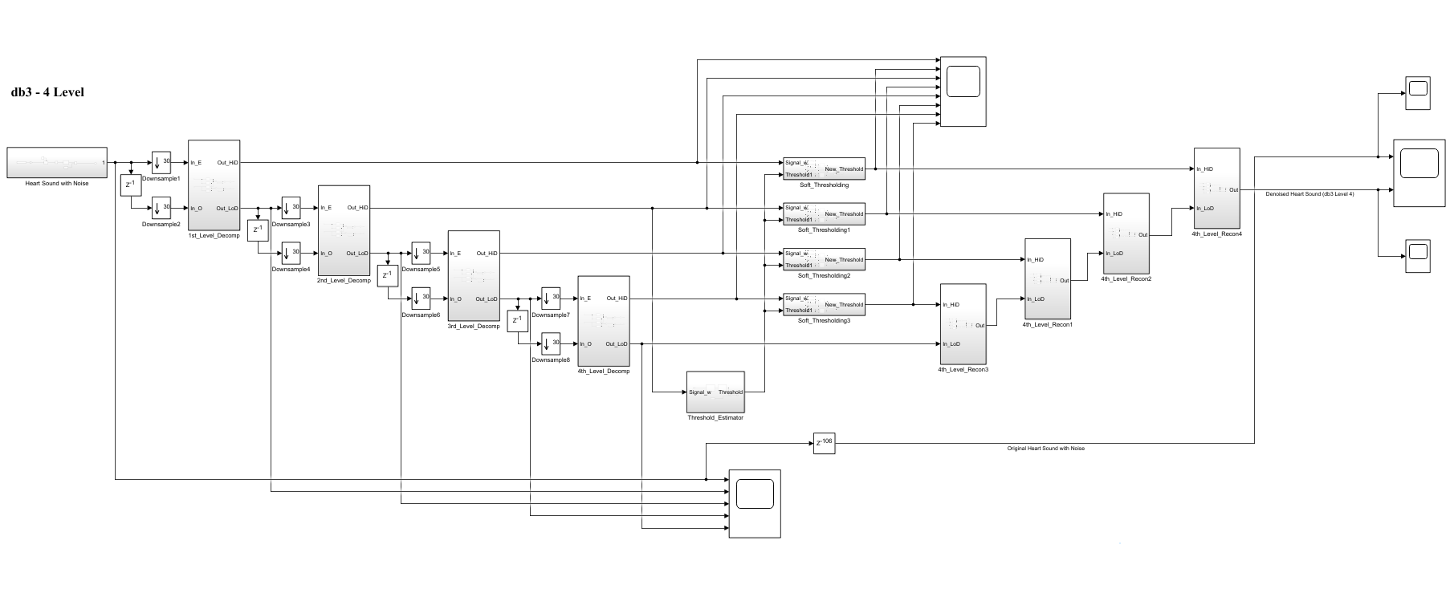

(b) db3 LEVEL 4 SIMULATION RESULT

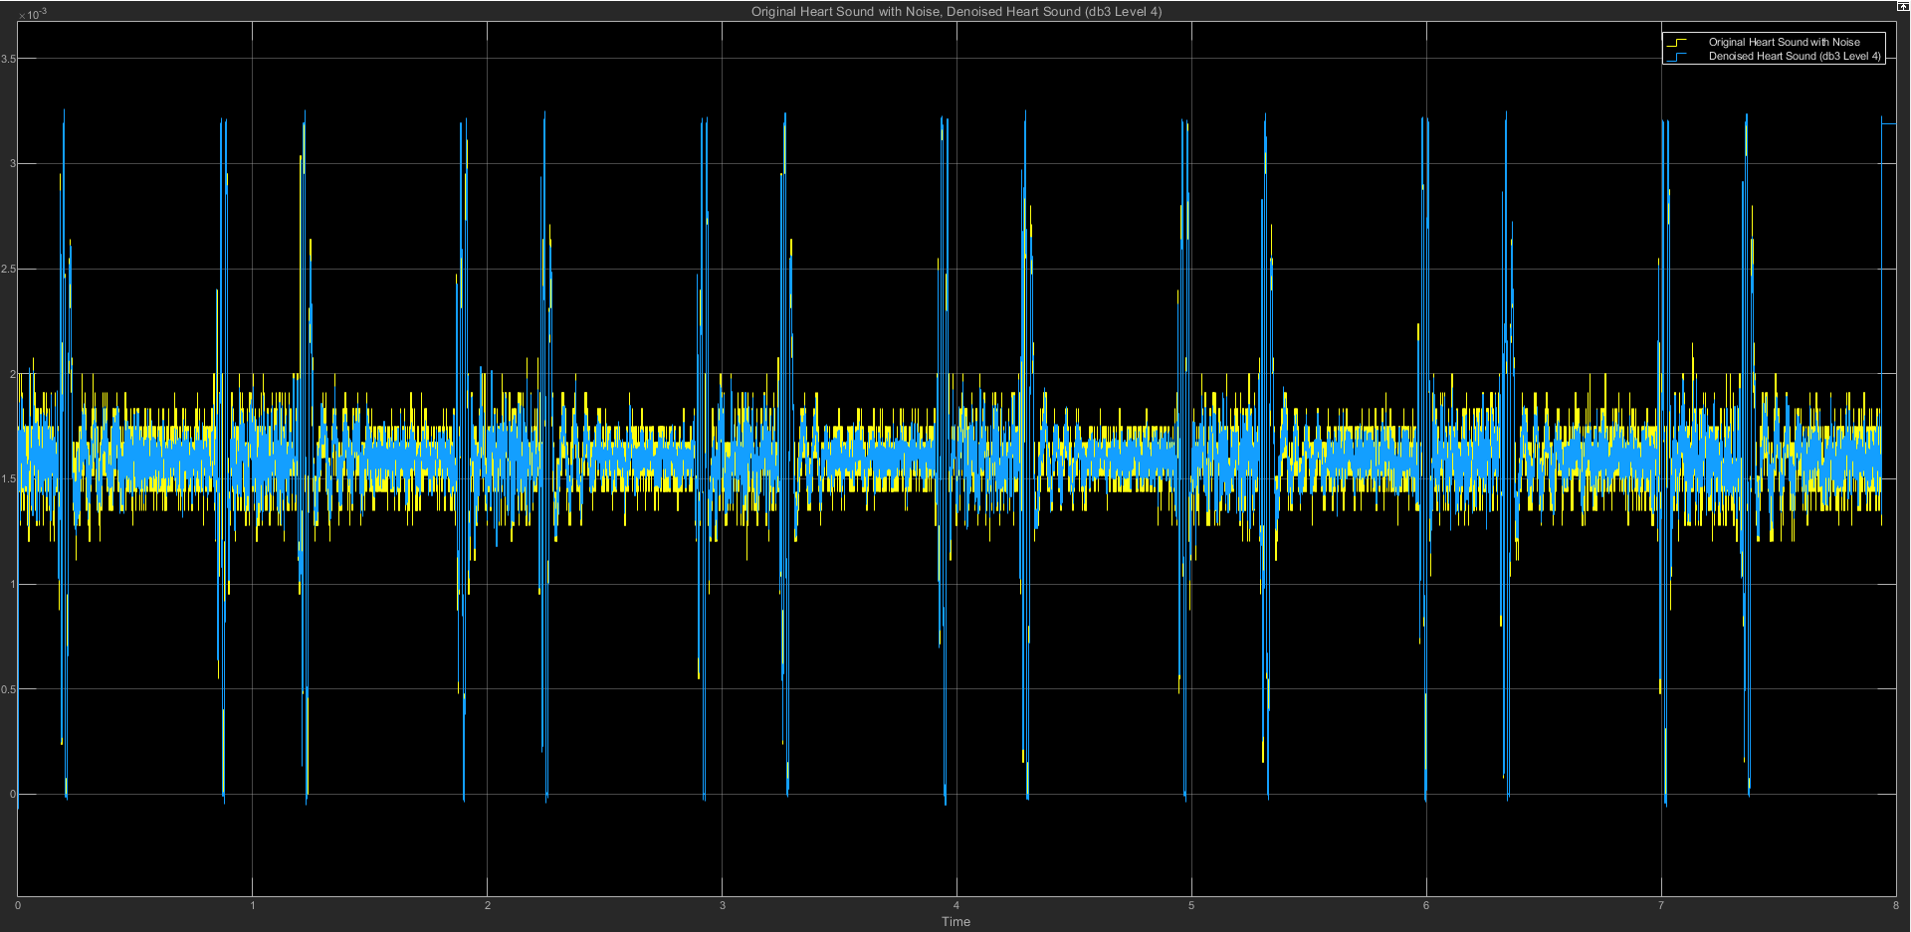

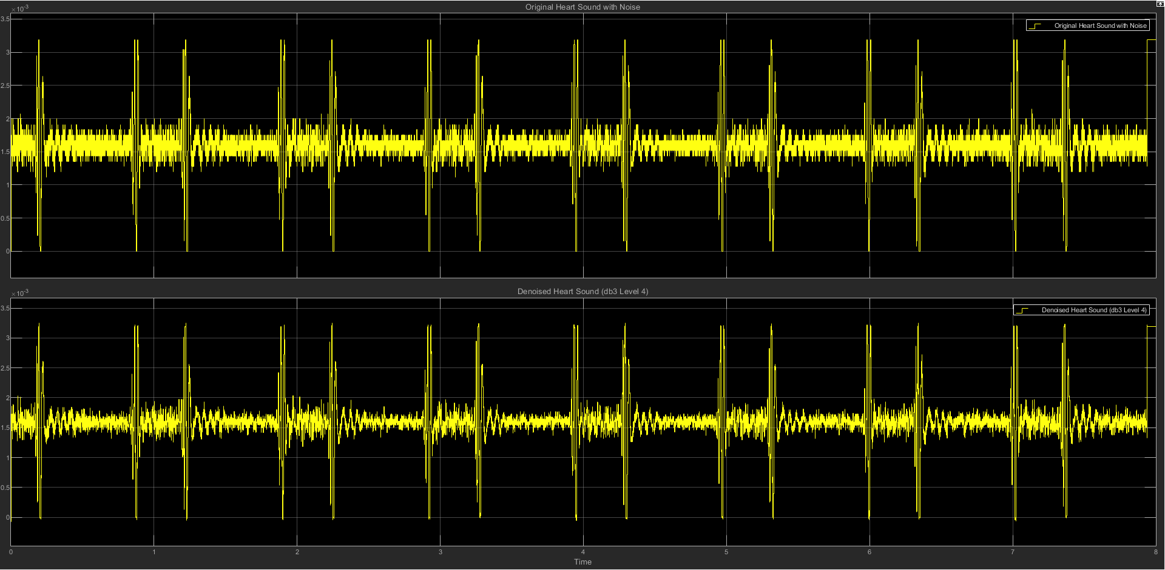

(c) db3 LEVEL 4 STATISTICS RESULT

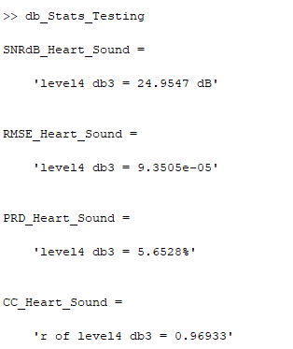

(d) db3 LEVEL 4 SCATTER PLOT RESULT

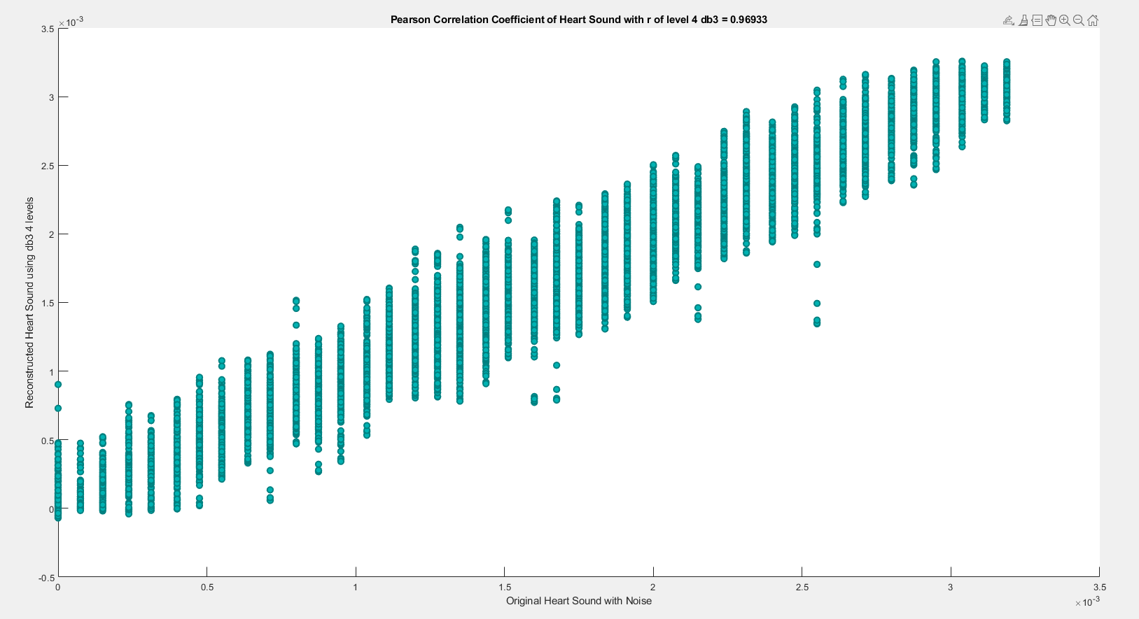

**(4) db3 LEVEL 5**

(a) db3 LEVEL 5 ARCHITECTURE

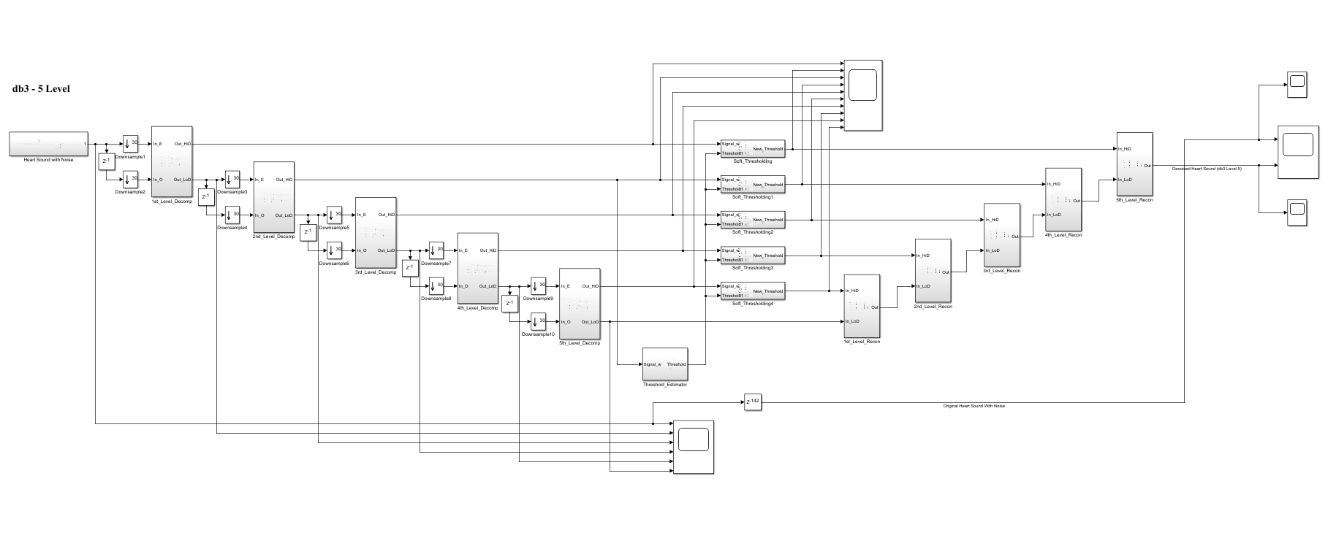

(b) db3 LEVEL 5 SIMULATION RESULT

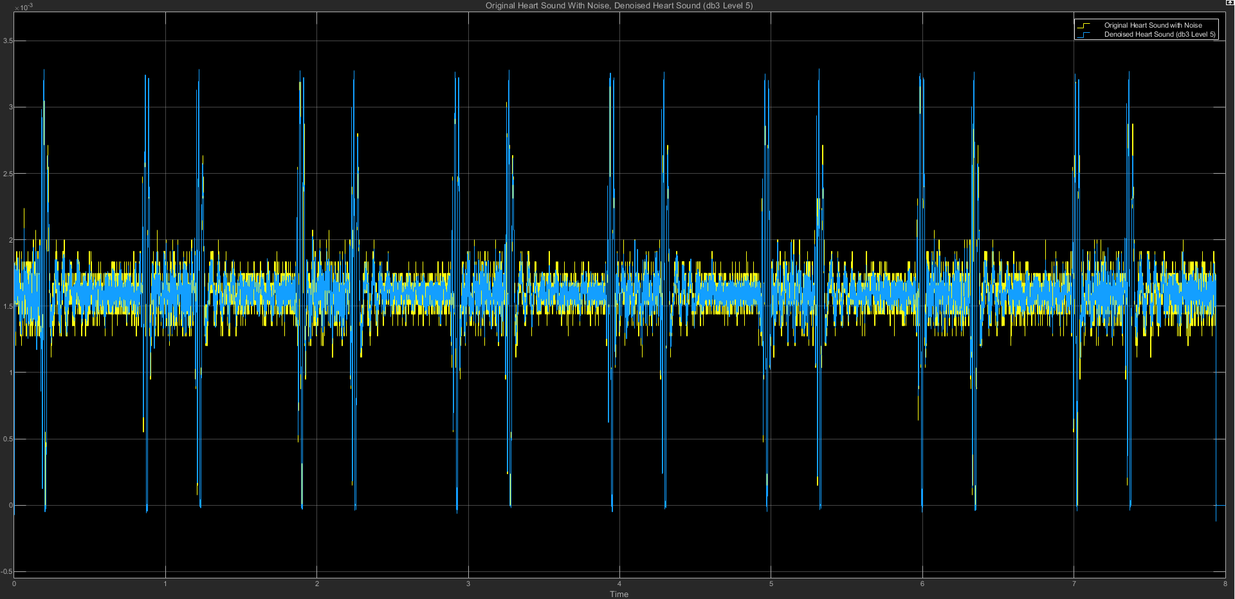

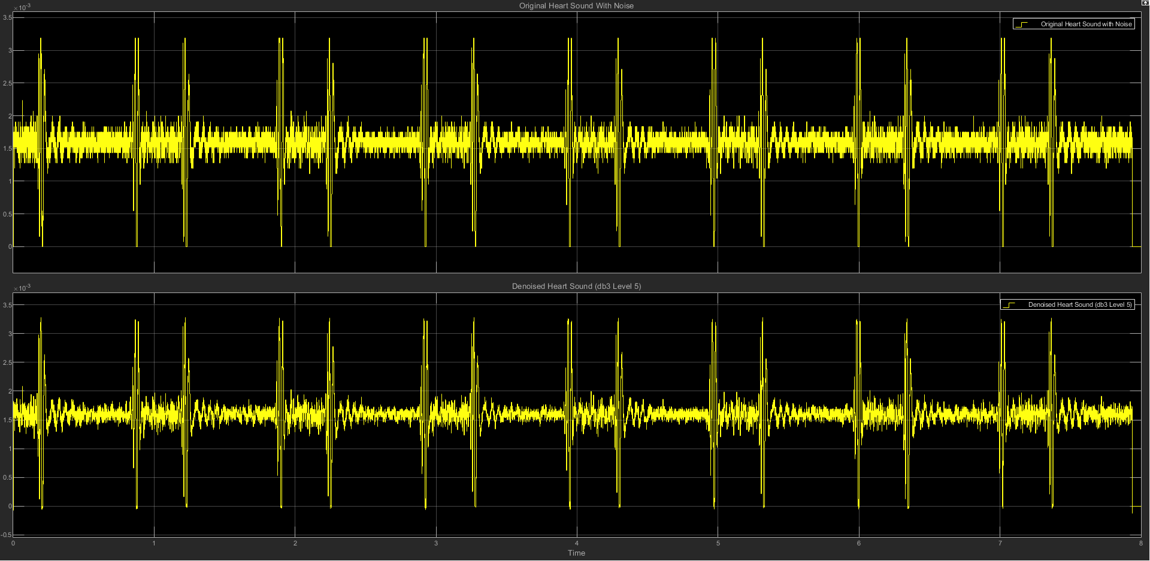

(c) db3 LEVEL 5 STATISTICS RESULT

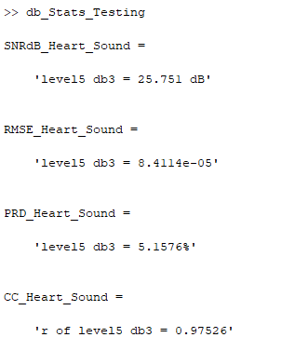

(d) db3 LEVEL 5 SCATTER PLOT RESULT

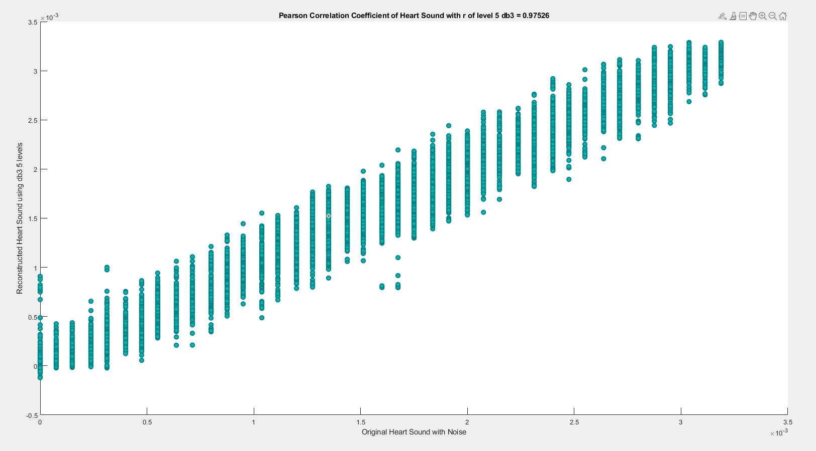

**(5) db3 LEVEL 6**

(a) db3 LEVEL 6 ARCHITECTURE

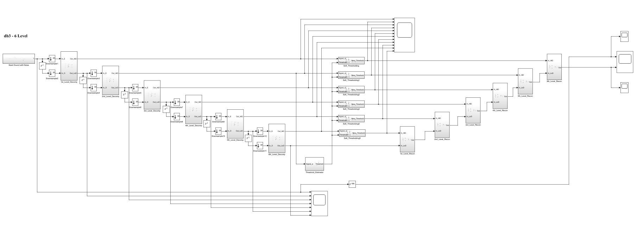

(b) db3 LEVEL 6 SIMULATION RESULT

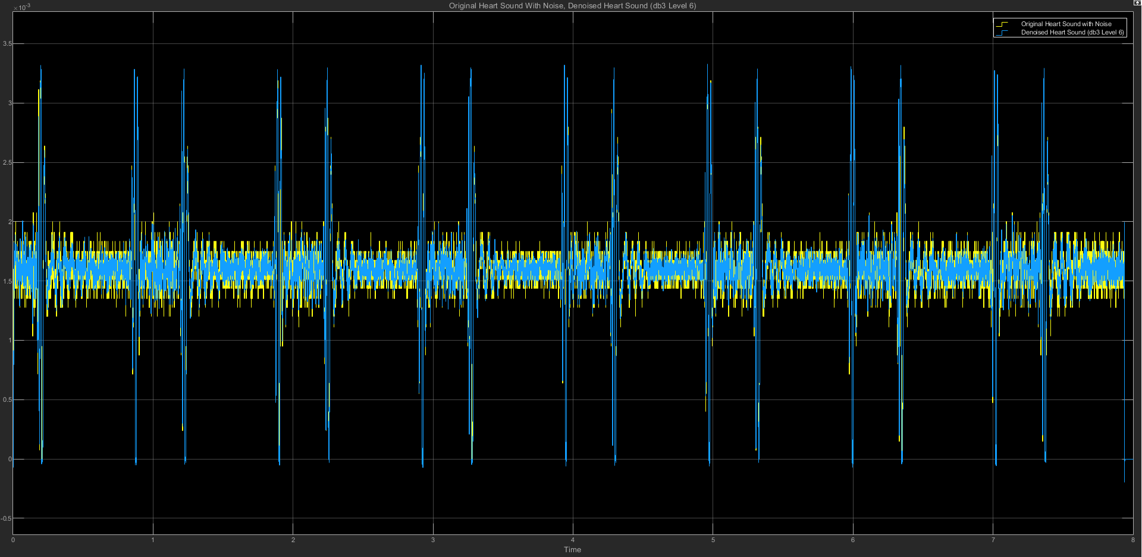

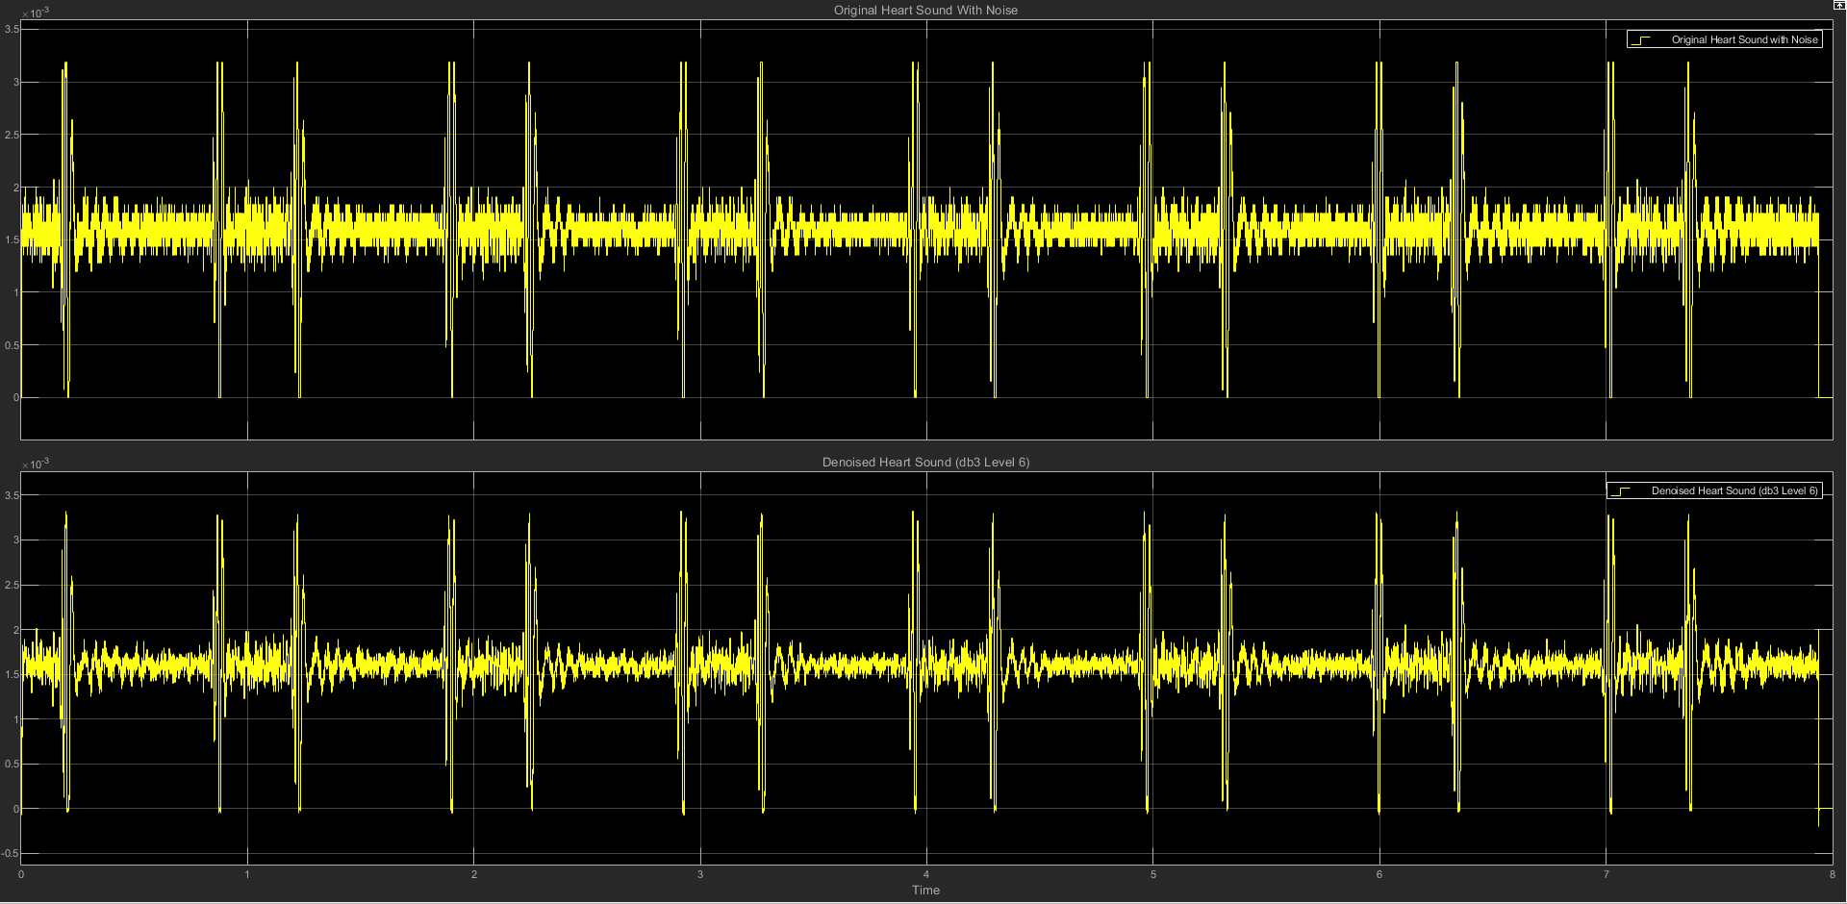

(c) db3 LEVEL 6 STATISTICS RESULT

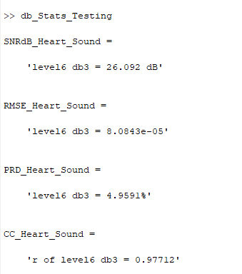

(d) db3 LEVEL 6 SCATTER PLOT RESULT

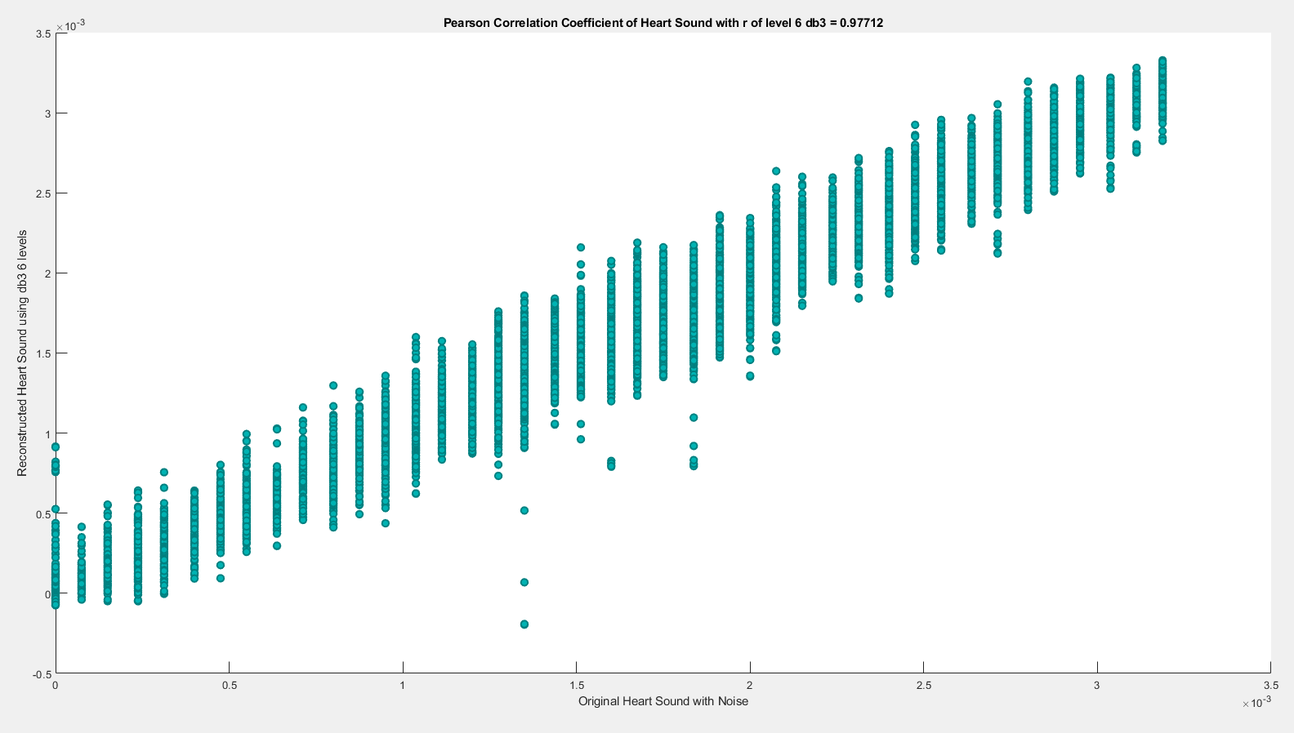

**(6) db3 LEVEL 7**

(a) db3 LEVEL 7 ARCHITECTURE

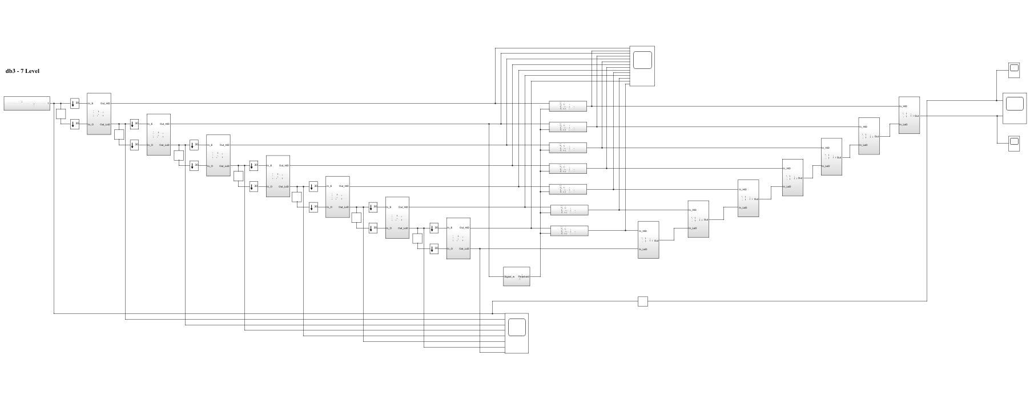

(b) db3 LEVEL 7 SIMULATION RESULT

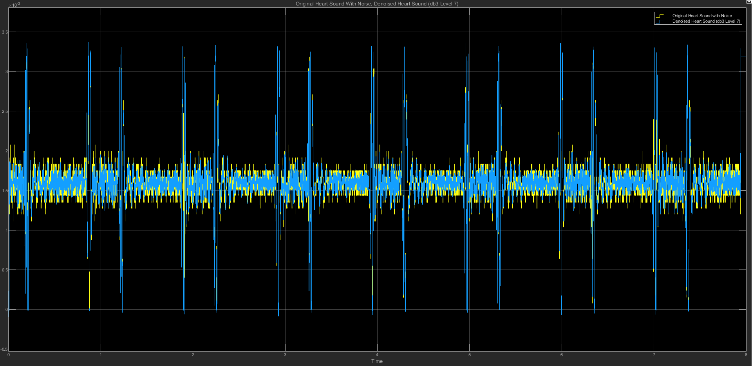

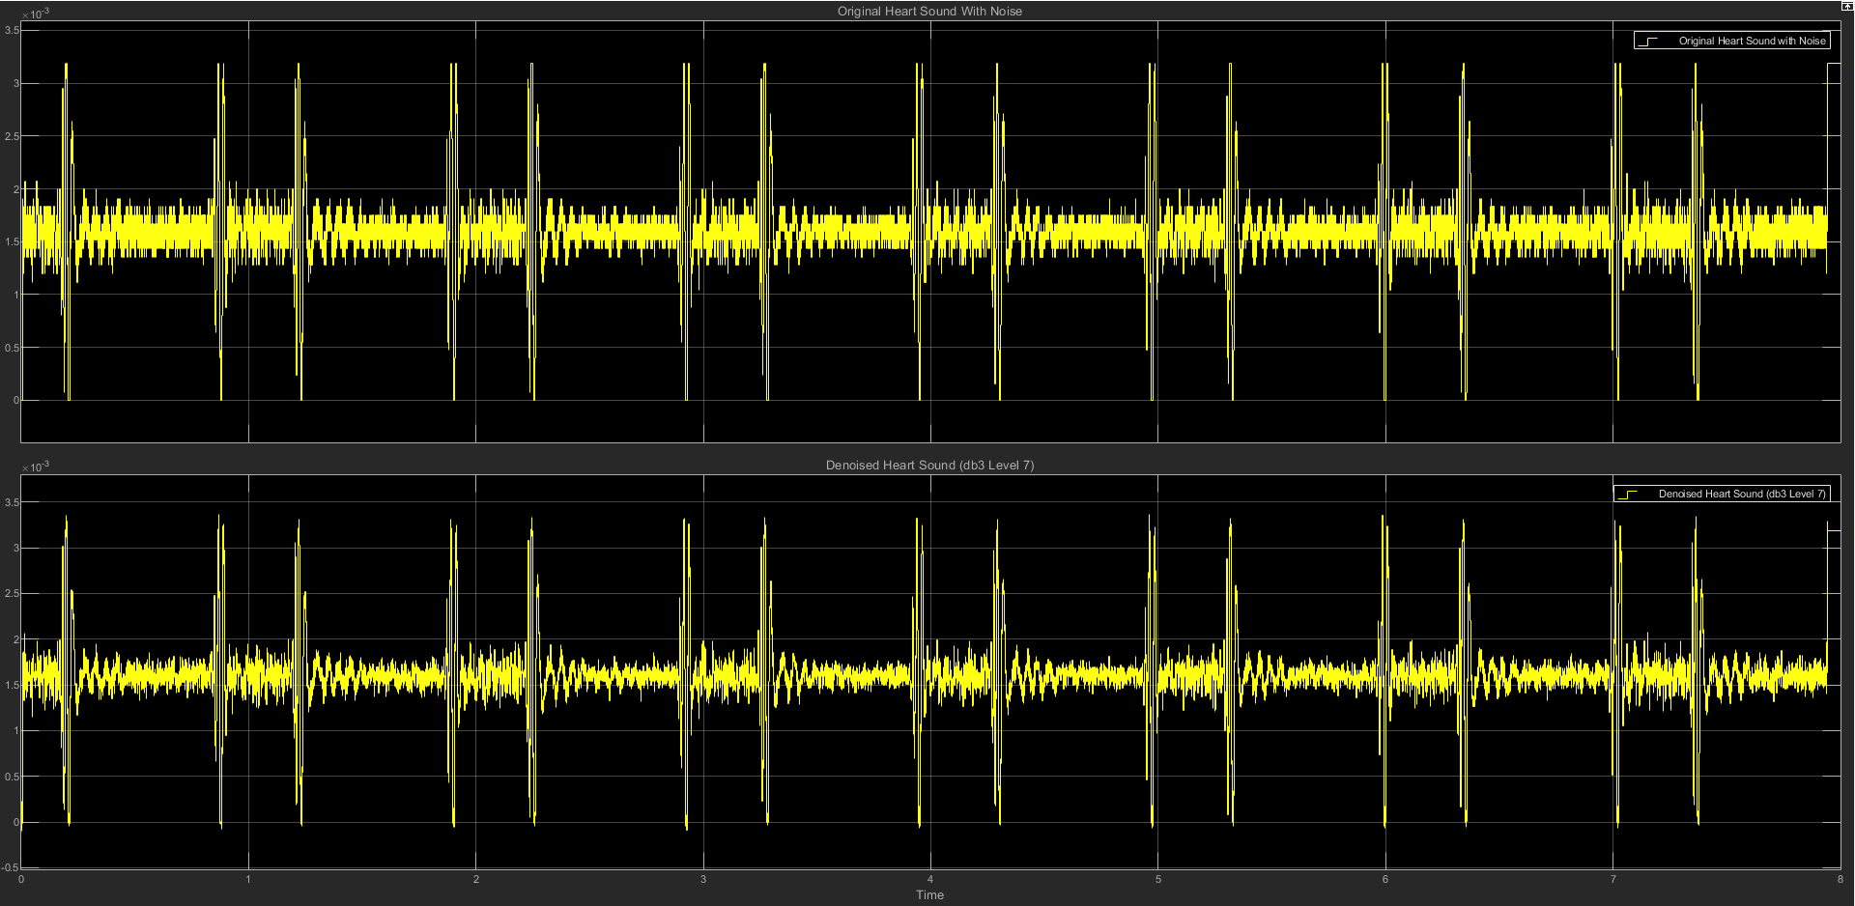

(c) db3 LEVEL 7 STATISTICS RESULT

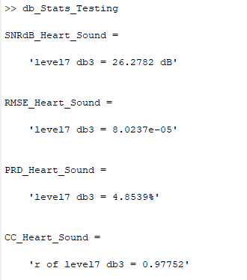

(d) db3 LEVEL 7 SCATTER PLOT RESULT

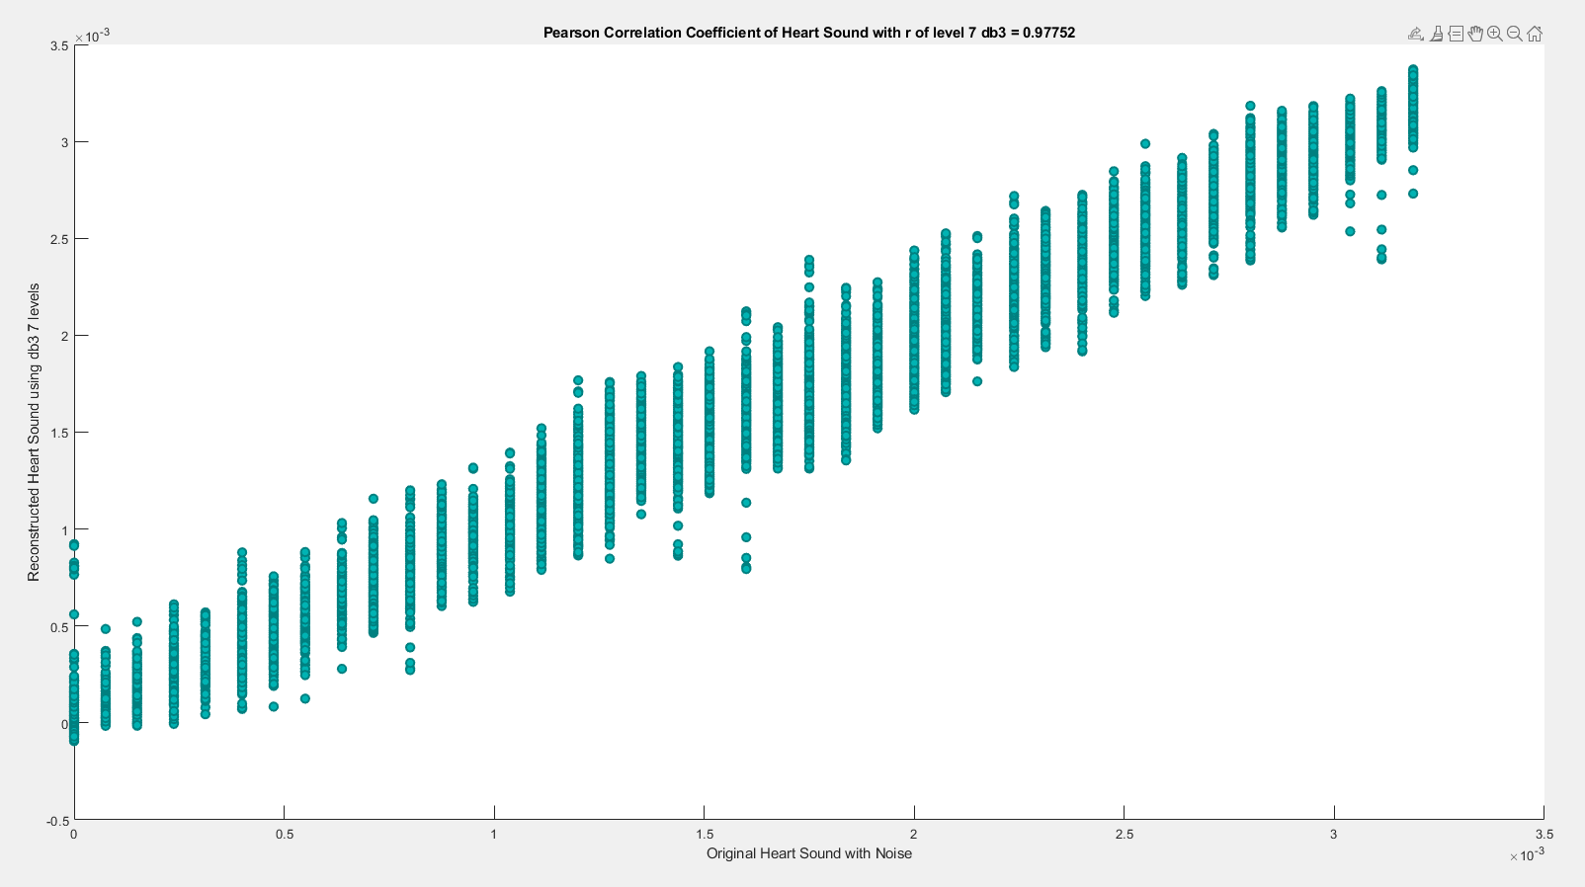

========================================================================

**db4**

| **db4** | **SNRdB_Heart**  **_Sound** | **RMSE_Heart**  **_Sound** | **PRD_Heart_Sound** | **CC_Heart**  **_Sound** |
| --- | --- | --- | --- | --- |
| Level 2 | 23.9162 dB | 0.00010541 | 6.3708% | 0.96112 |
| Level 3 | 23.9904 dB | 0.00010306 | 6.3165% | 0.96225 |
| Level 4 | 24.3743 dB | 9.8604e-05 | 6.0435% | 0.96545 |
| Level 5 | 24.8989 dB | 9.4118e-05 | 5.6893% | 0.96895 |
| Level 6 | 25.4598 dB | 8.8191e-05 | 5.3335% | 0.97273 |
| Level 7 | 26.2229 dB | 8.0754e-05 | 4.8849% | 0.97715 |

**(1) db4 LEVEL 2**

(a) db4 LEVEL 2 ARCHITECTURE

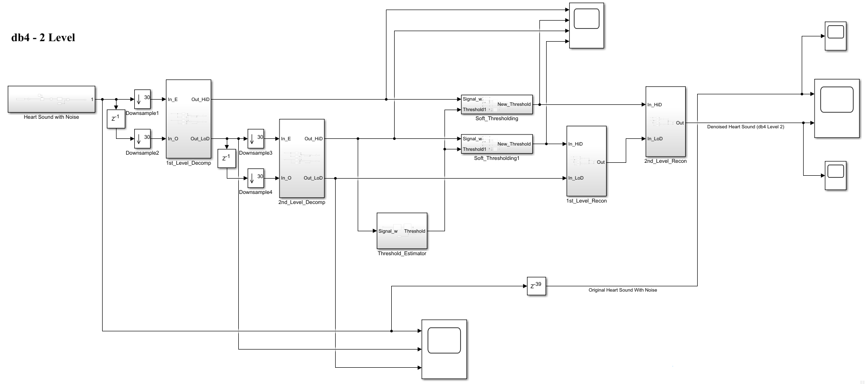

(b) db4 LEVEL 2 SIMULATION RESULT

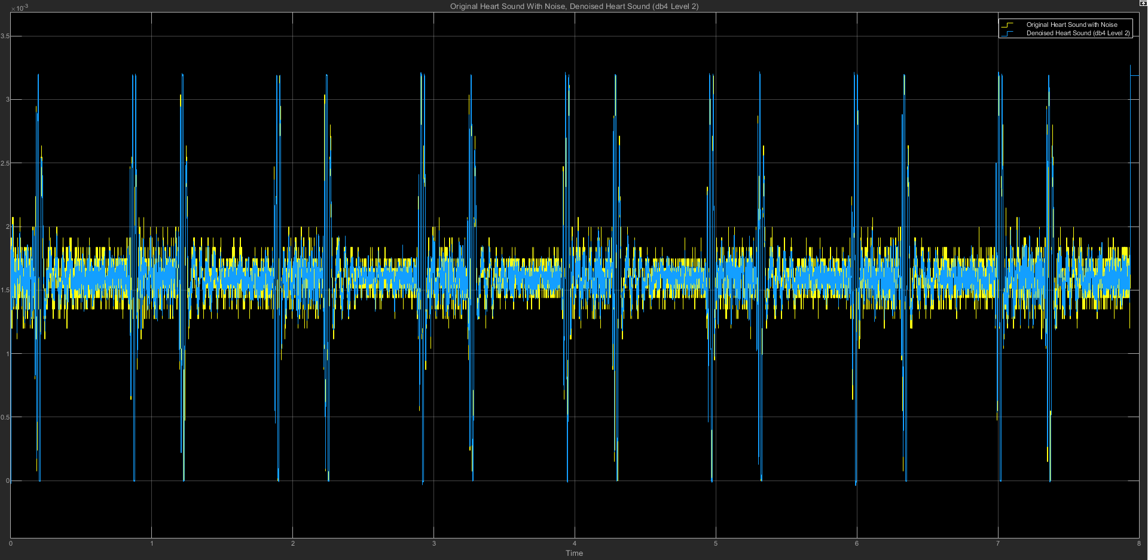

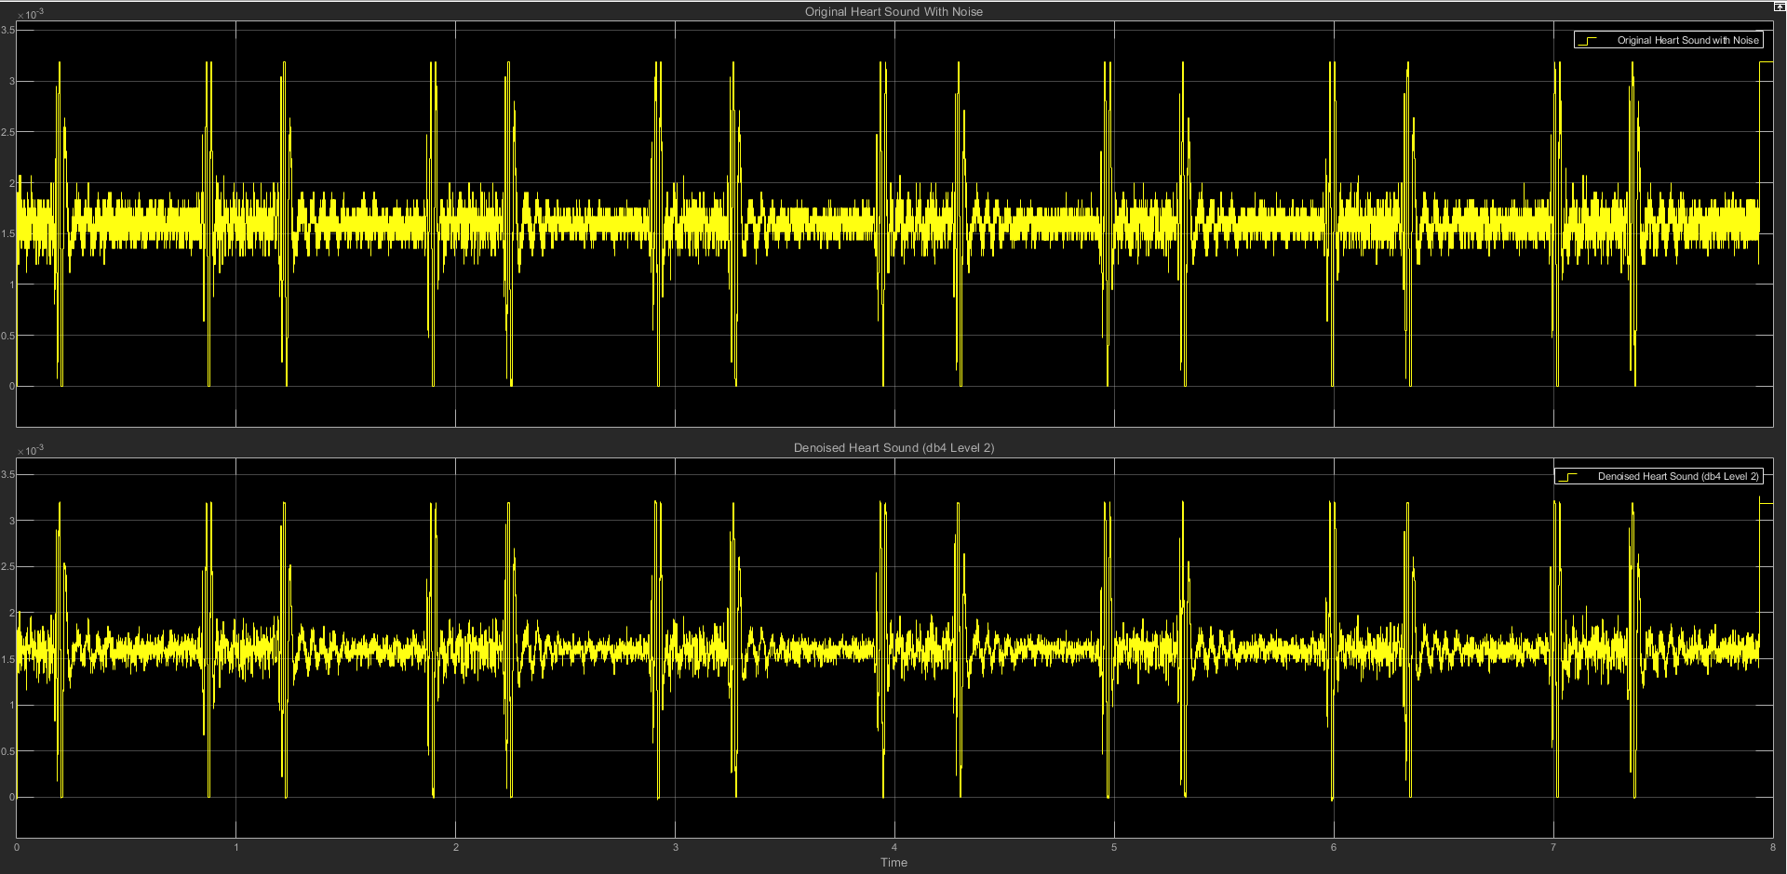

(c) db4 LEVEL 2 STATISTICS RESULT

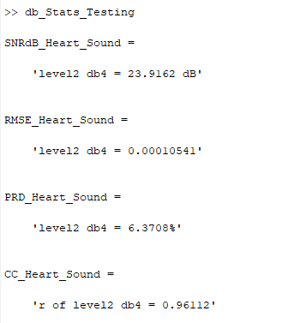

(d) db4 LEVEL 2 SCATTER PLOT RESULT

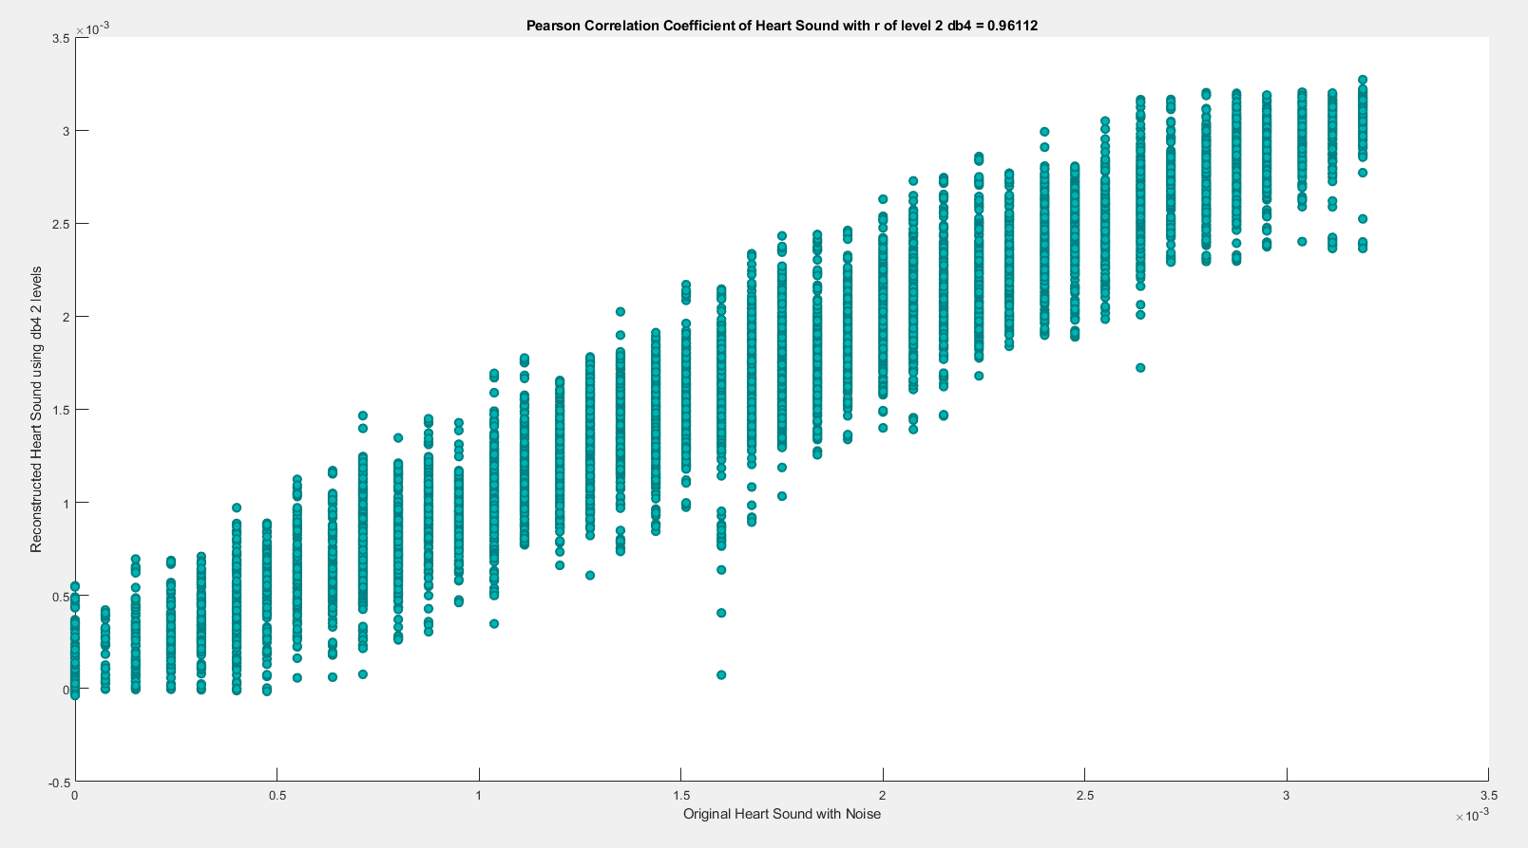

**(2) db4 LEVEL 3**

(a) db4 LEVEL 3 ARCHITECTURE

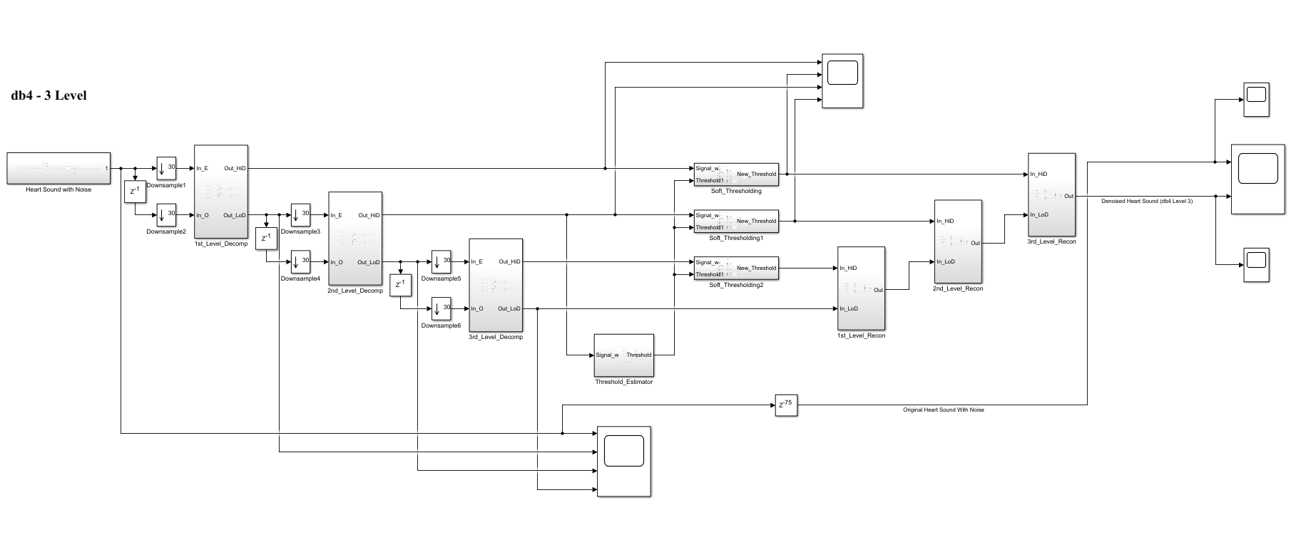

(b) db4 LEVEL 3 SIMULATION RESULT

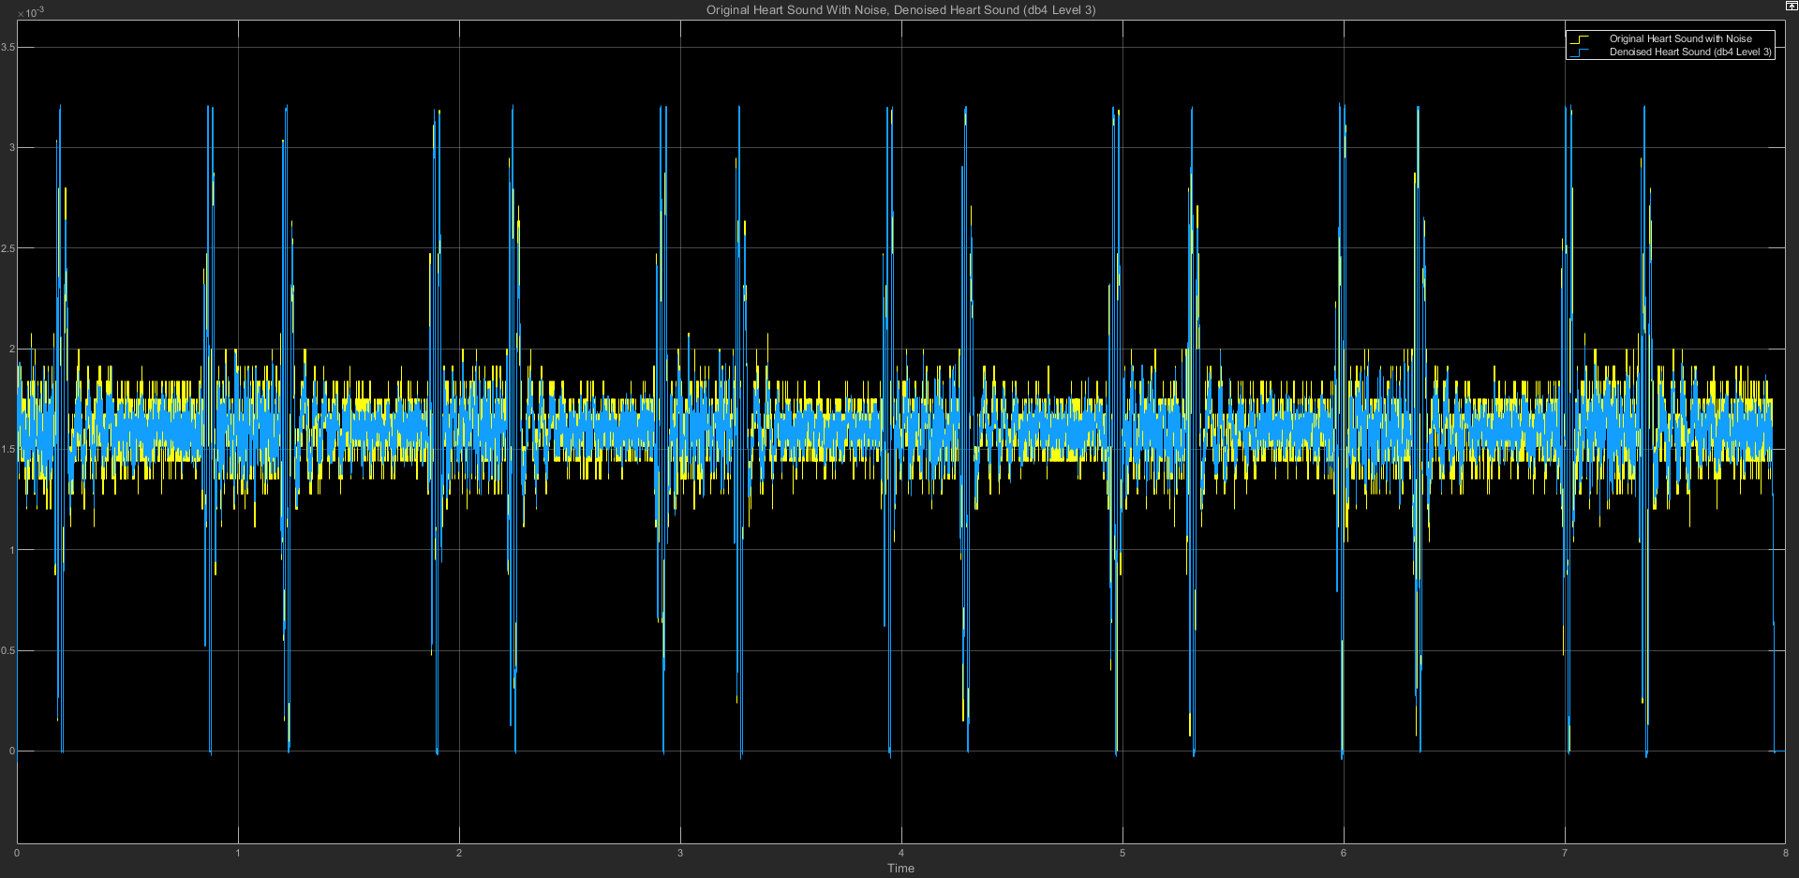

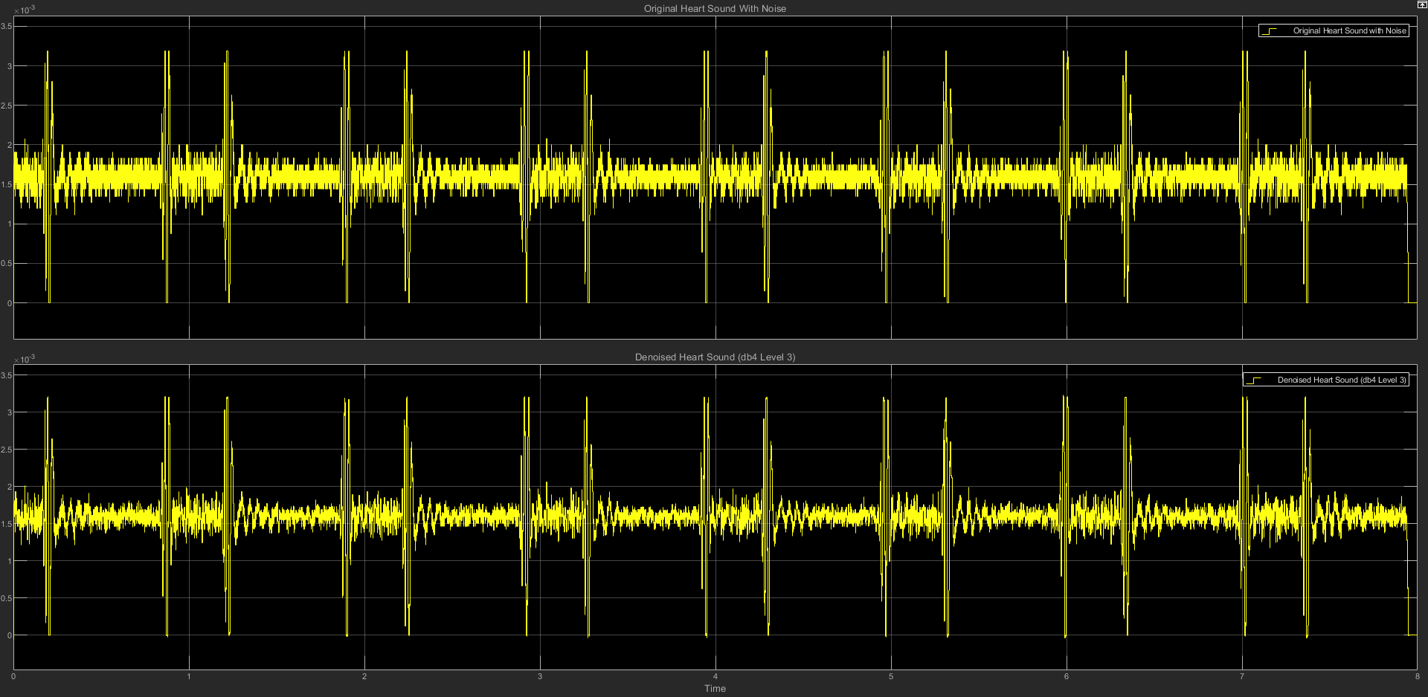

(c) db4 LEVEL 3 STATISTICS RESULT

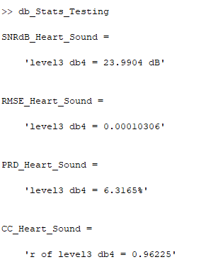

(d) db4 LEVEL 3 SCATTER PLOT RESULT

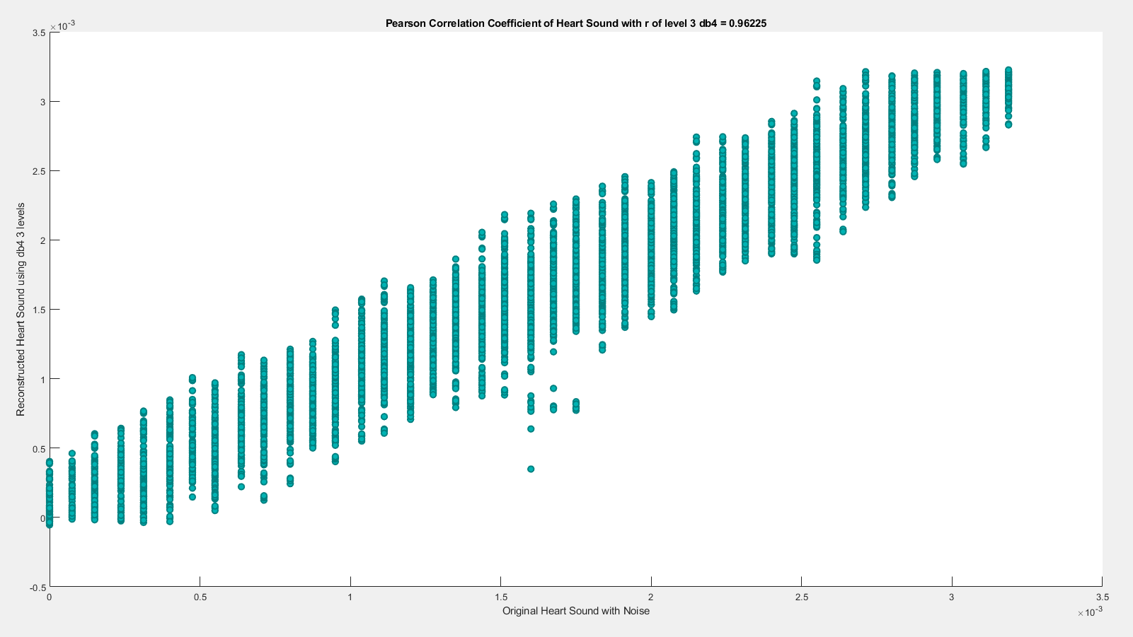

**(3) db4 LEVEL 4**

(a) db4 LEVEL 4 ARCHITECTURE

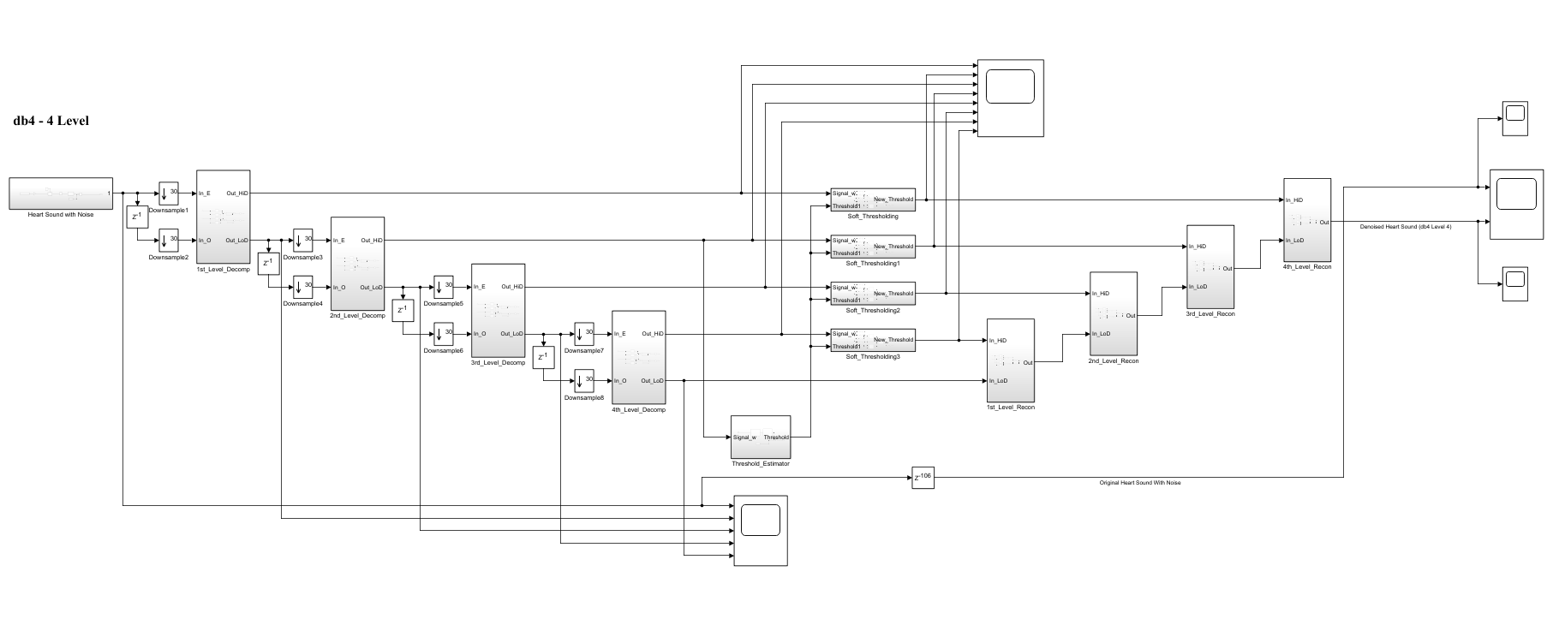

(b) db4 LEVEL 4 SIMULATION RESULT

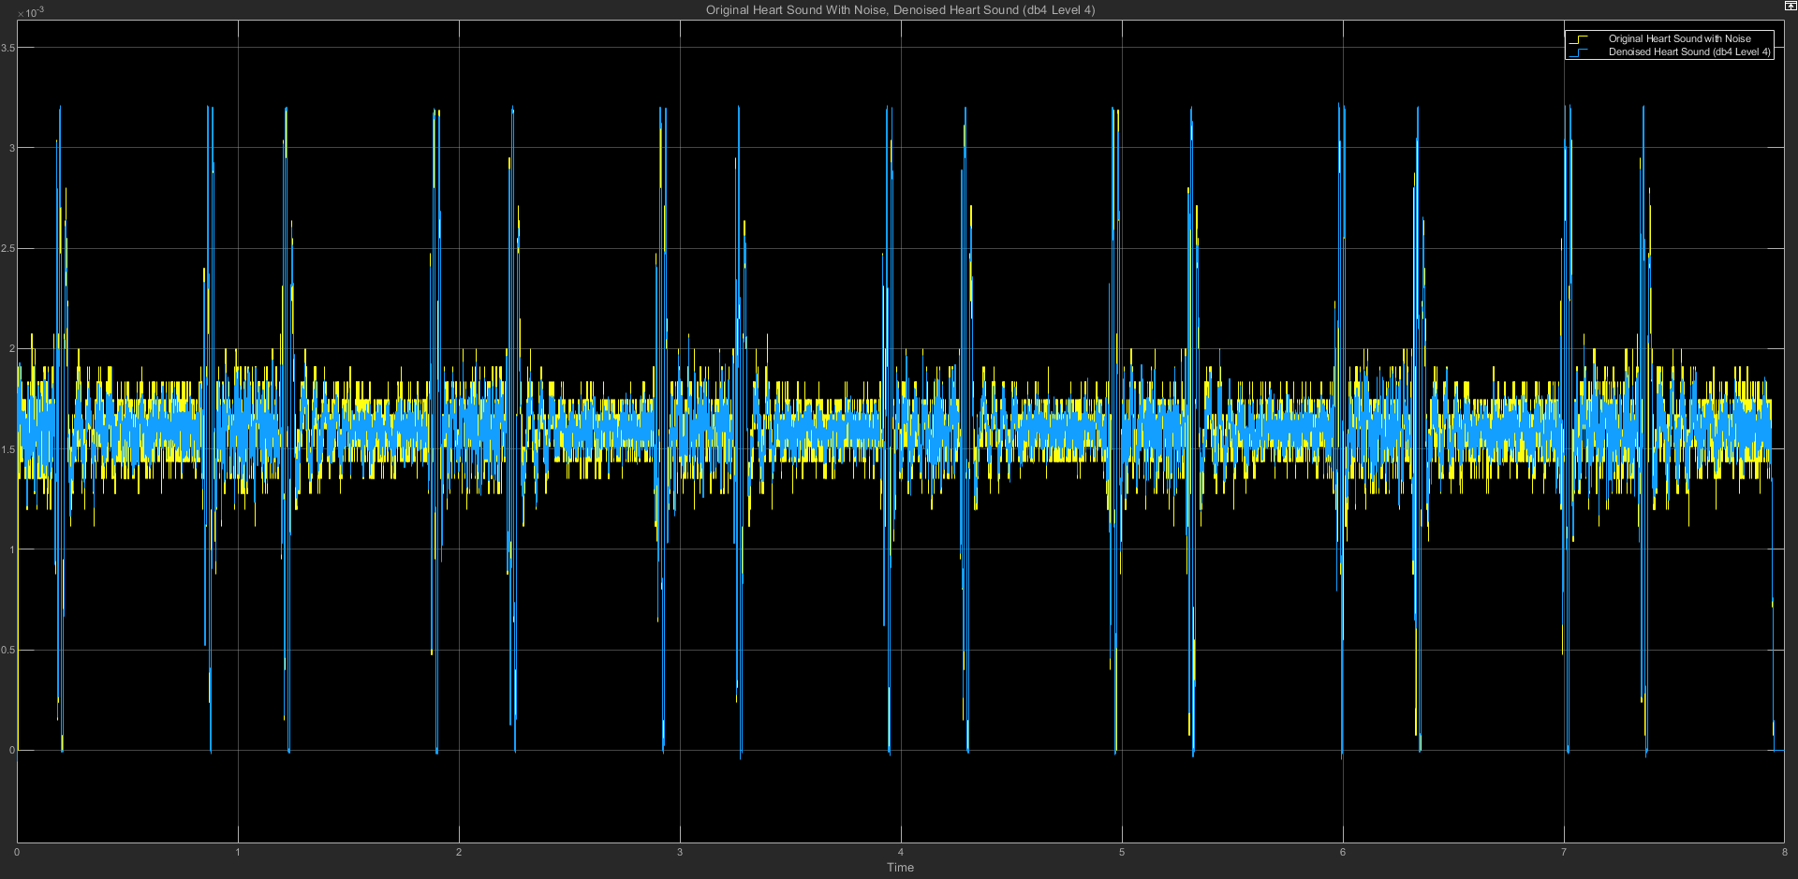

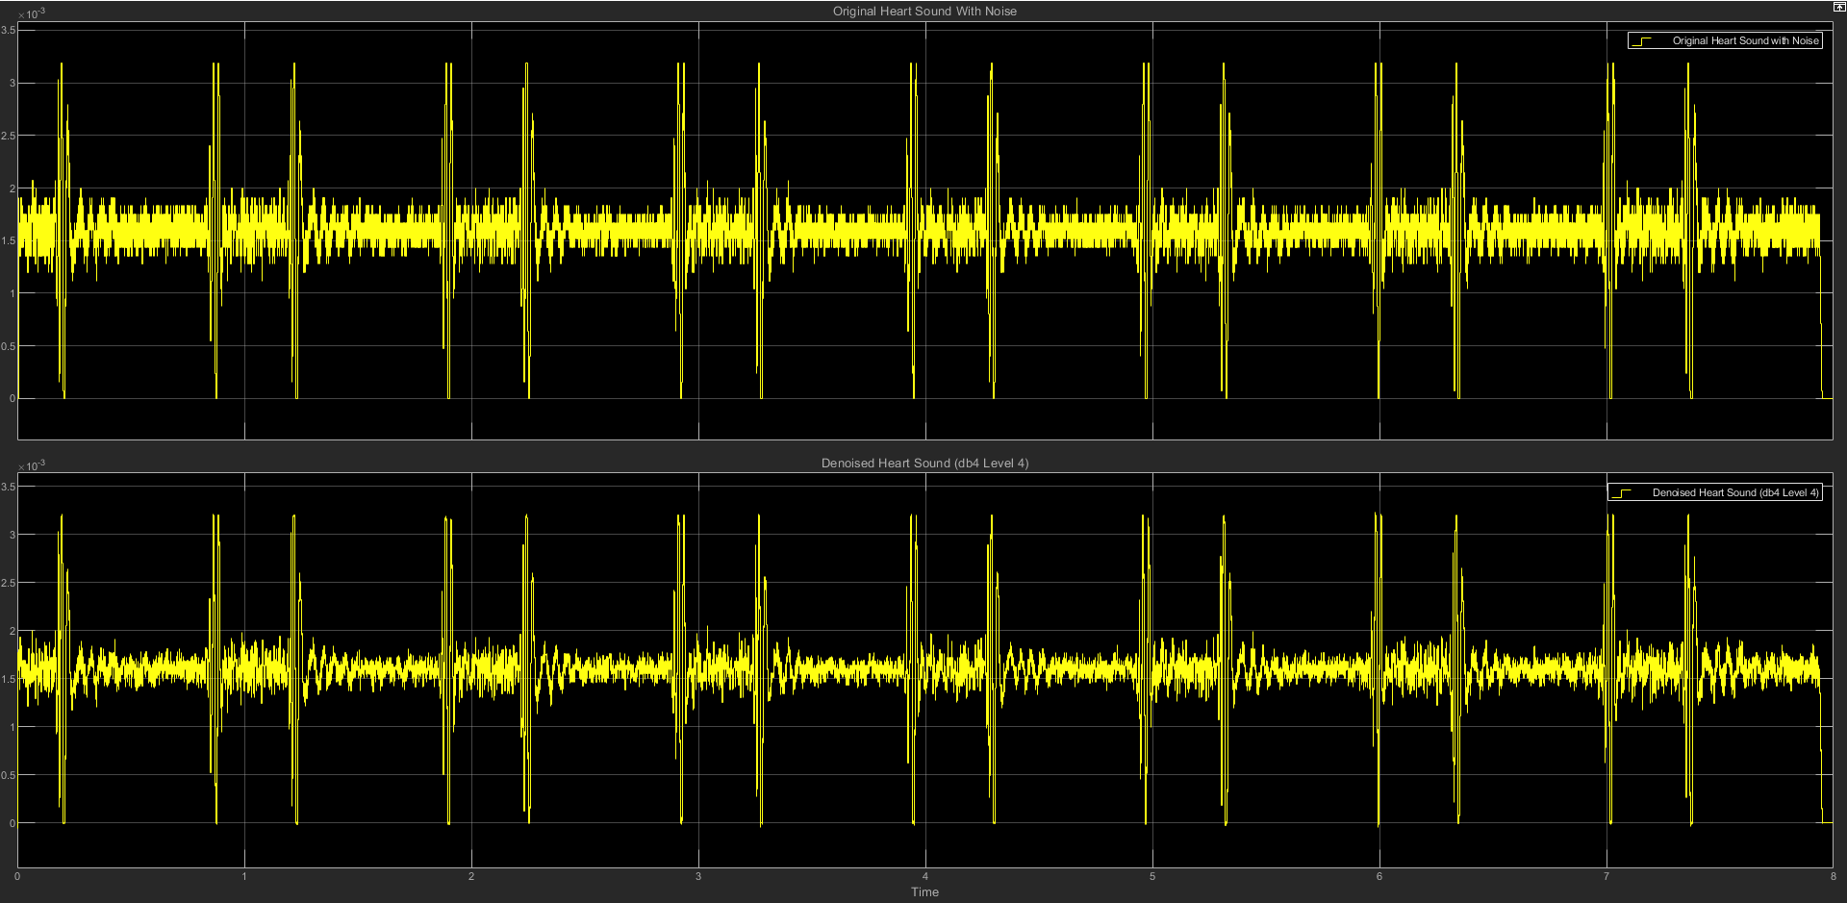

(c) db4 LEVEL 4 STATISTICS RESULT

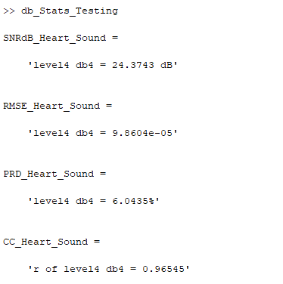

(d) db4 LEVEL 4 SCATTER PLOT RESULT

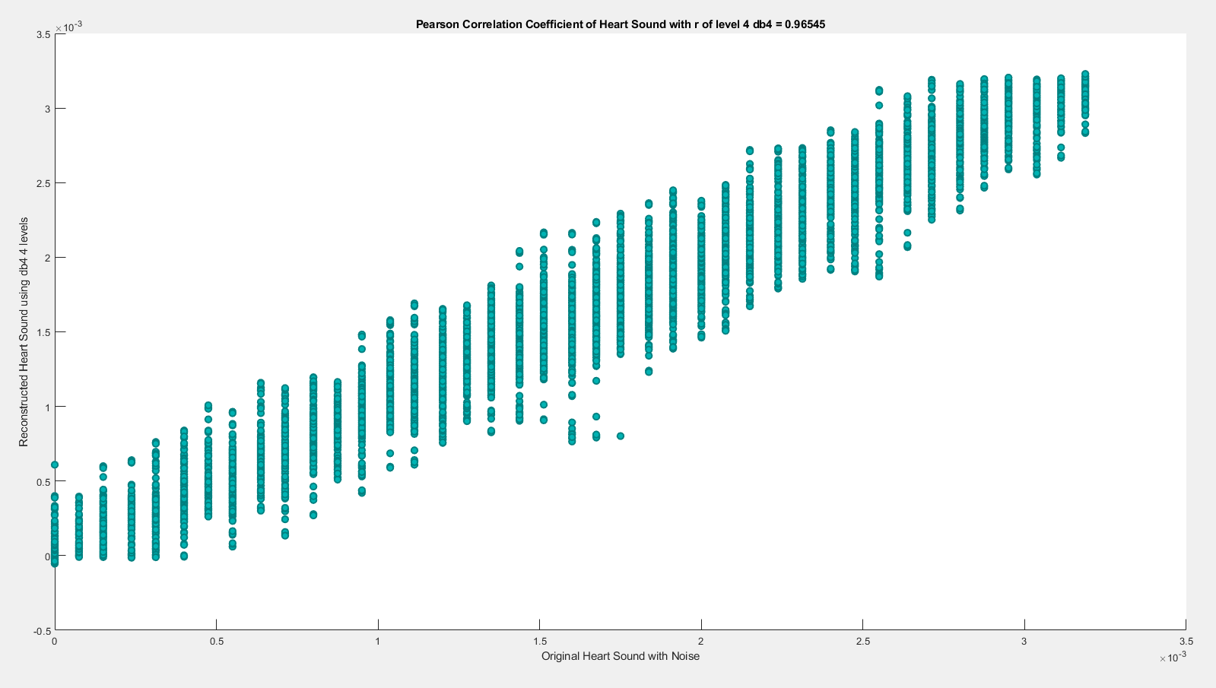

**(4) db4 LEVEL 5**

(a) db4 LEVEL 5 ARCHITECTURE

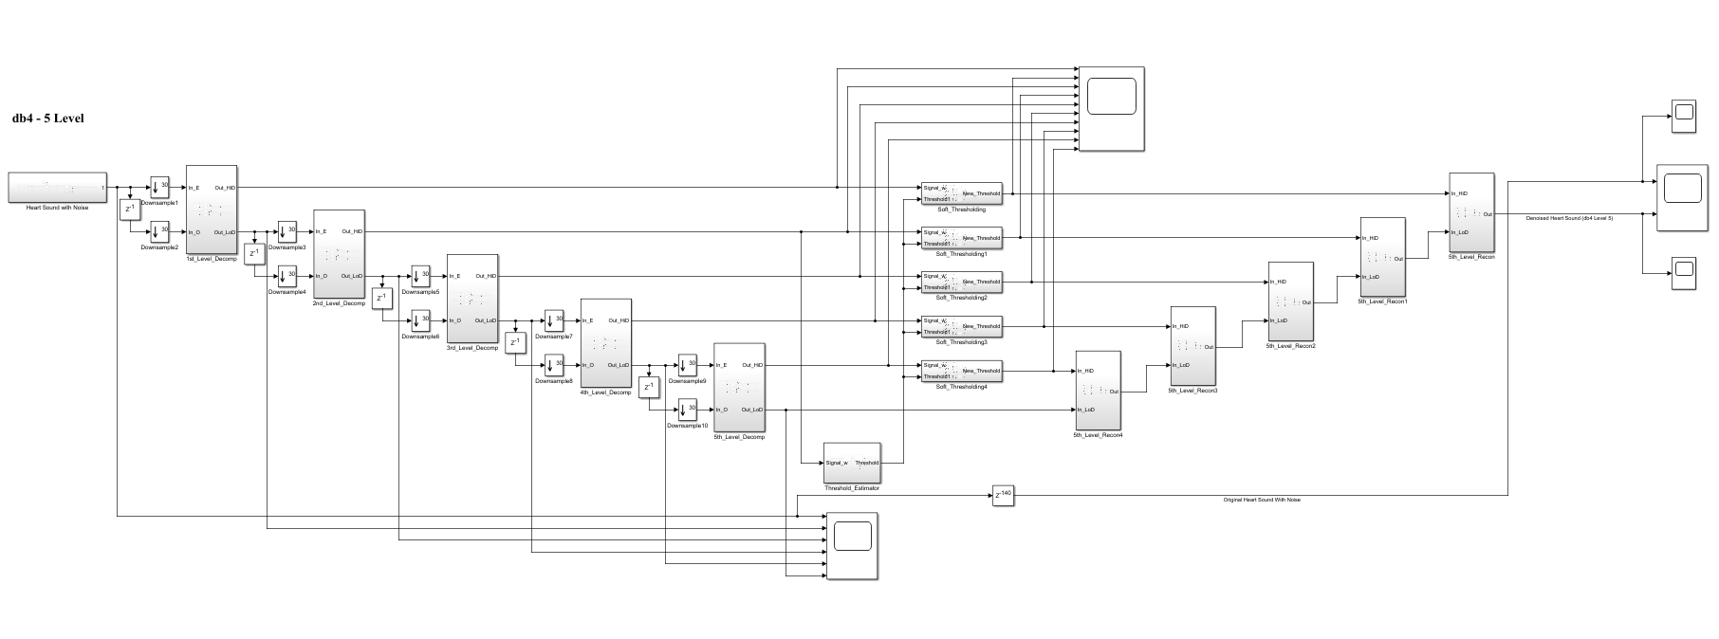

(b) db4 LEVEL 5 SIMULATION RESULT

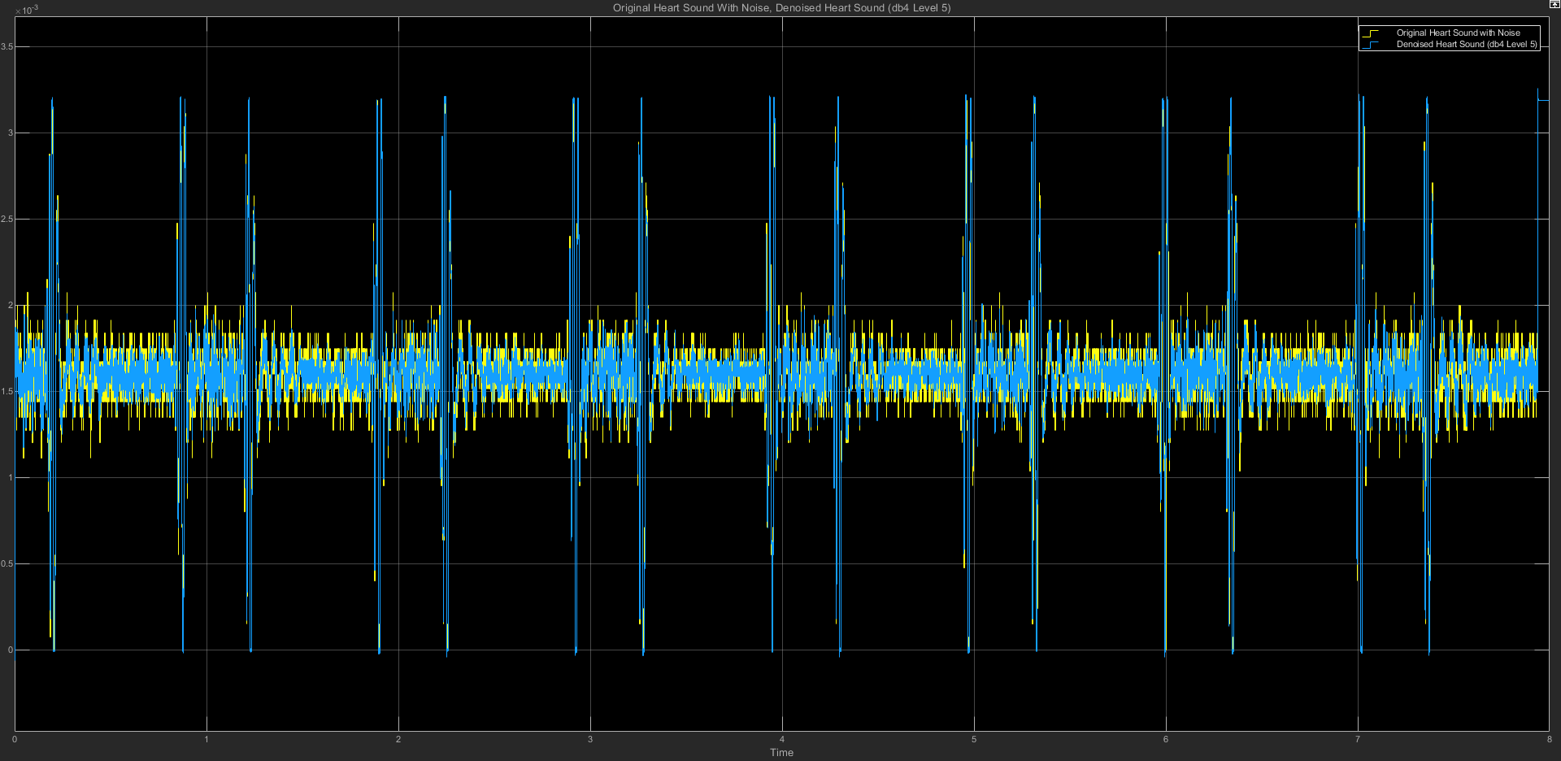

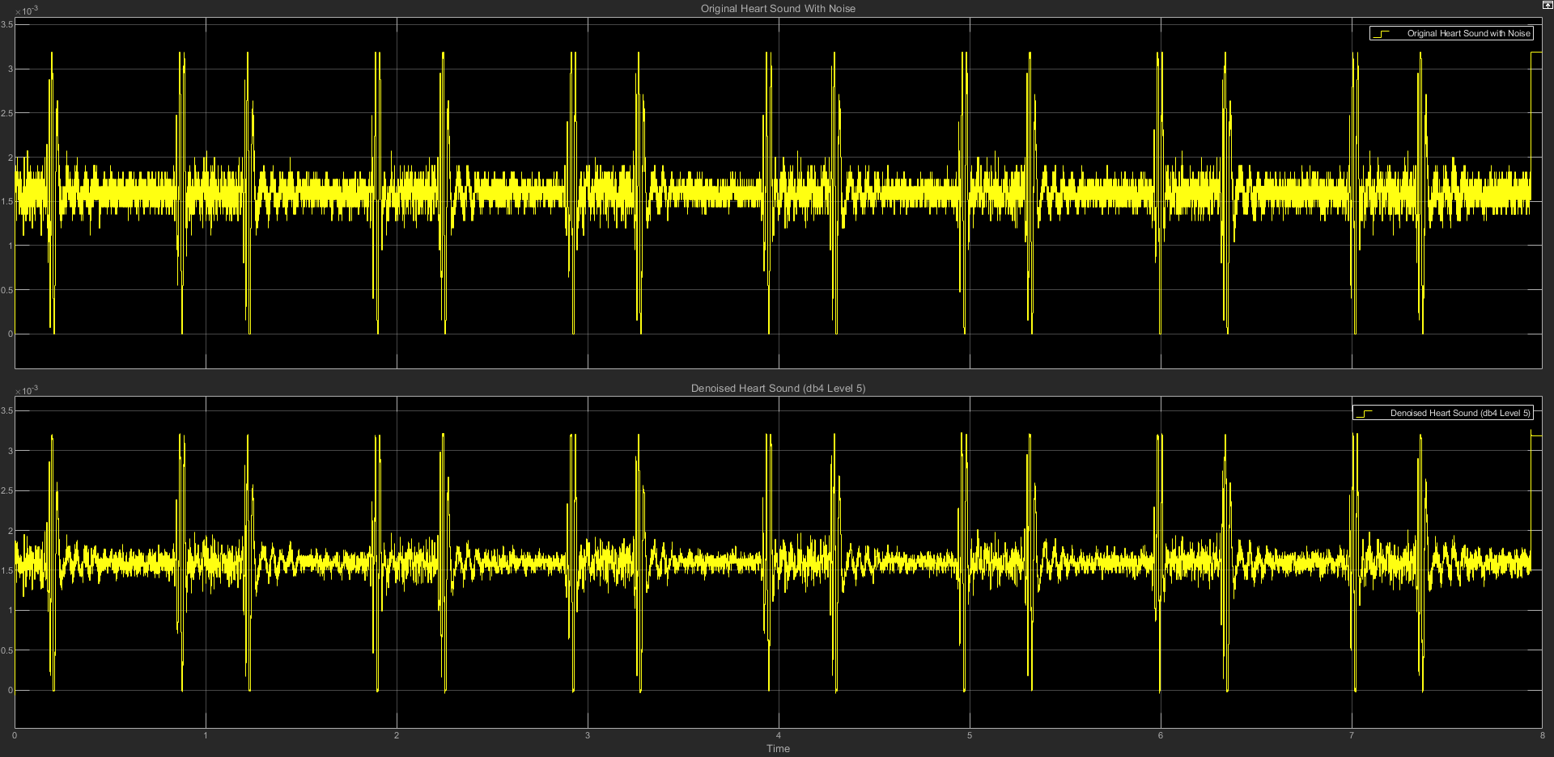

(c) db4 LEVEL 5 STATISTICS RESULT

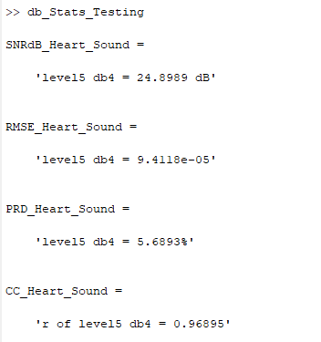

(d) db4 LEVEL 5 SCATTER PLOT RESULT

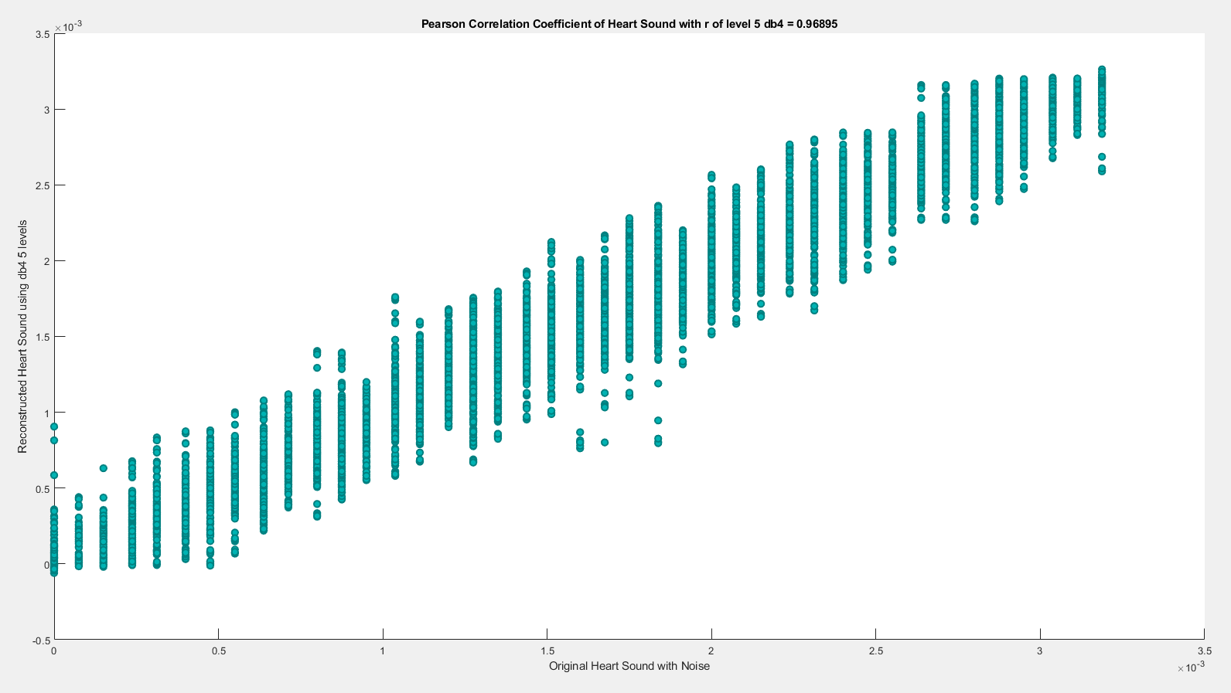

**(5) db4 LEVEL 6**

(a) db4 LEVEL 6 ARCHITECTURE

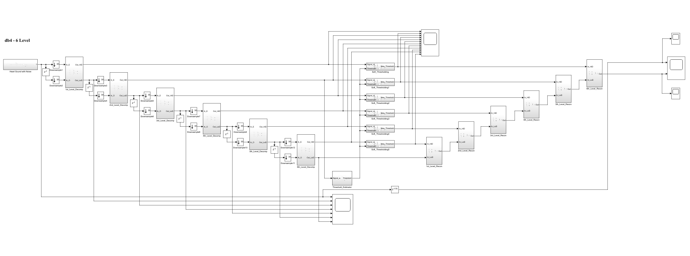

(b) db4 LEVEL 6 SIMULATION RESULT

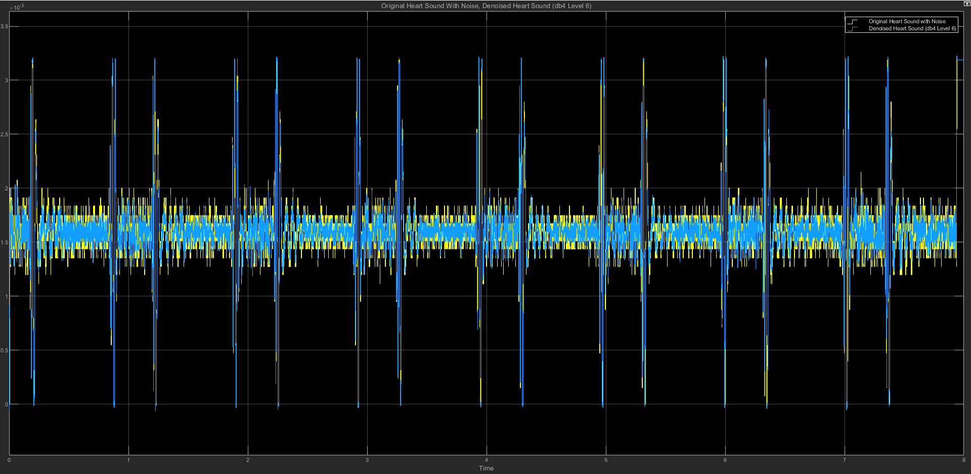

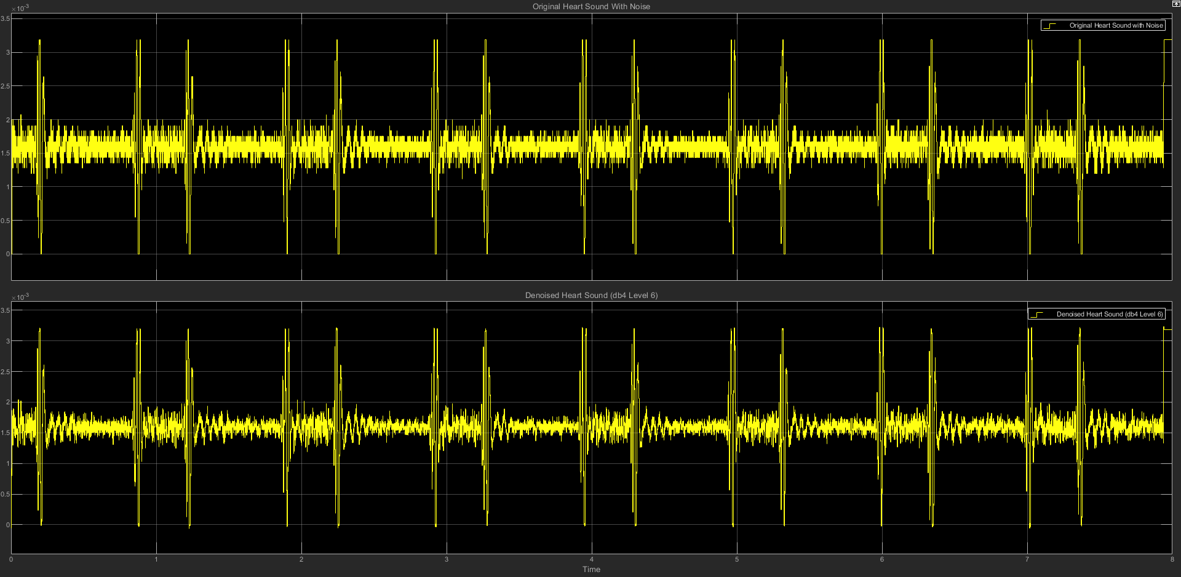

(c) db4 LEVEL 6 STATISTICS RESULT

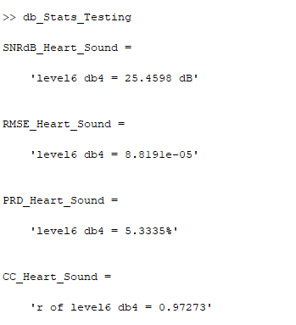

(d) db4 LEVEL 6 SCATTER PLOT RESULT

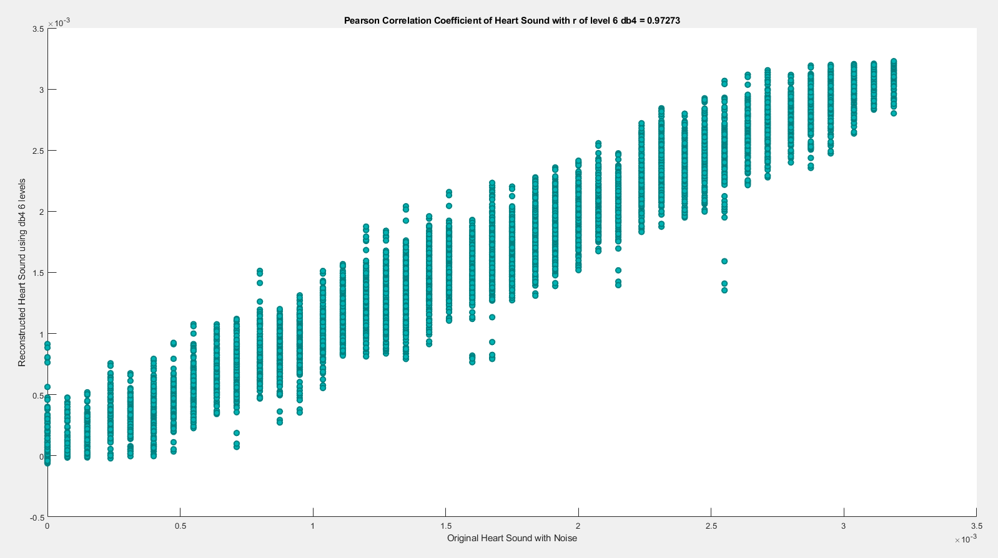

**(6) db4 LEVEL 7**

(a) db4 LEVEL 7 ARCHITECTURE

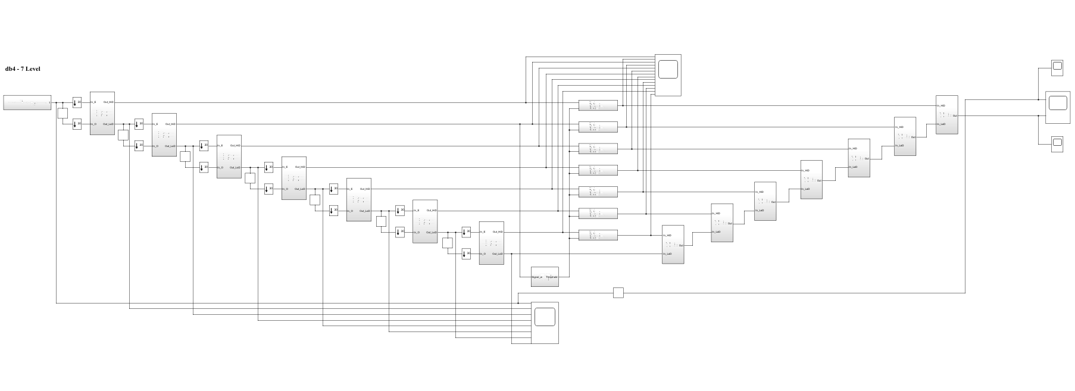

(b) db4 LEVEL 7 SIMULATION RESULT

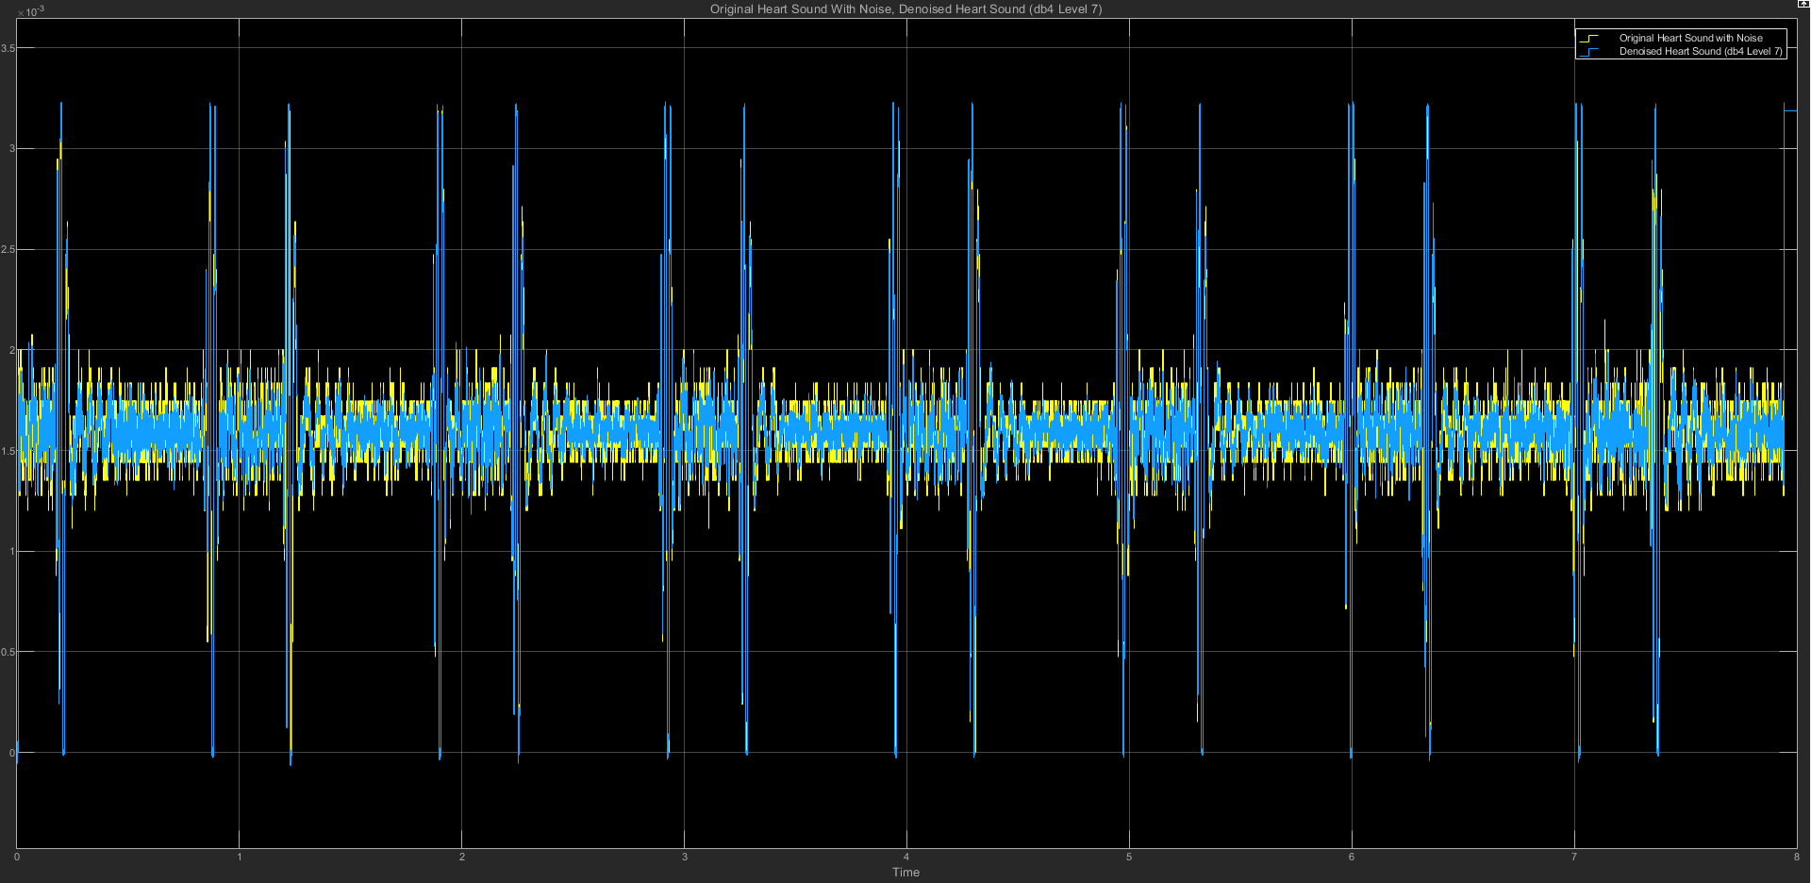

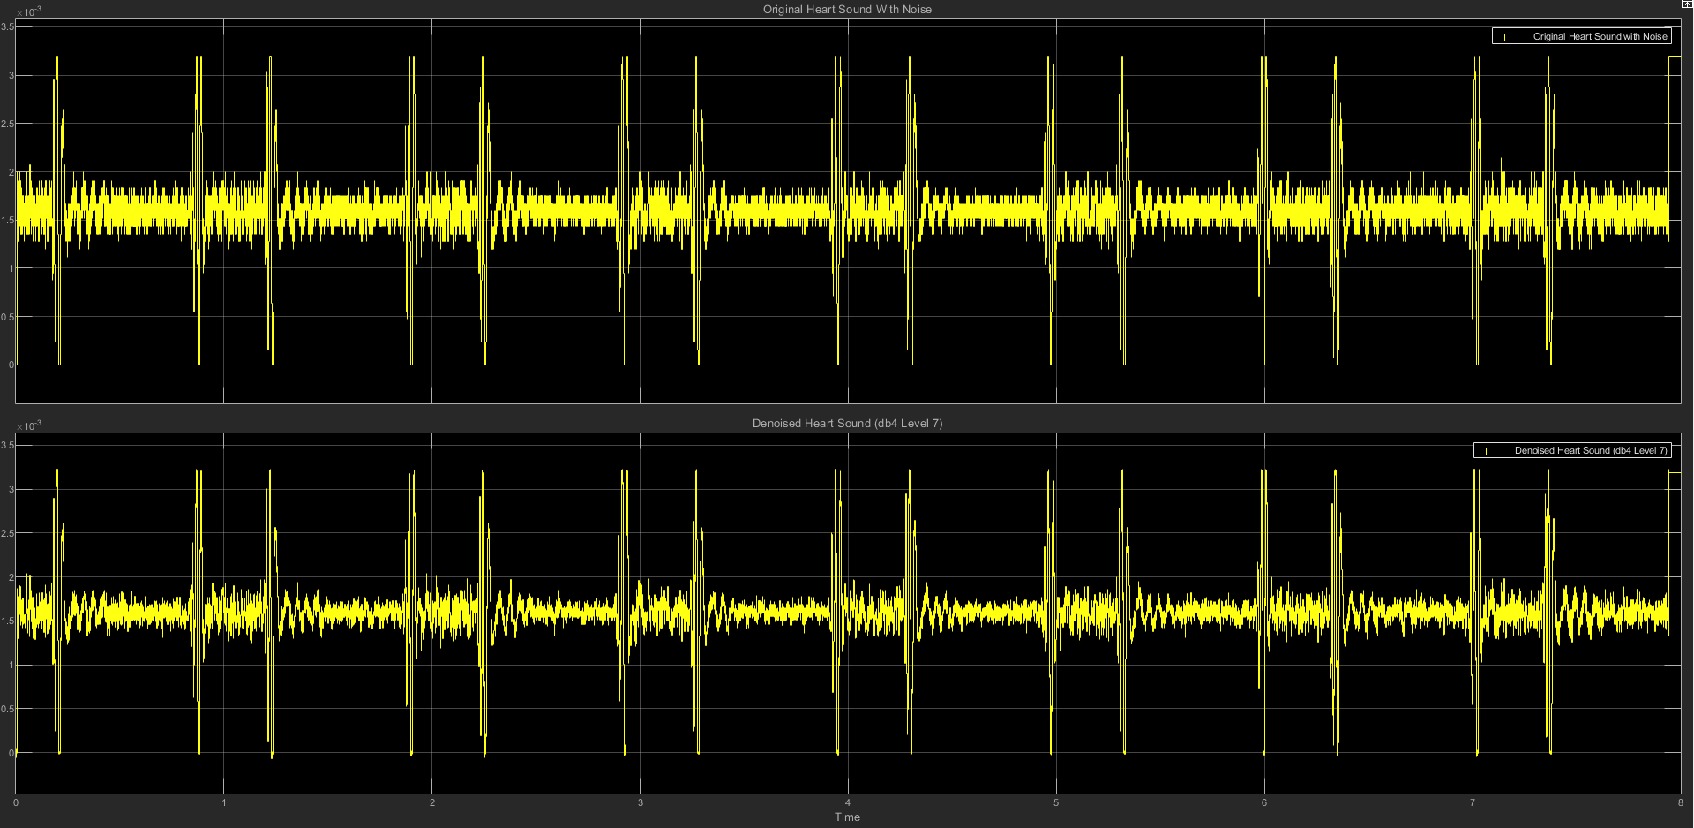

(c) db4 LEVEL 7 STATISTICS RESULT

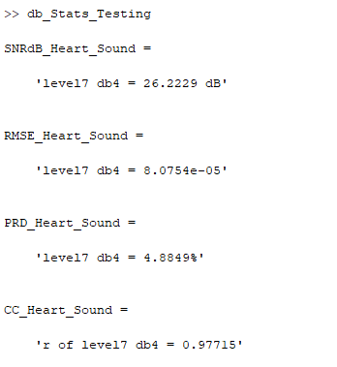

(d) db4 LEVEL 7 SCATTER PLOT RESULT

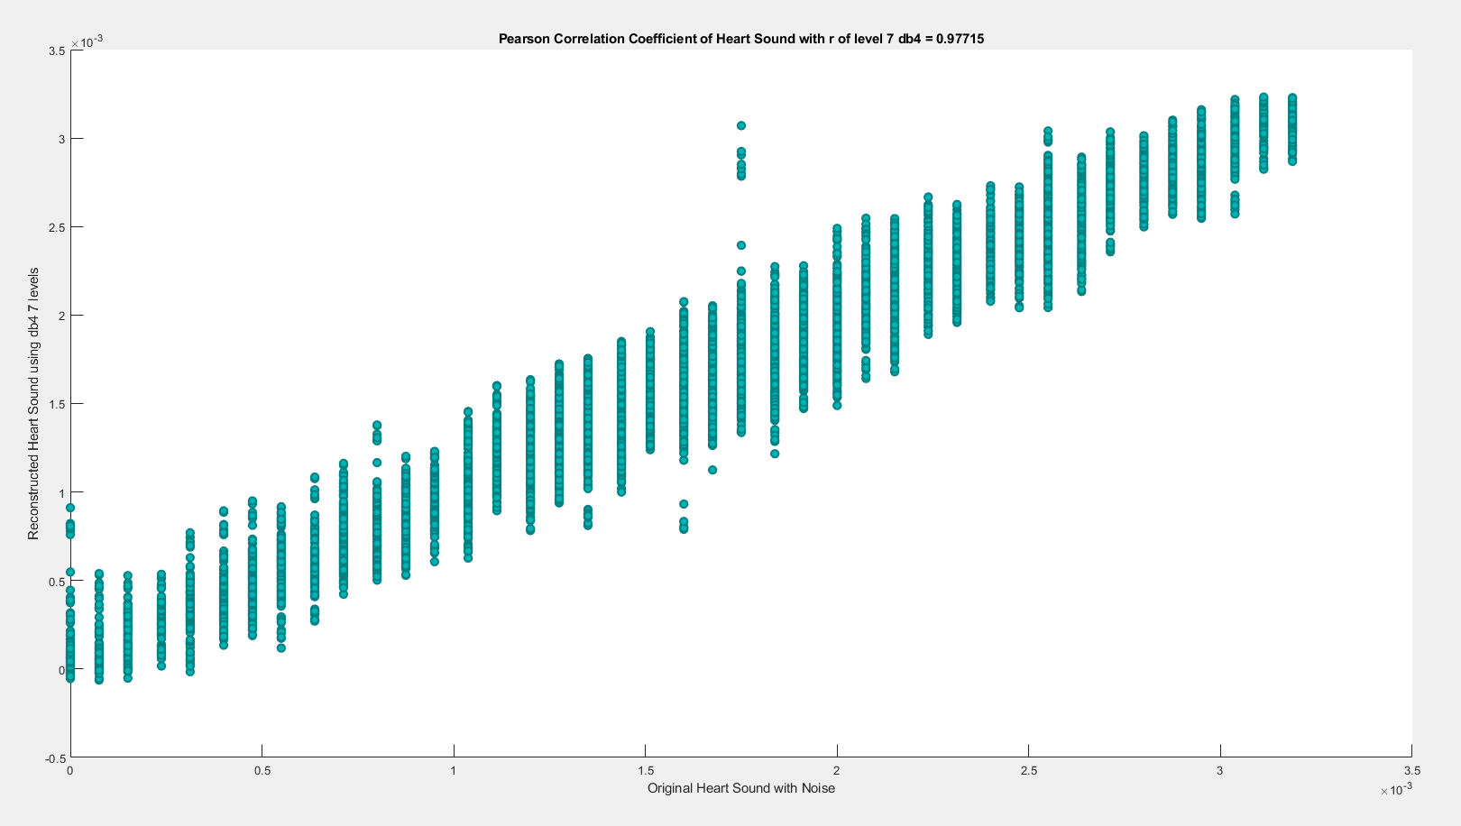

========================================================================

**db5**

| **db5** | **SNRdB_Heart**  **_Sound** | **RMSE_Heart**  **_Sound** | **PRD_Heart_Sound** | **CC_Heart**  **_Sound** |
| --- | --- | --- | --- | --- |
| Level 2 | 24.1006 dB | 0.0001032 | 6.2369% | 0.96261 |
| Level 3 | 24.0221 dB | 0.00010416 | 6.2935% | 0.96201 |
| Level 4 | 24.4244 dB | 9.9375e-05 | 6.0087% | 0.96529 |
| Level 5 | 24.7502 dB | 9.44e-05 | 5.7875% | 0.96881 |
| Level 6 | 25.4557 dB | 8.8201e-05 | 5.336% | 0.97274 |
| Level 7 | 26.3309 dB | 7.9731e-05 | 4.8245% | 0.97774 |

**(1) db5 LEVEL 2**

(a) db5 LEVEL 2 ARCHITECTURE

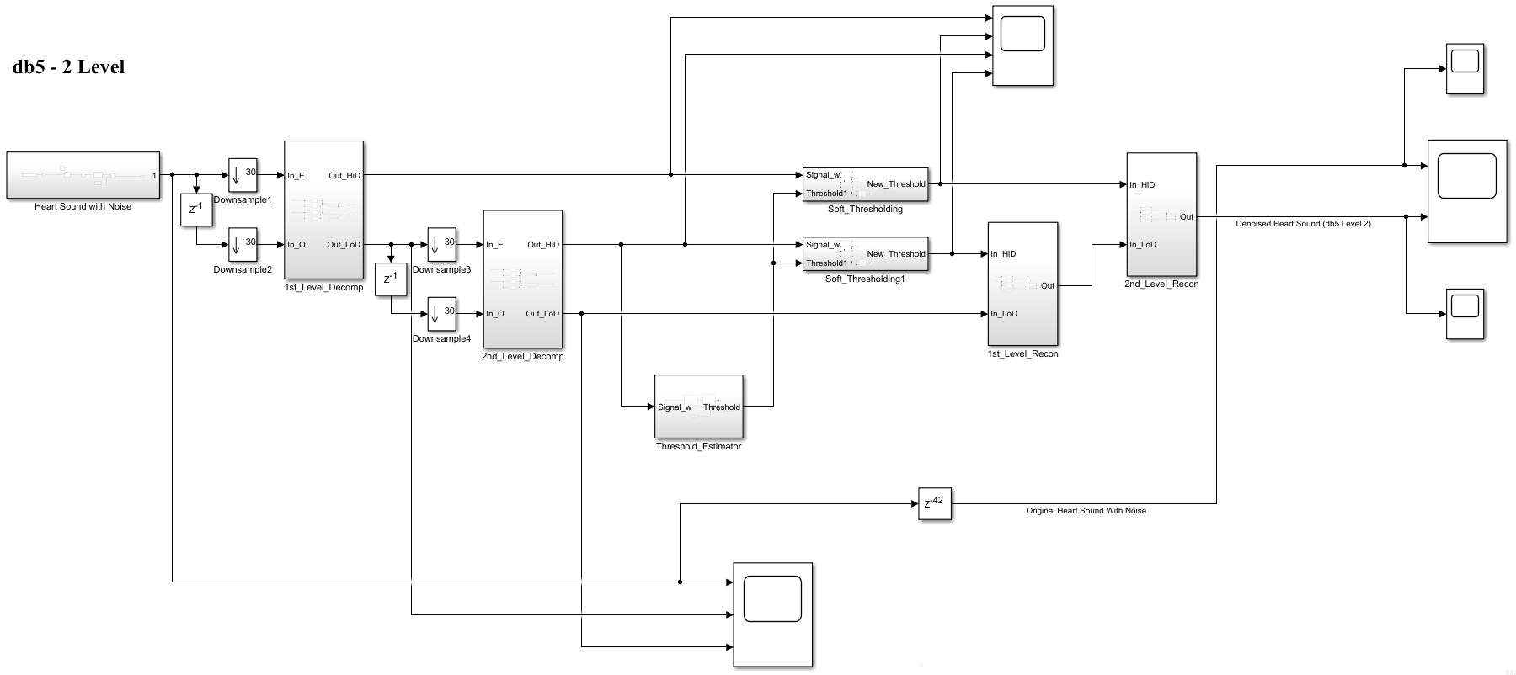

(b) db5 LEVEL 2 SIMULATION RESULT

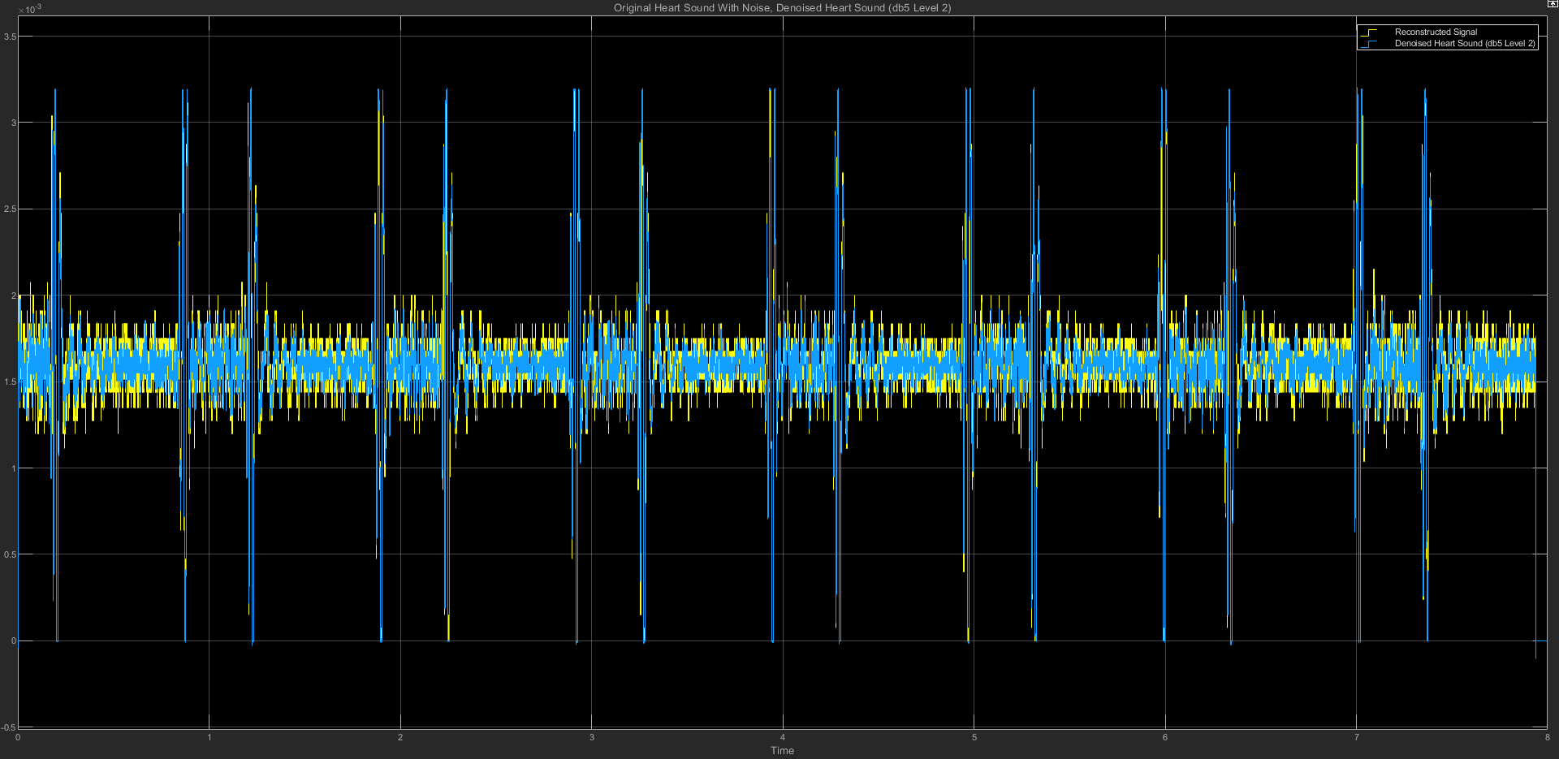

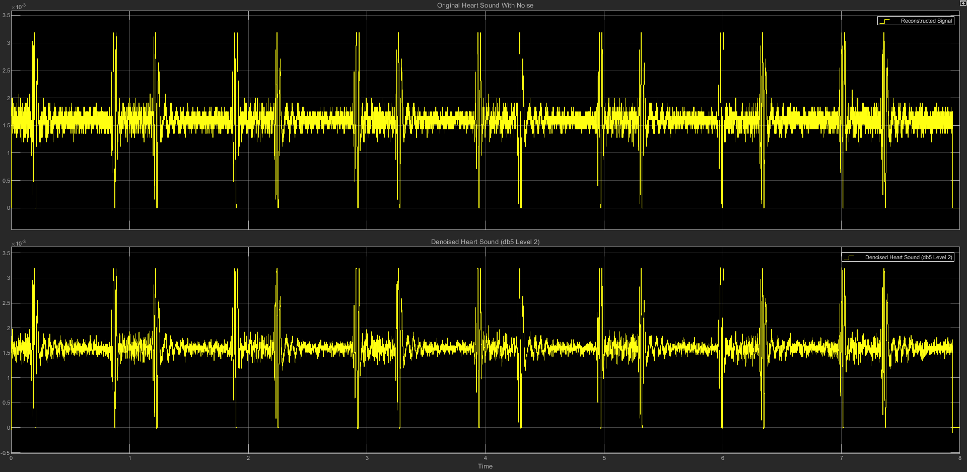

(c) db5 LEVEL 2 STATISTICS RESULT

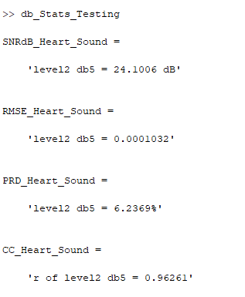

(d) db5 LEVEL 2 SCATTER PLOT RESULT

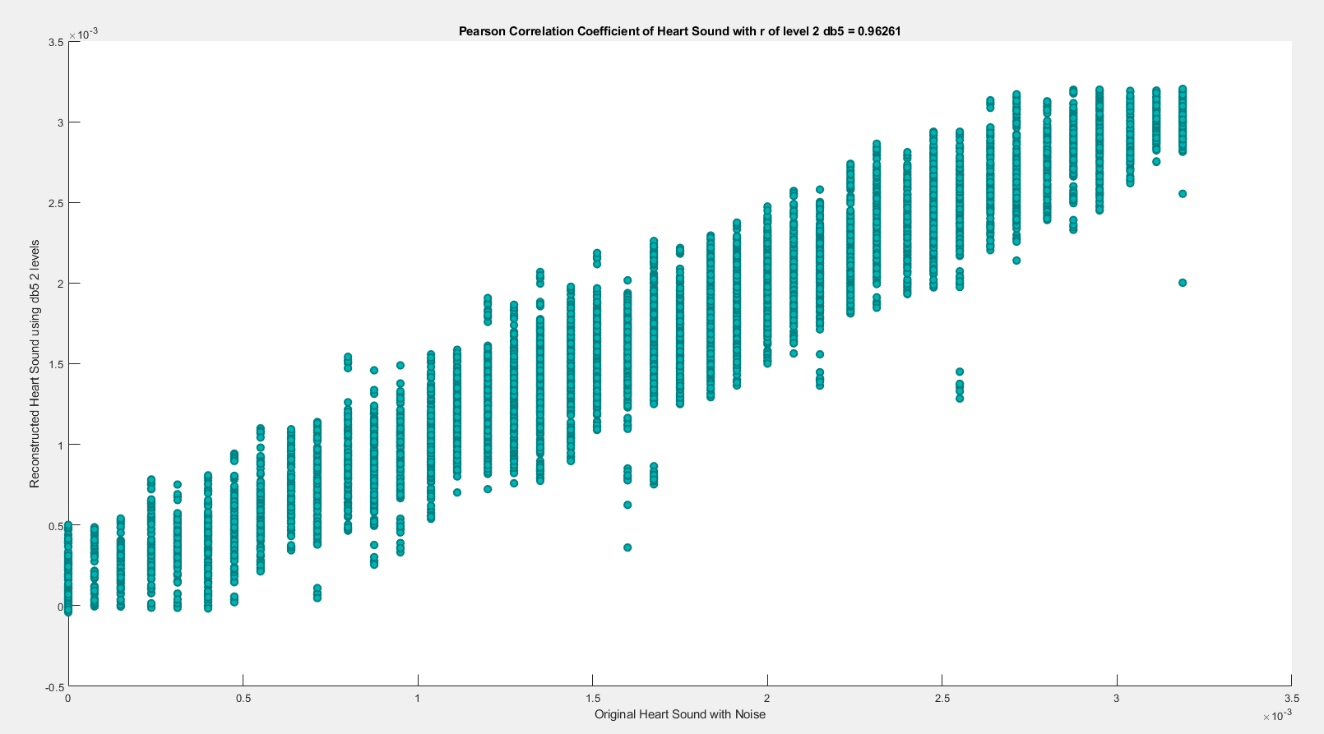

**(2) db5 LEVEL 3**

(a) db5 LEVEL 3 ARCHITECTURE

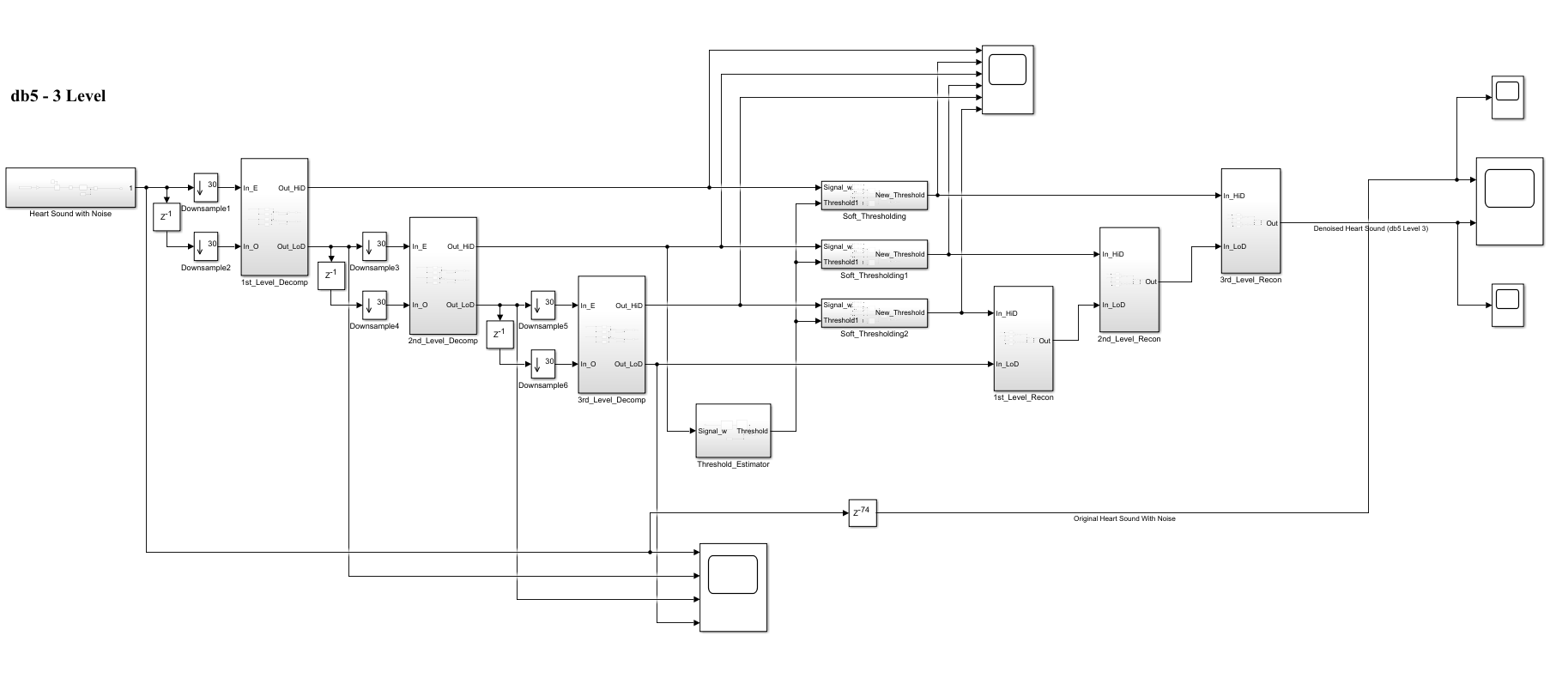

(b) db5 LEVEL 3 SIMULATION RESULT

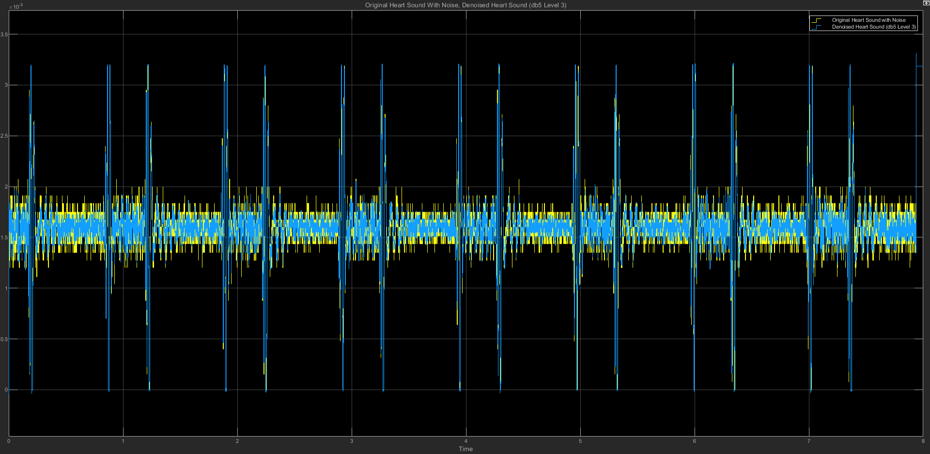

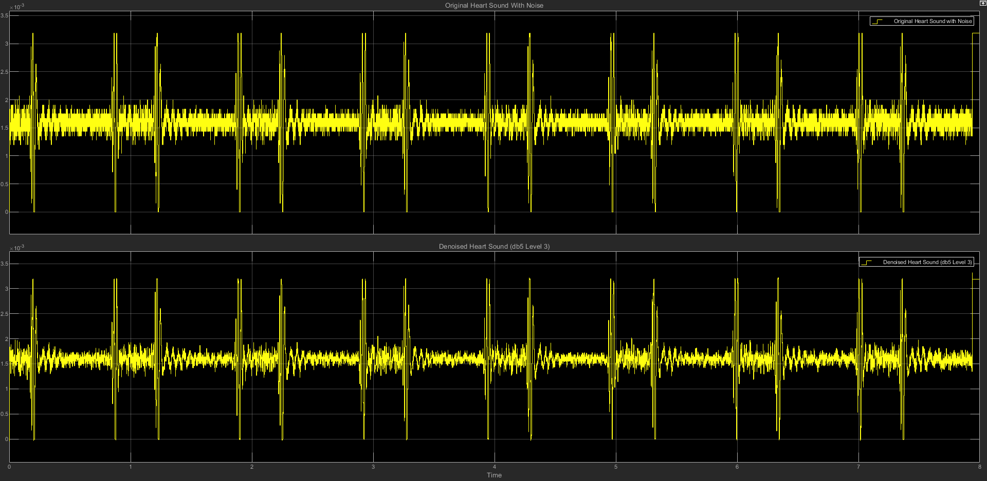

(c) db5 LEVEL 3 STATISTICS RESULT

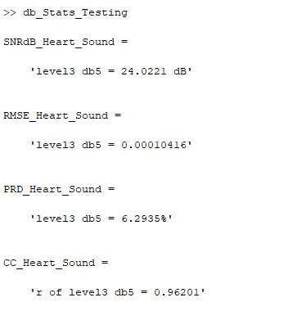

(d) db5 LEVEL 3 SCATTER PLOT RESULT

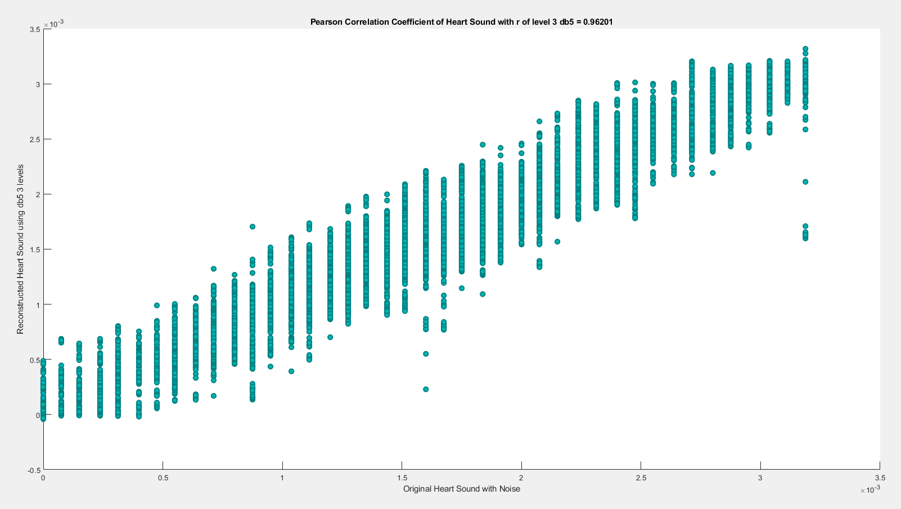

**(3) db5 LEVEL 4**

(a) db5 LEVEL 4 ARCHITECTURE

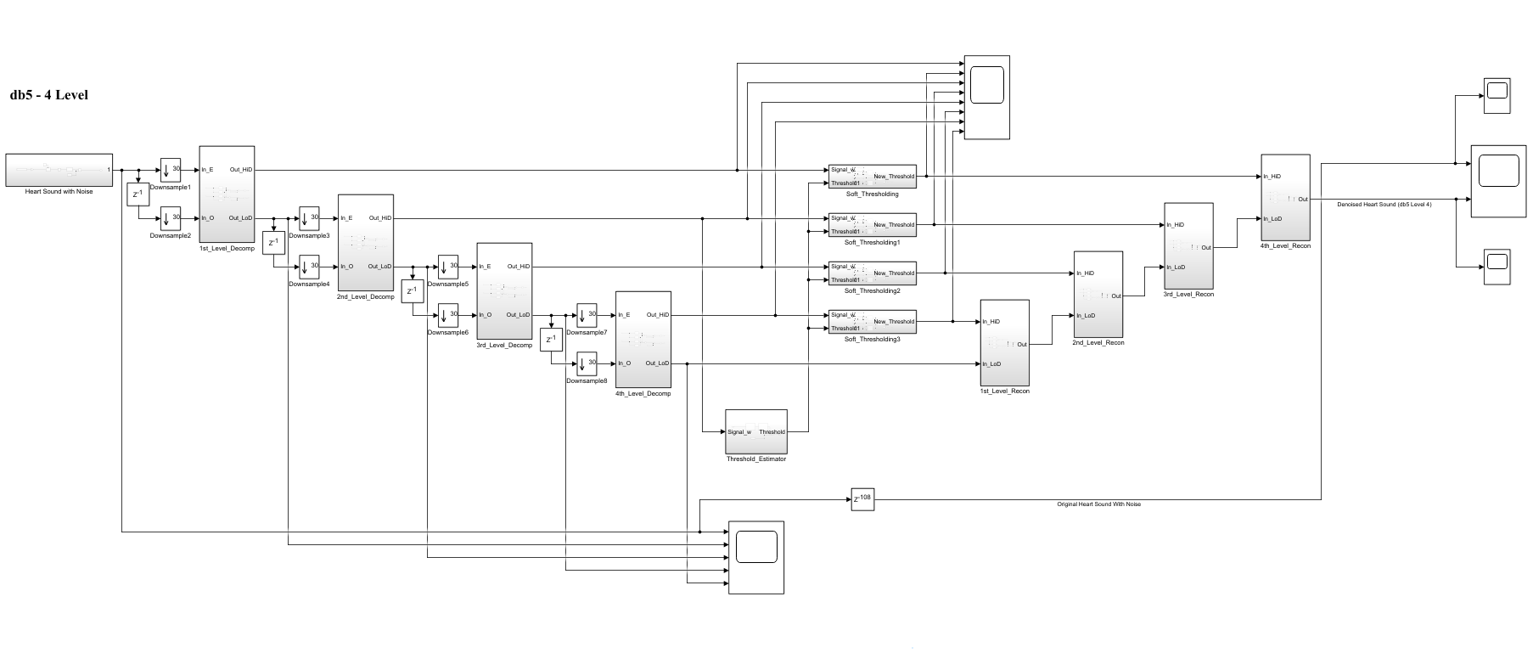

(b) db5 LEVEL 4 SIMULATION RESULT

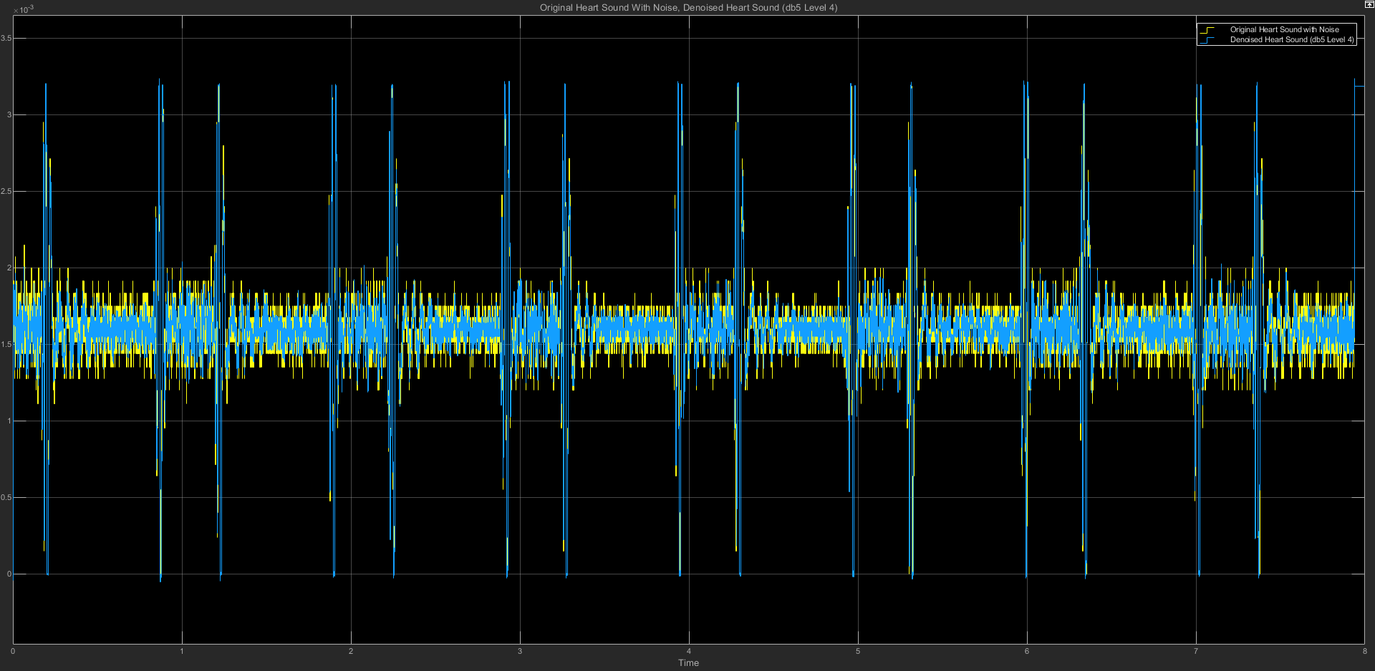

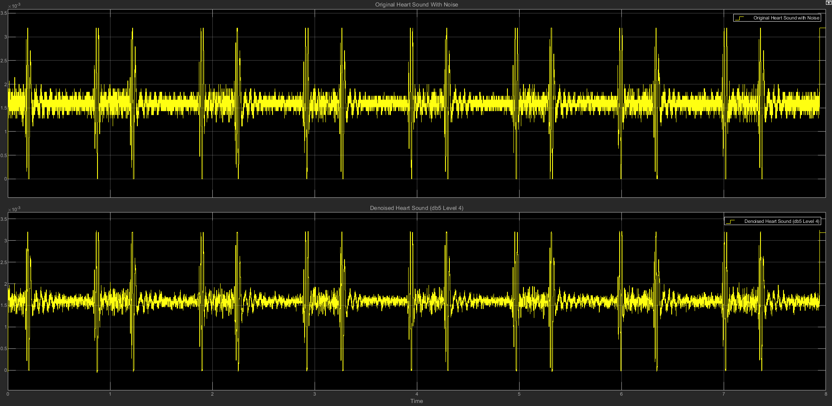

(c) db5 LEVEL 4 STATISTICS RESULT

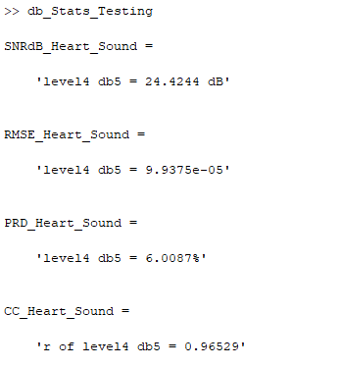

(d) db5 LEVEL 4 SCATTER PLOT RESULT

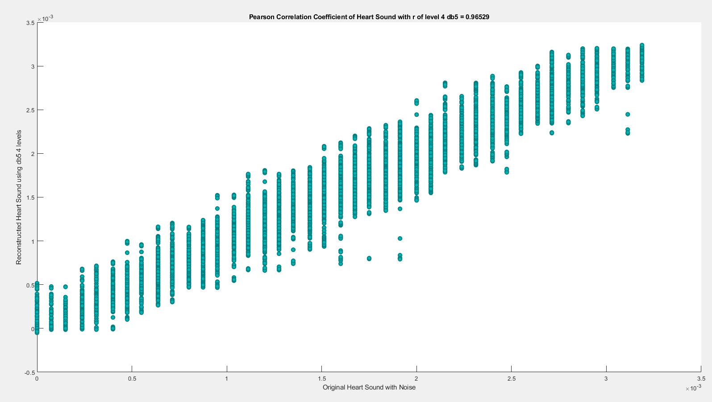

**(4) db5 LEVEL 5**

(a) db5 LEVEL 5 ARCHITECTURE

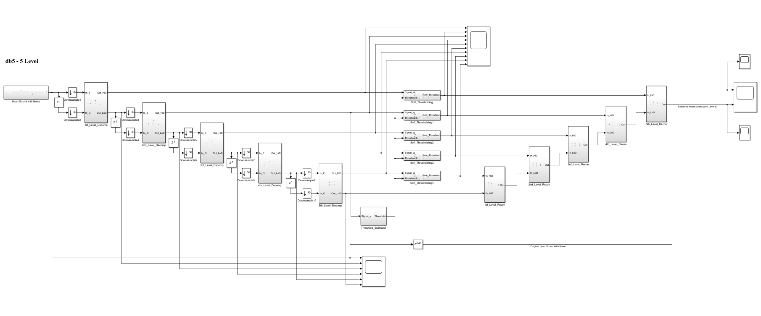

(b) db5 LEVEL 5 SIMULATION RESULT

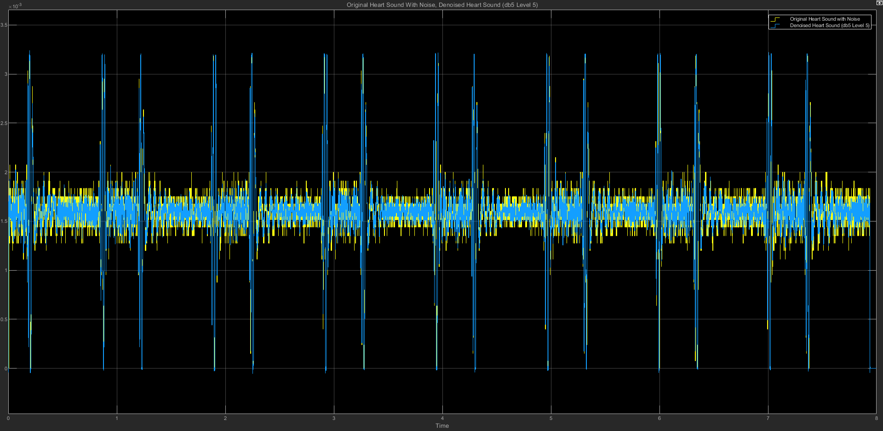

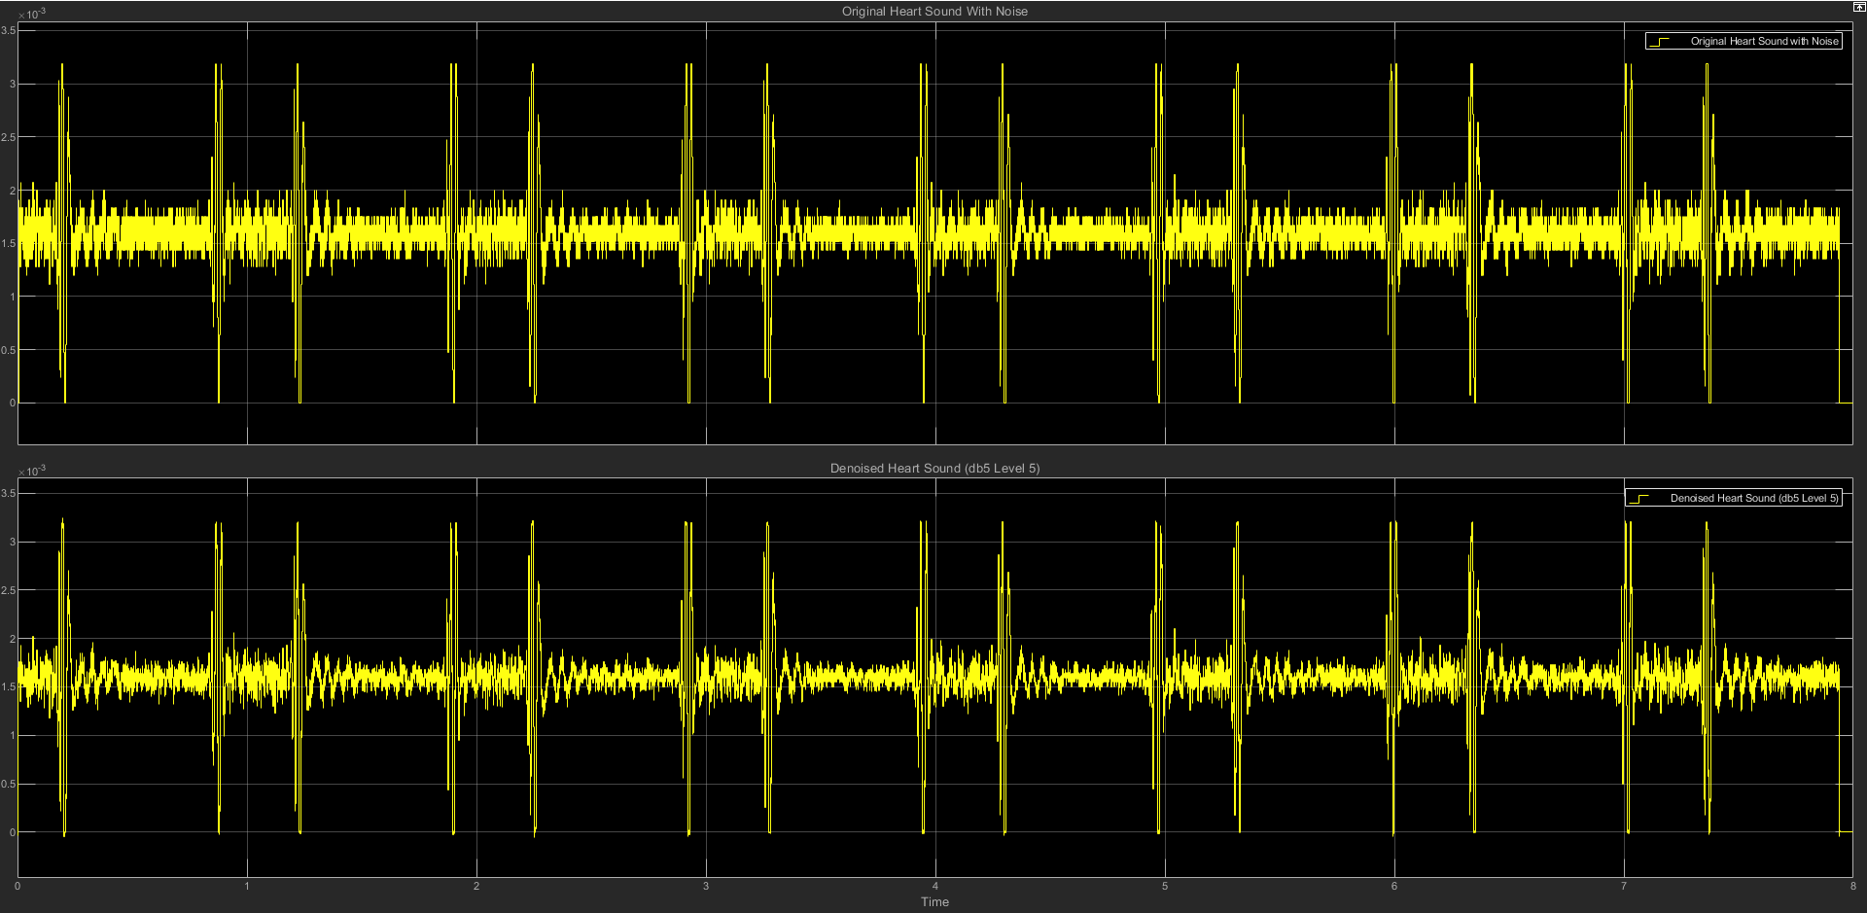

(c) db5 LEVEL 5 STATISTICS RESULT

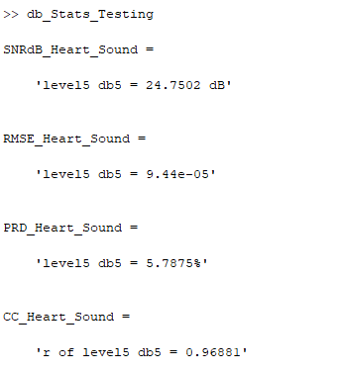

(d) db5 LEVEL 5 SCATTER PLOT RESULT

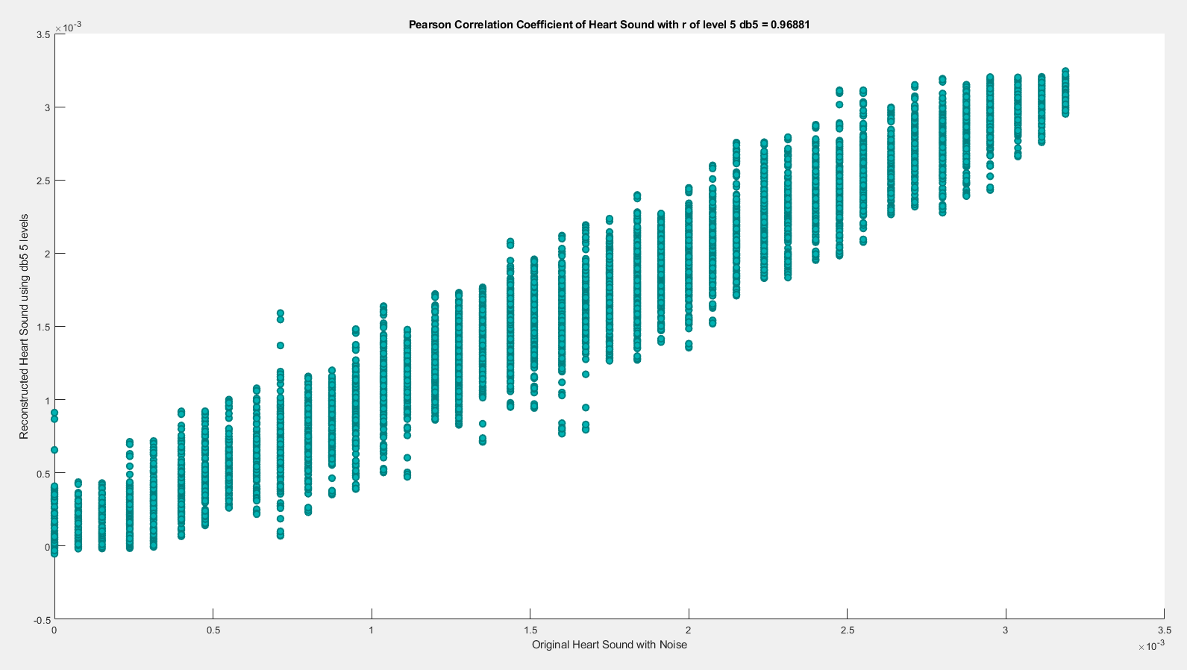

**(5) db5 LEVEL 6**

(a) db5 LEVEL 6 ARCHITECTURE

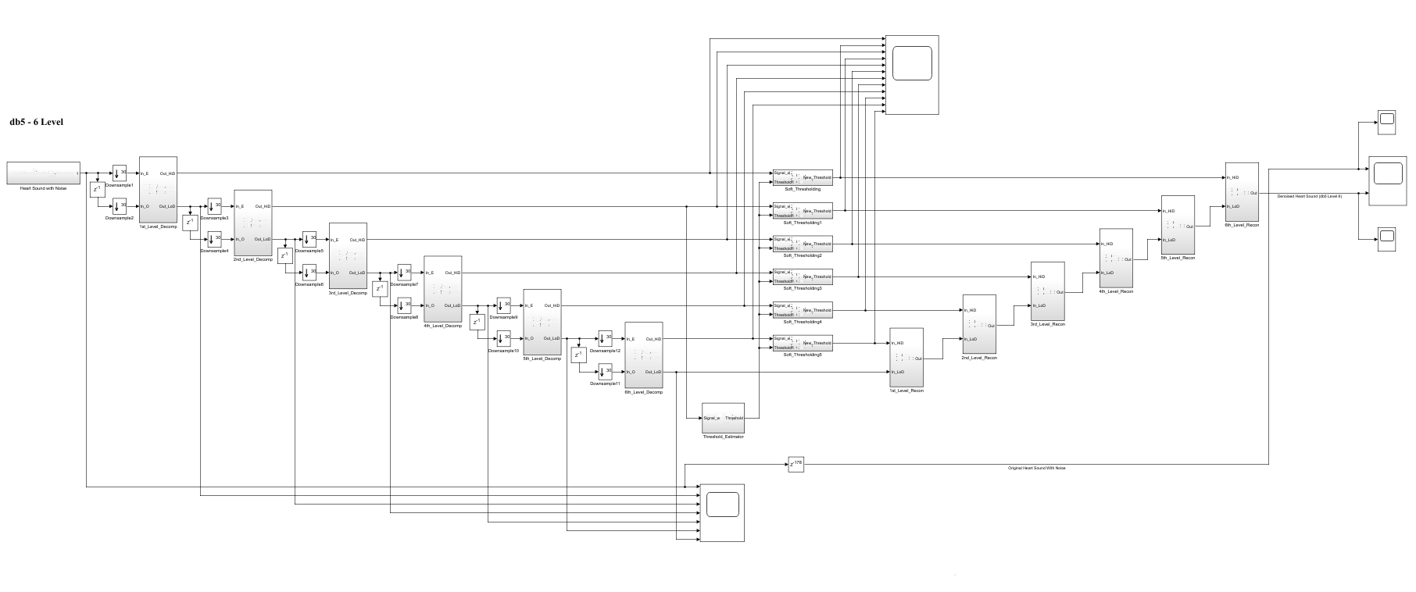

(b) db5 LEVEL 6 SIMULATION RESULT

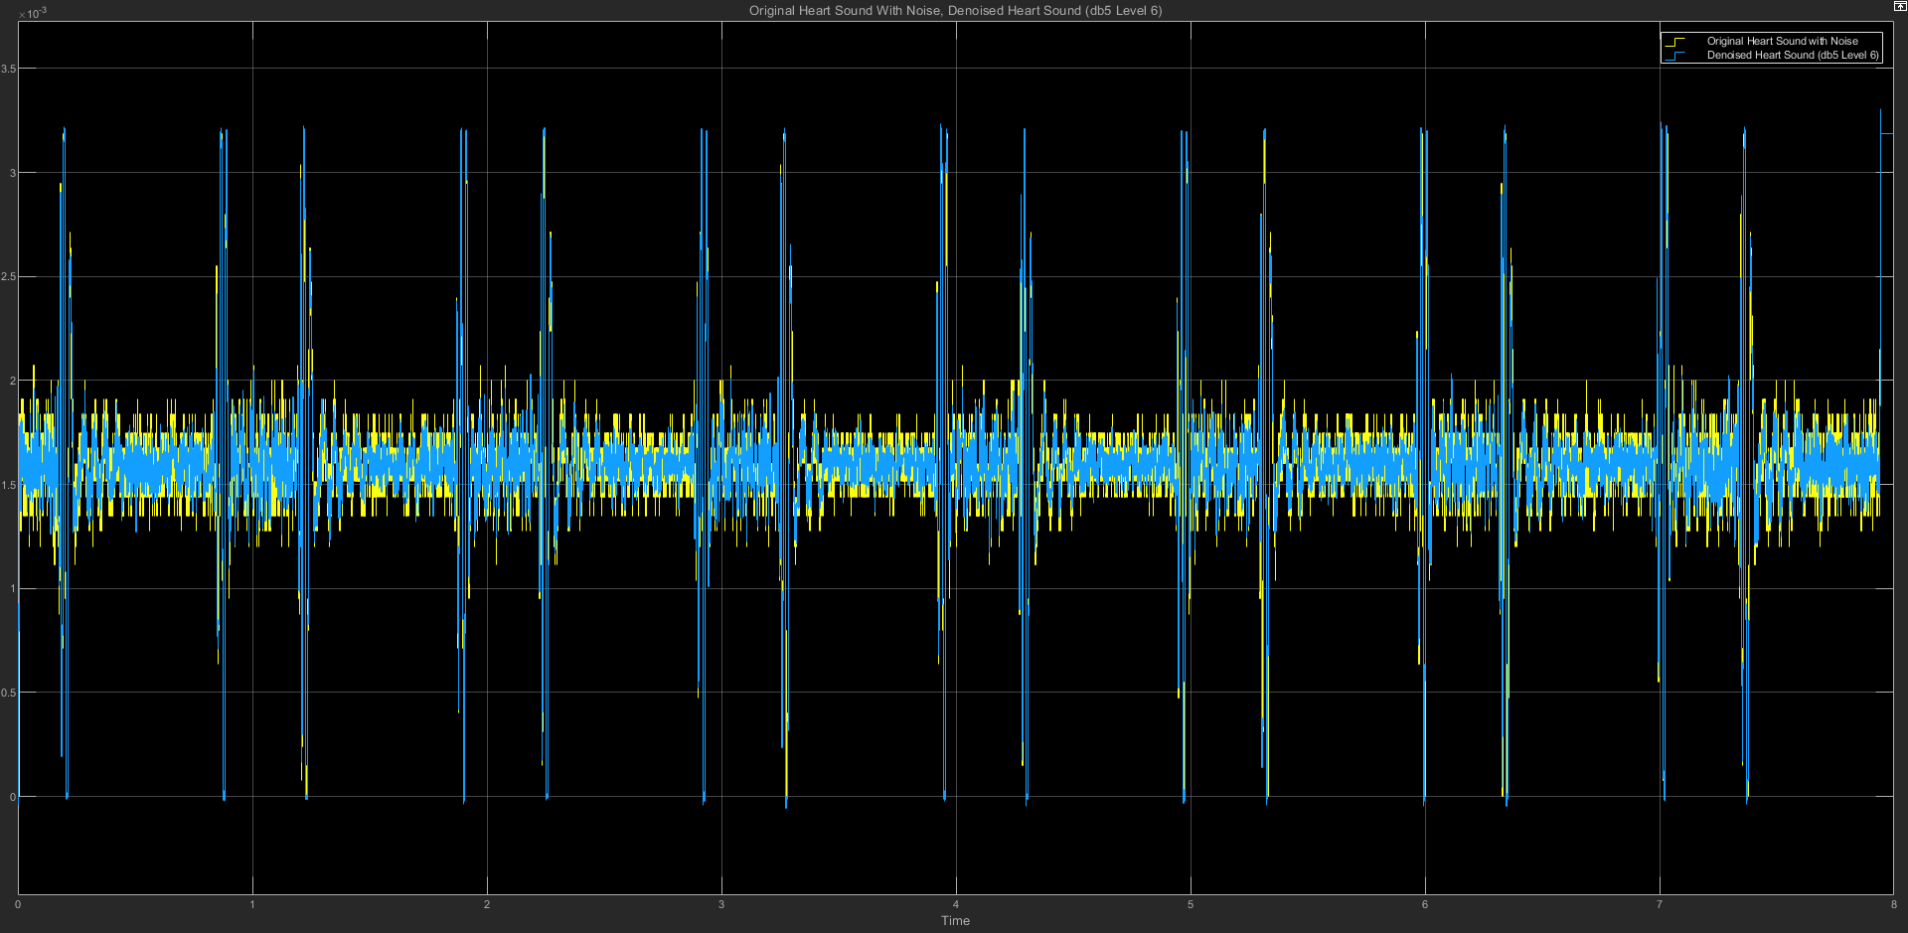

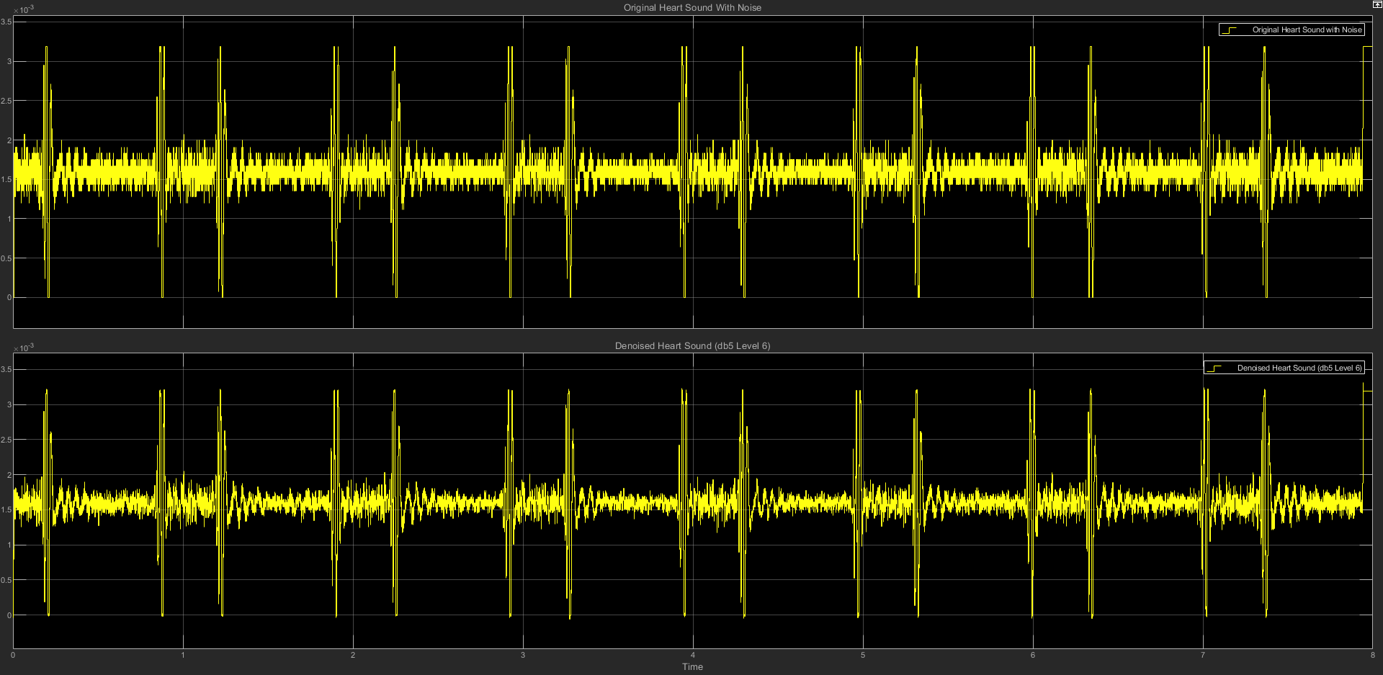

(c) db5 LEVEL 6 STATISTICS RESULT

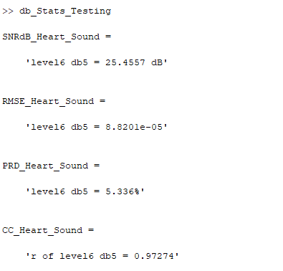

(d) db5 LEVEL 6 SCATTER PLOT RESULT

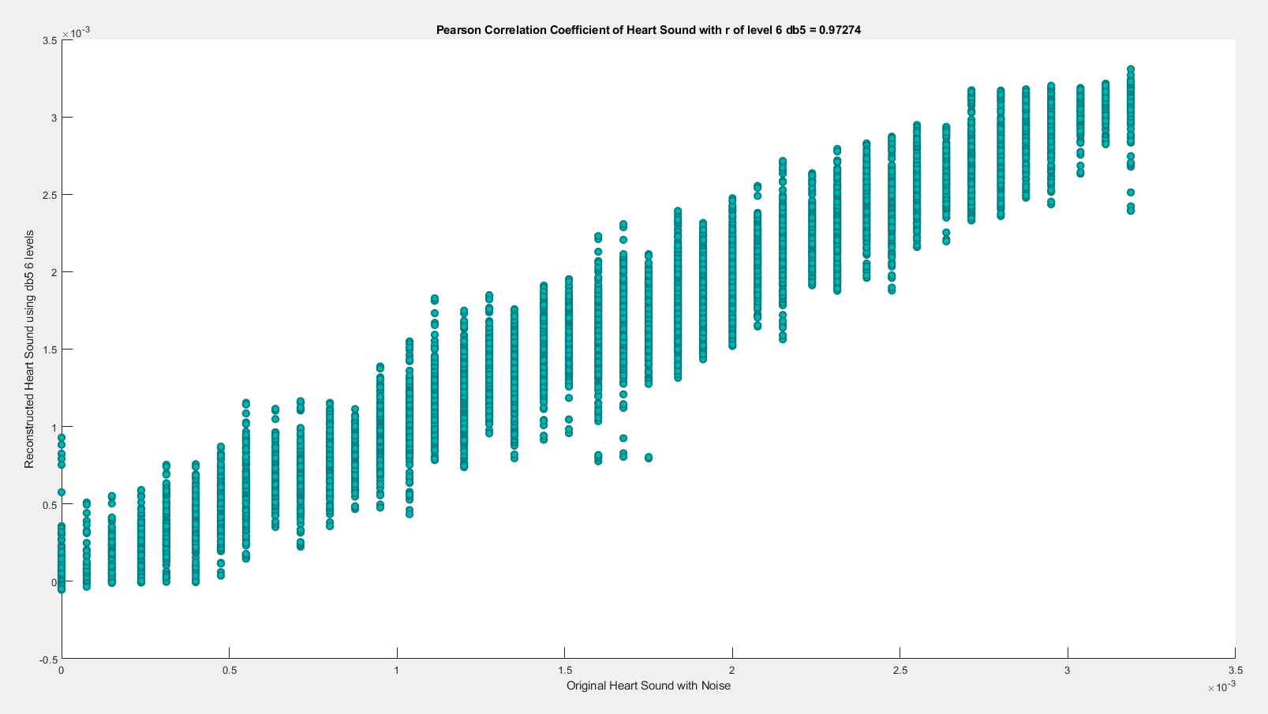

**(6) db5 LEVEL 7**

(a) db5 LEVEL 7 ARCHITECTURE

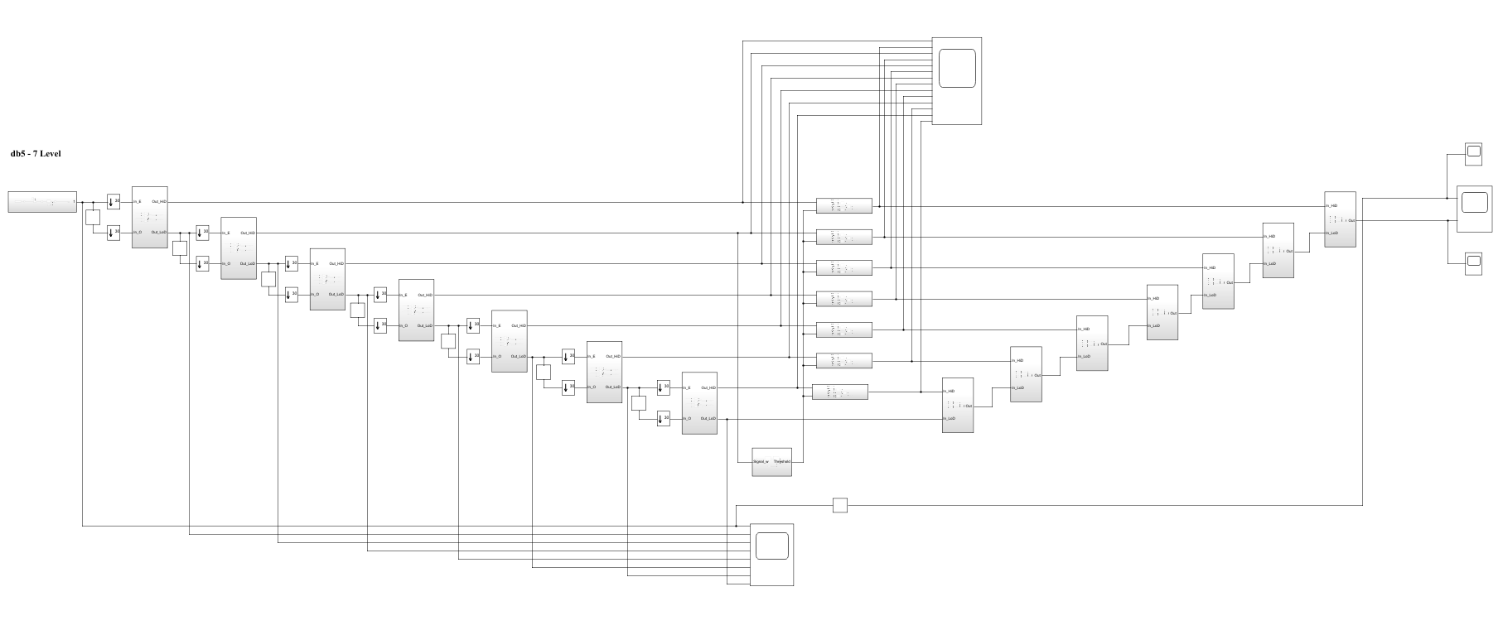

(b) db5 LEVEL 7 SIMULATION RESULT

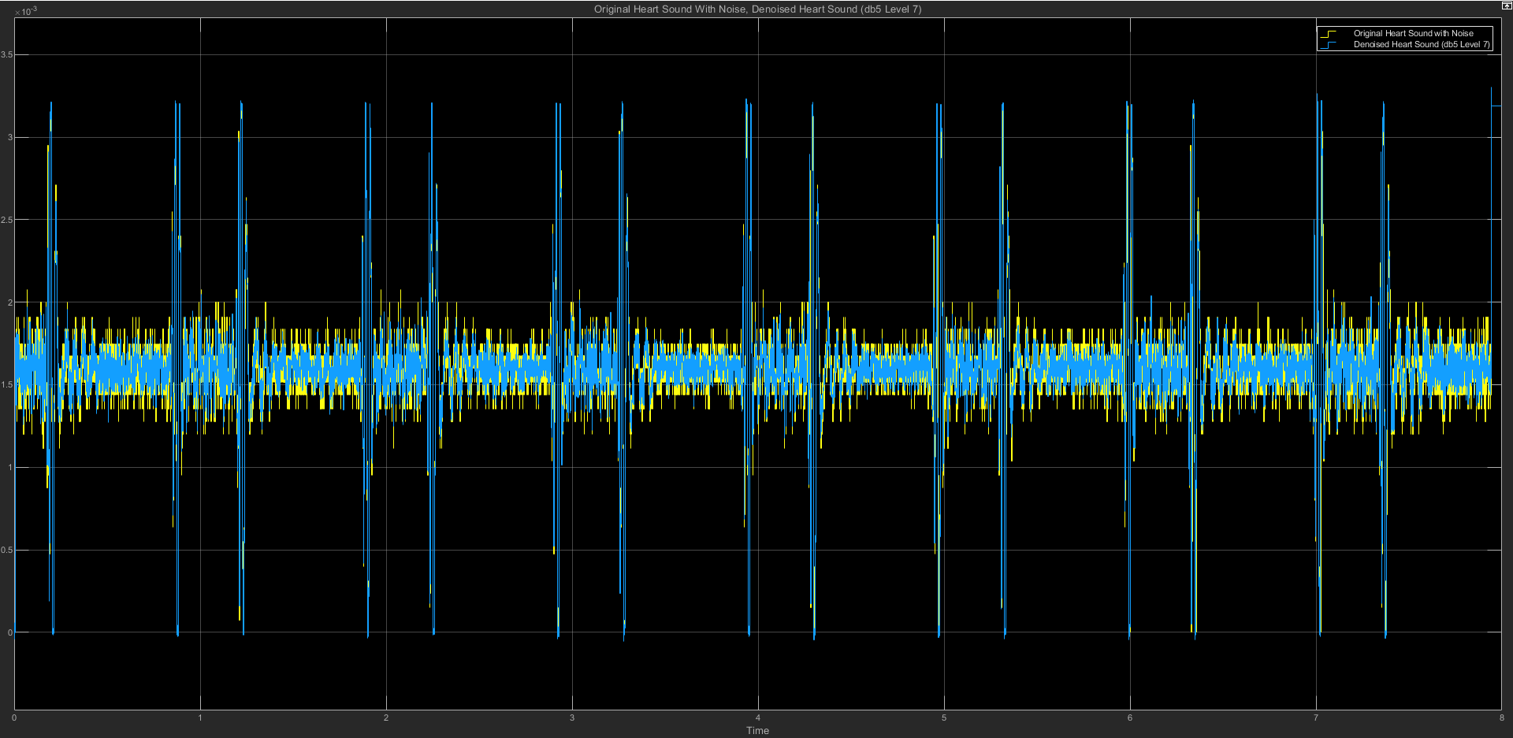

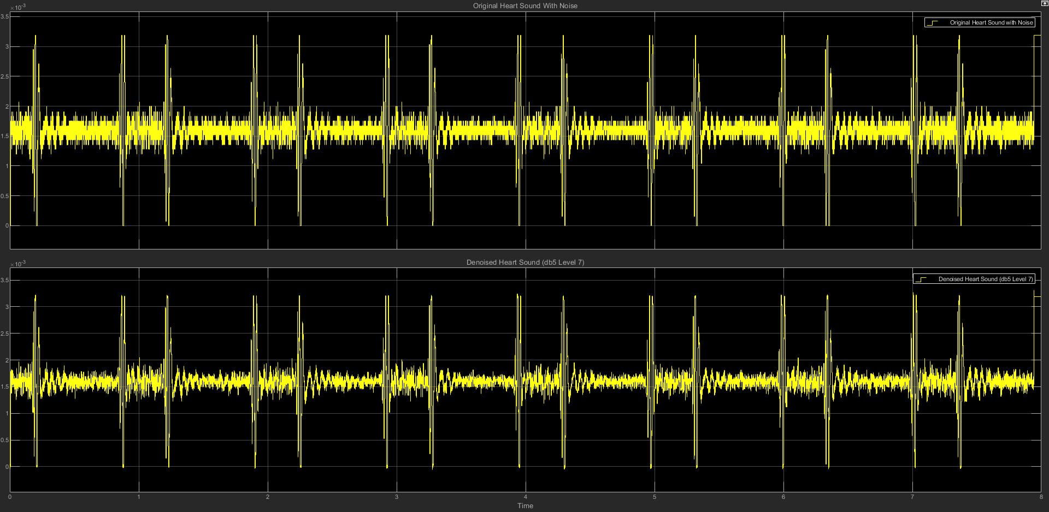

(c) db5 LEVEL 7 STATISTICS RESULT

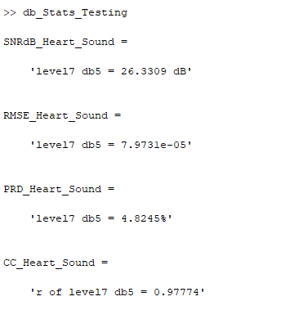

(d) db5 LEVEL 7 SCATTER PLOT RESULT

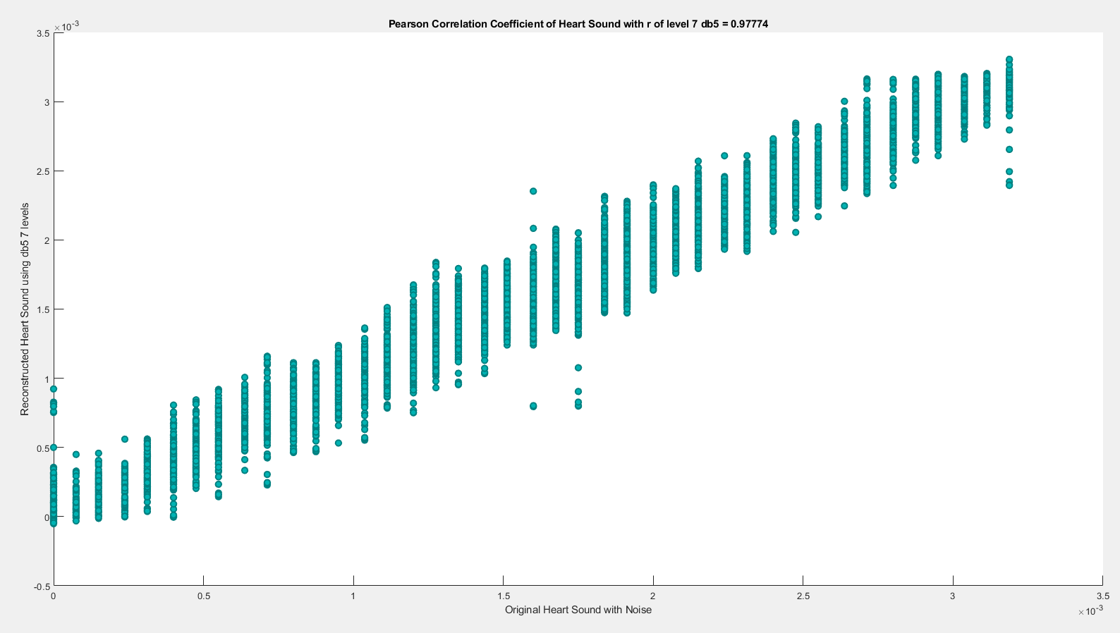

========================================================================

**db6**

| **db6** | **SNRdB_Heart**  **_Sound** | **RMSE_Heart**  **_Sound** | **PRD_Heart_Sound** | **CC_Heart**  **_Sound** |
| --- | --- | --- | --- | --- |
| Level 2 | 24.2486 dB | 0.00010146 | 6.1315% | 0.96387 |
| Level 3 | 24.6026 dB | 9.6004e-05 | 5.8867% | 0.96775 |
| Level 4 | 24.7335 dB | 9.4518e-05 | 5.7987% | 0.96865 |
| Level 5 | 25.4221 dB | 8.7282e-05 | 5.3567% | 0.97328 |
| Level 6 | 25.8209 dB | 8.343e-05 | 5.1163% | 0.97561 |
| Level 7 | 26.2625 dB | 8.0408e-05 | 4.8627% | 0.97737 |

**(1) db6 LEVEL 2**

(a) db6 LEVEL 2 ARCHITECTURE

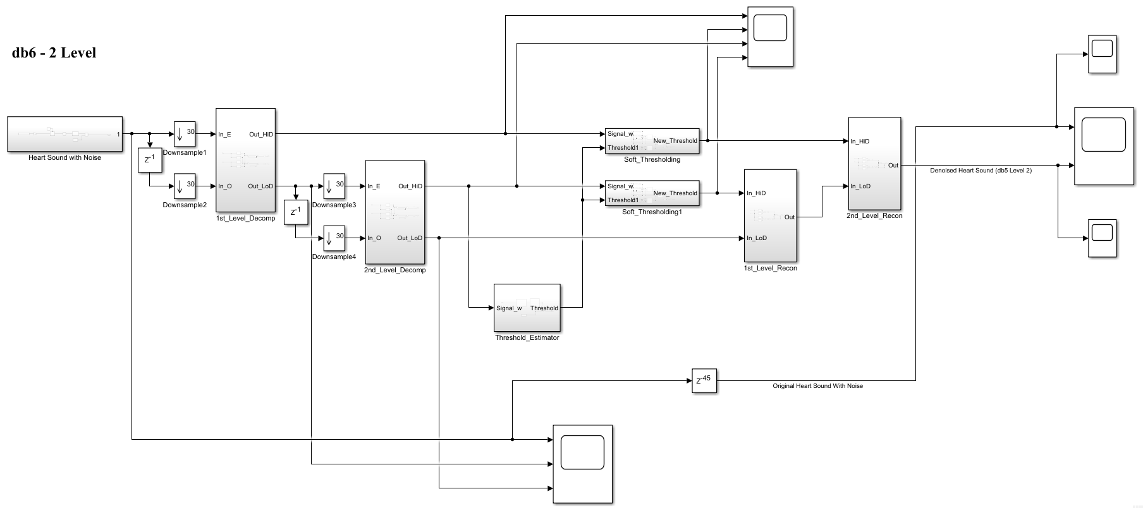

(b) db6 LEVEL 2 SIMULATION RESULT

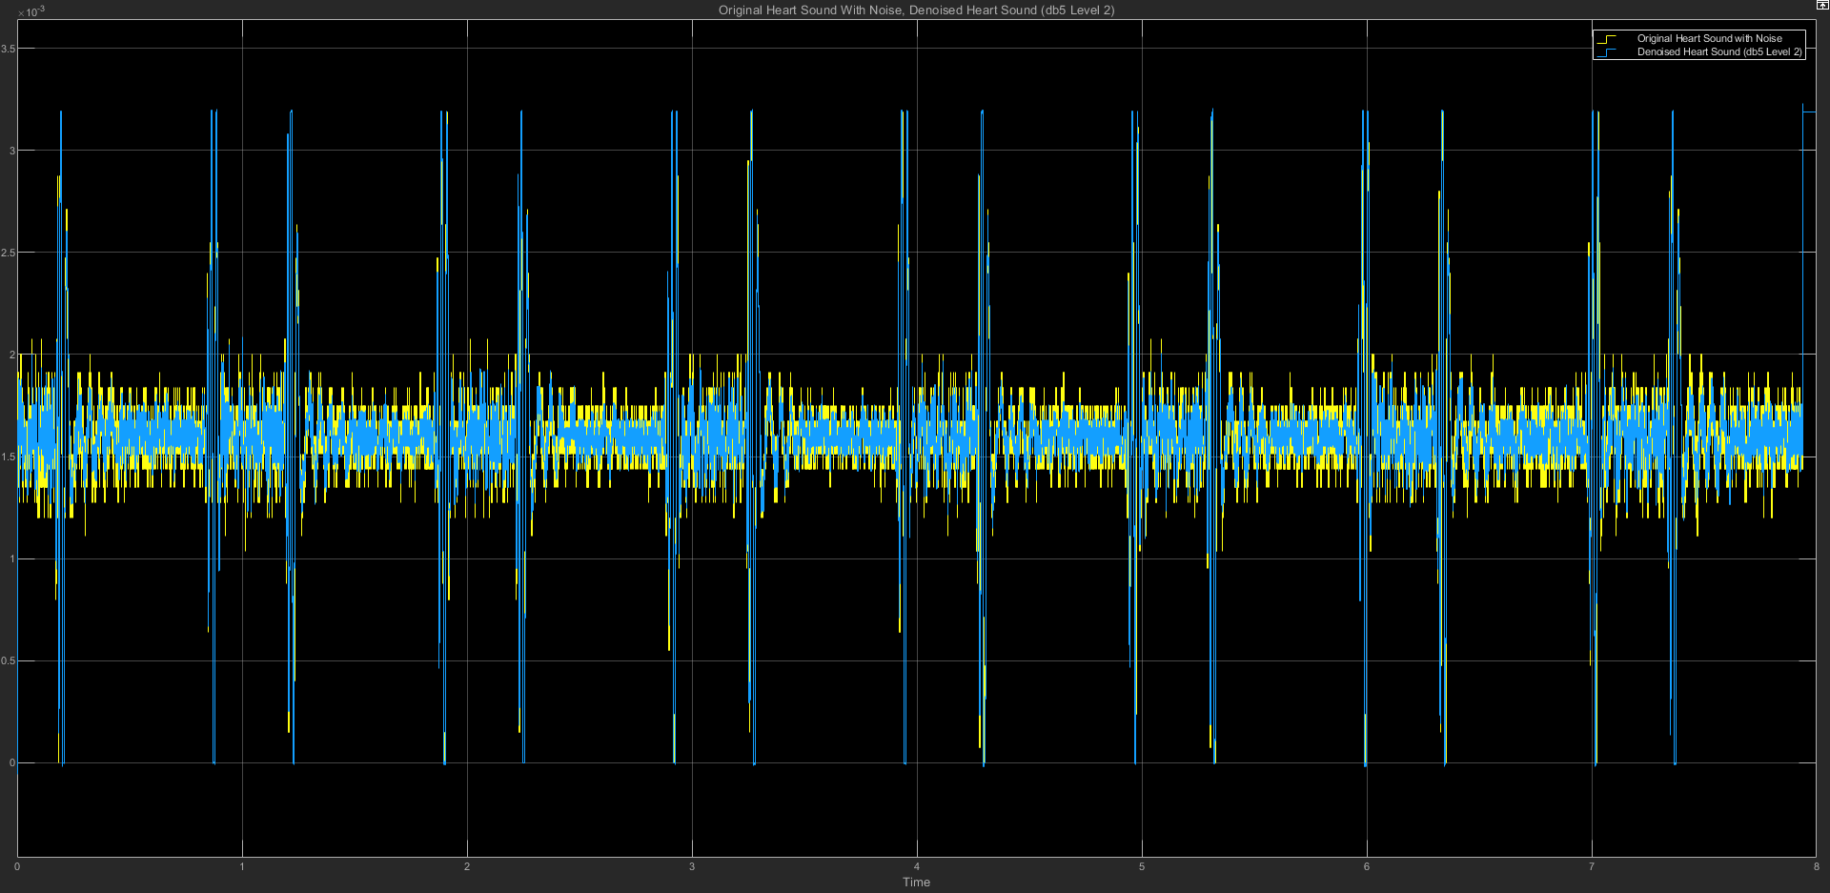

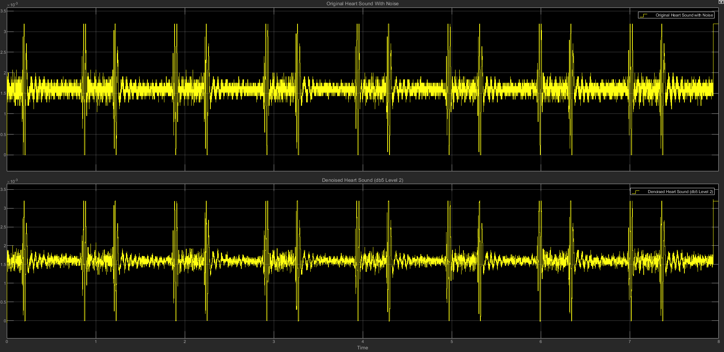

(c) db6 LEVEL 2 STATISTICS RESULT

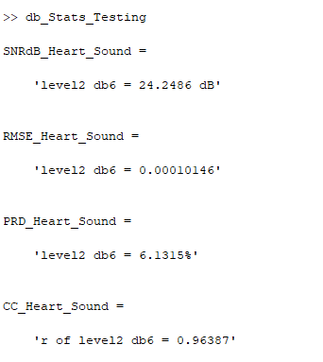

(d) db6 LEVEL 2 SCATTER PLOT RESULT

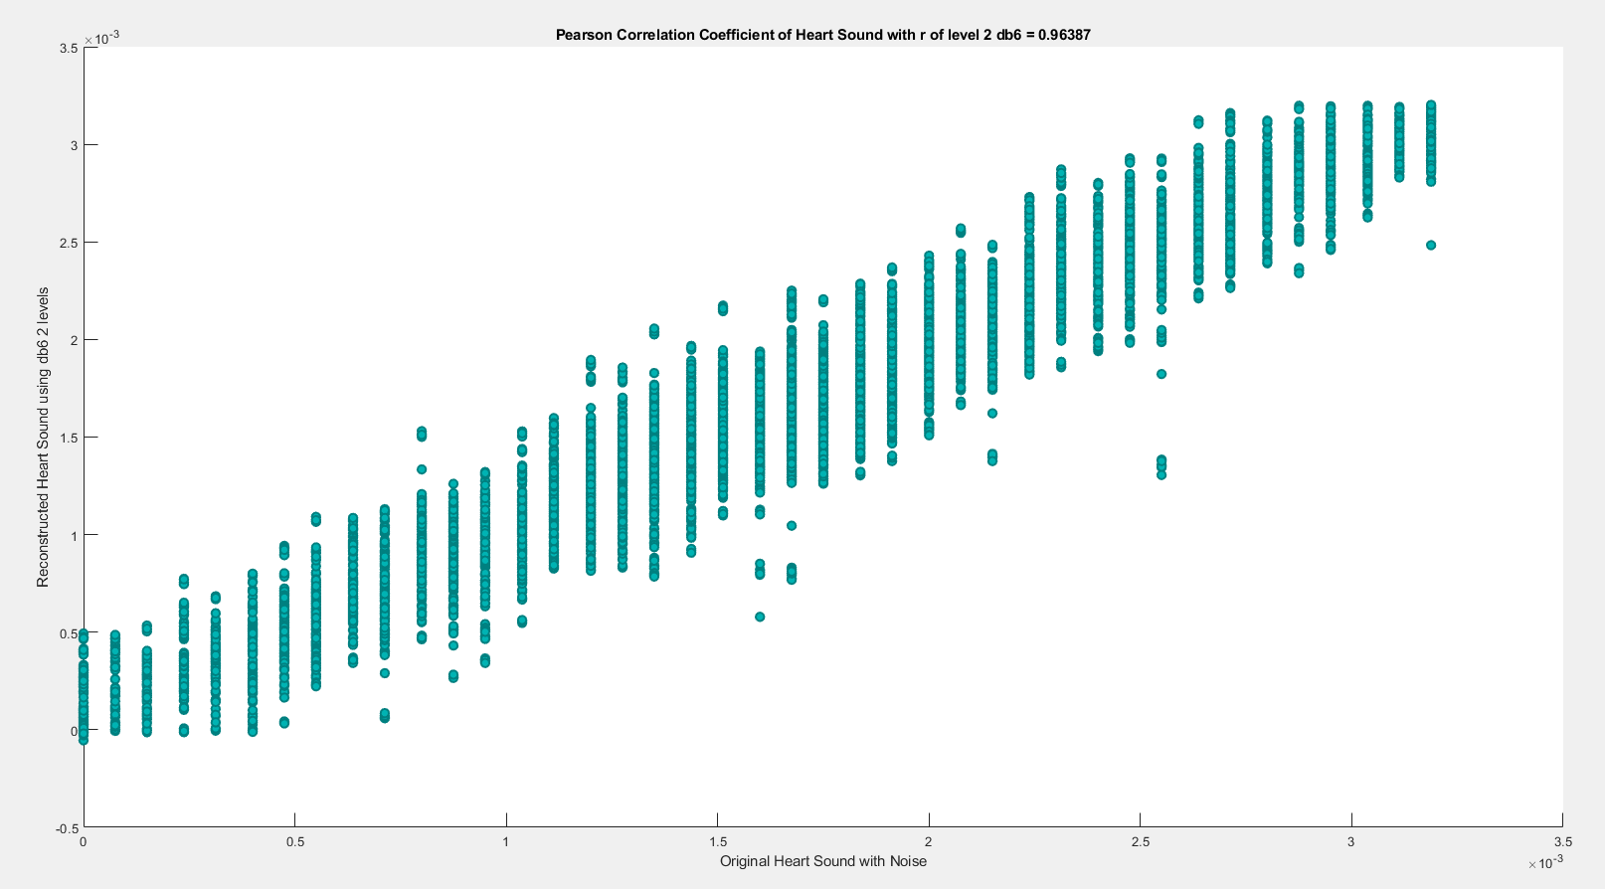

**(2) db6 LEVEL 3**

(a) db6 LEVEL 3 ARCHITECTURE

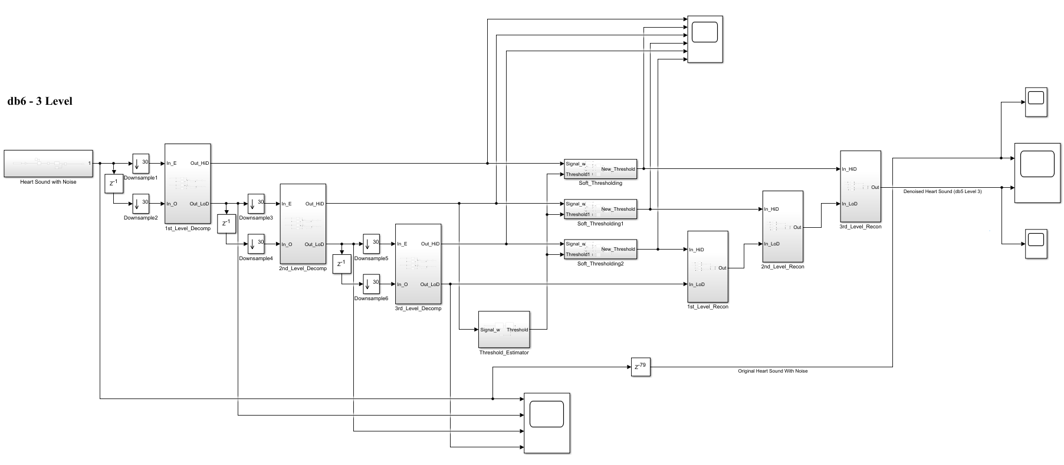

(b) db6 LEVEL 3 SIMULATION RESULT

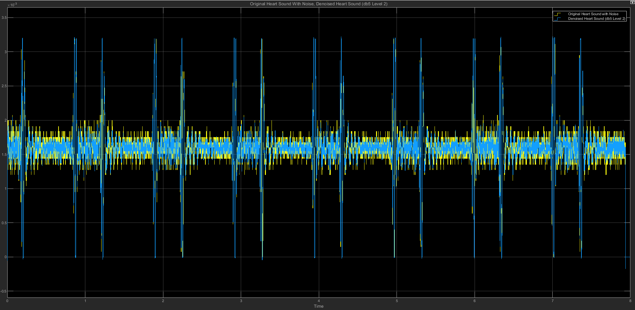

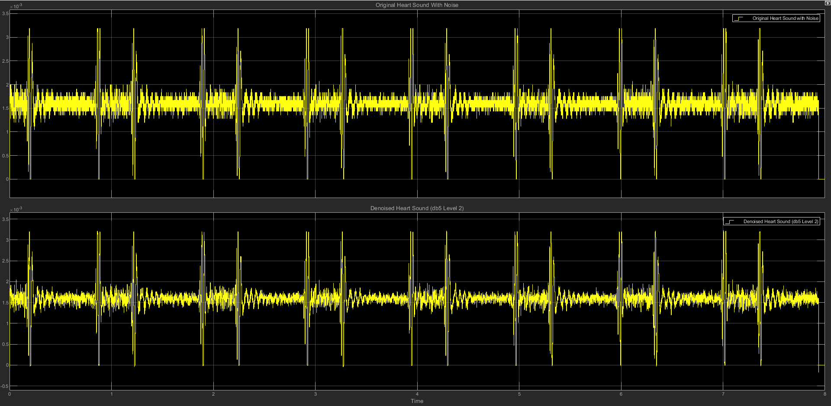

(c) db6 LEVEL 3 STATISTICS RESULT

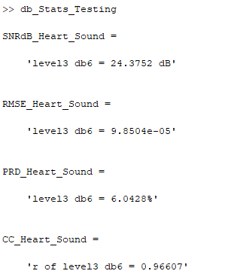

(d) db6 LEVEL 3 SCATTER PLOT RESULT

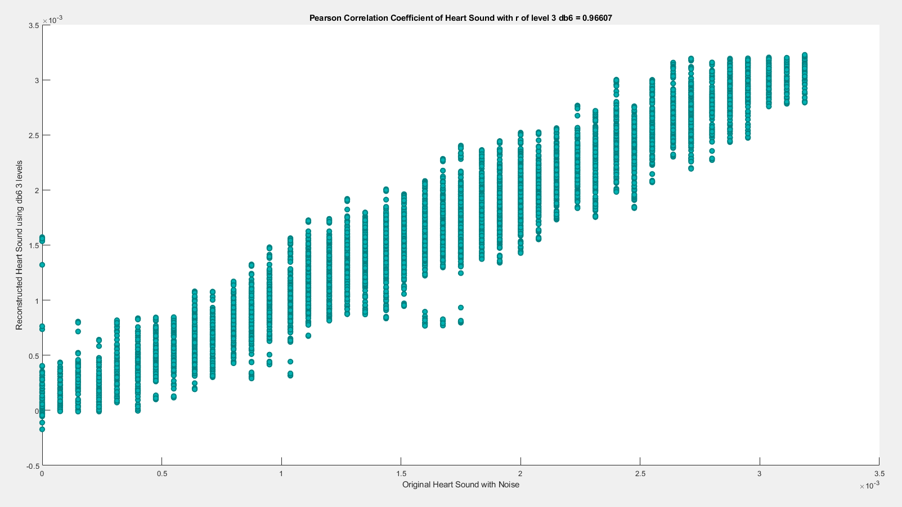

**(3) db6 LEVEL 4**

(a) db6 LEVEL 4 ARCHITECTURE

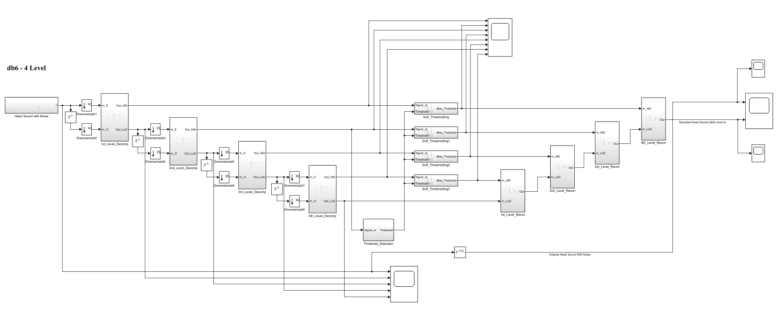

(b) db6 LEVEL 4 SIMULATION RESULT

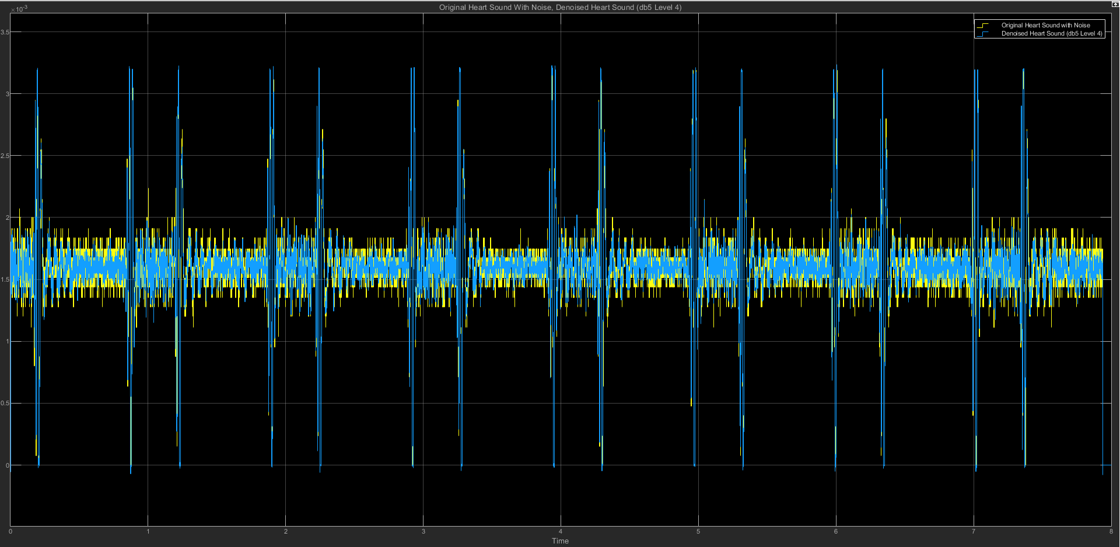

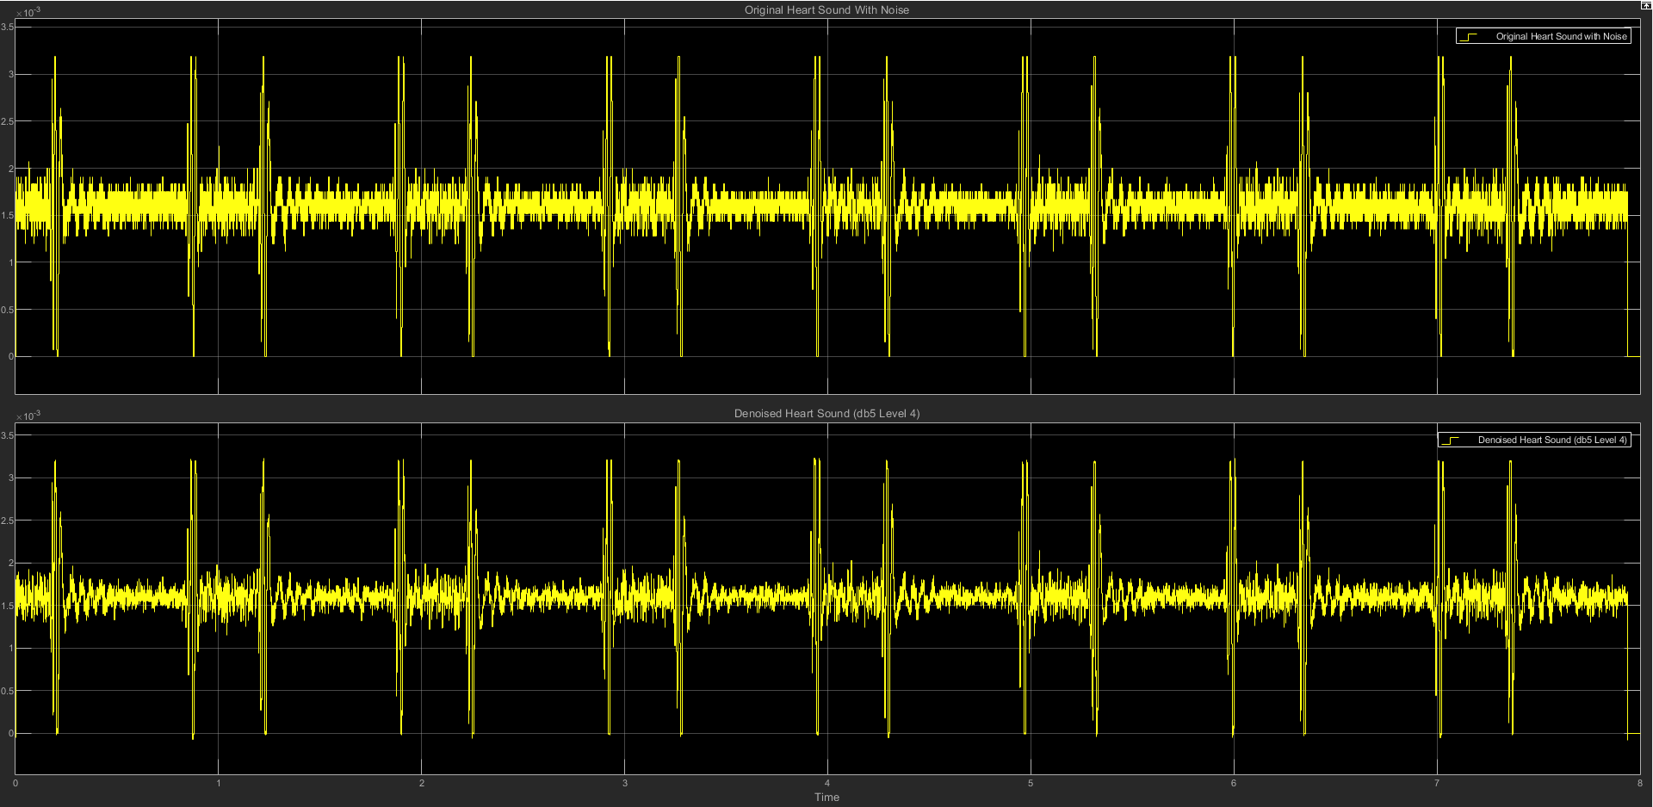

(c) db6 LEVEL 4 STATISTICS RESULT

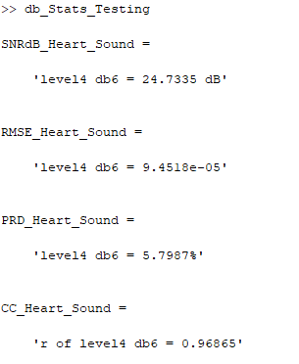

(d) db6 LEVEL 4 SCATTER PLOT RESULT

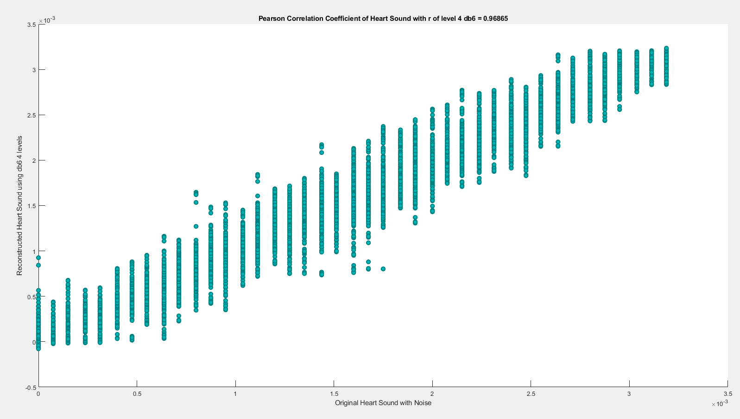

**(4) db6 LEVEL 5**

(a) db6 LEVEL 5 ARCHITECTURE

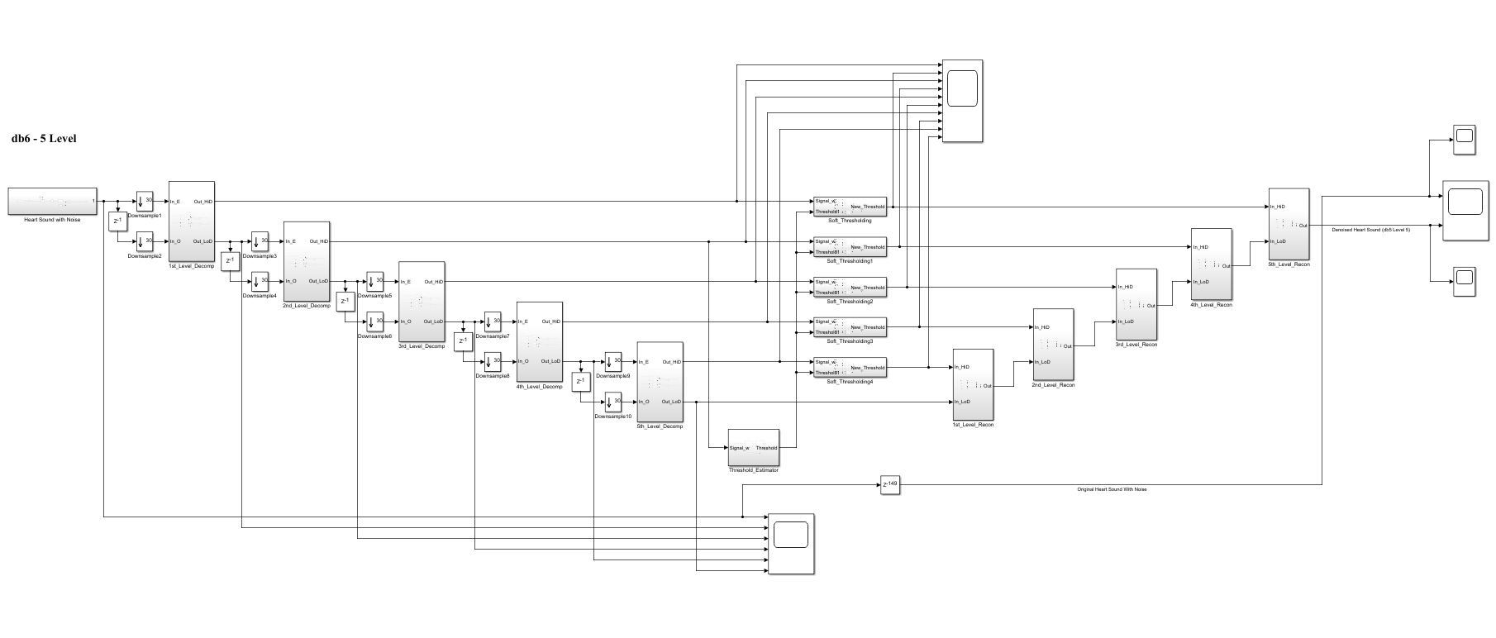

(b) db6 LEVEL 5 SIMULATION RESULT

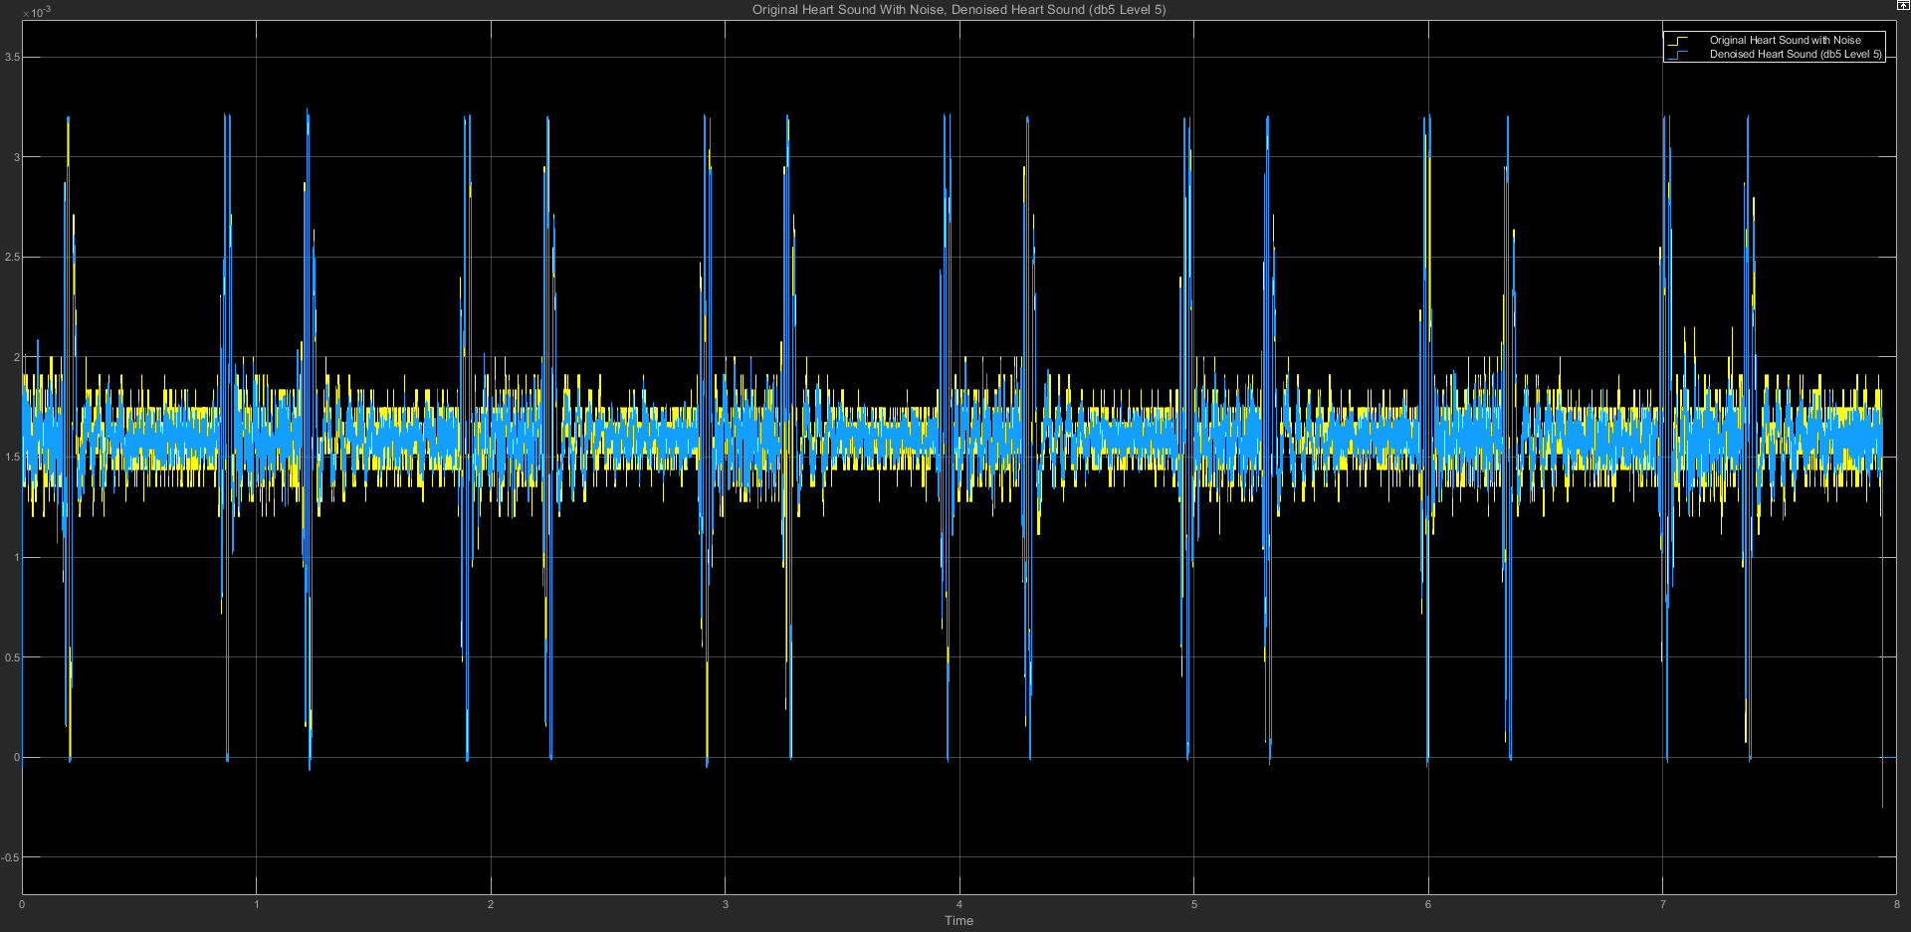

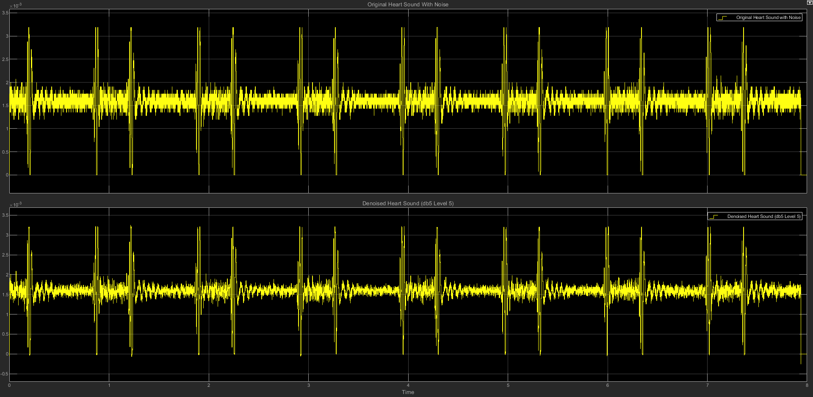

(c) db6 LEVEL 5 STATISTICS RESULT

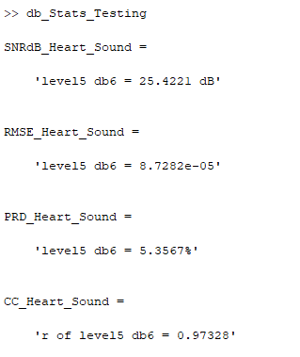

(d) db6 LEVEL 5 SCATTER PLOT RESULT

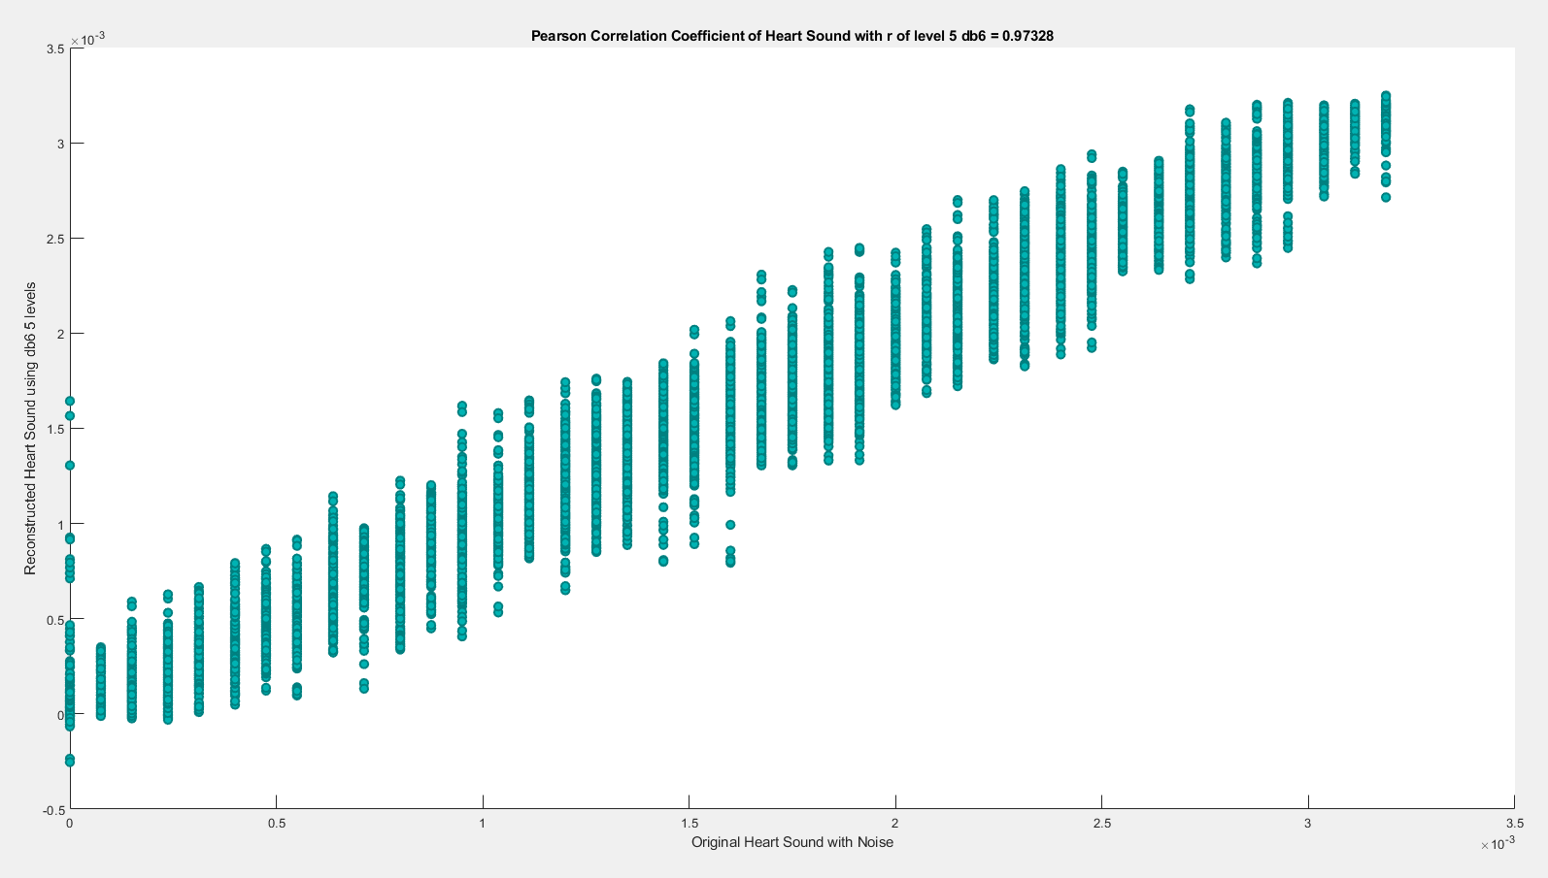

**(5) db6 LEVEL 6**

(a) db6 LEVEL 6 ARCHITECTURE

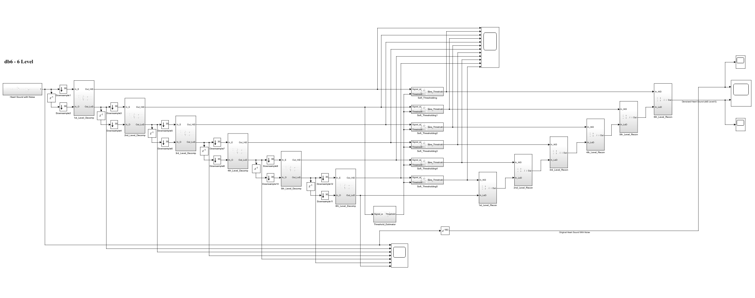

(b) db6 LEVEL 6 SIMULATION RESULT

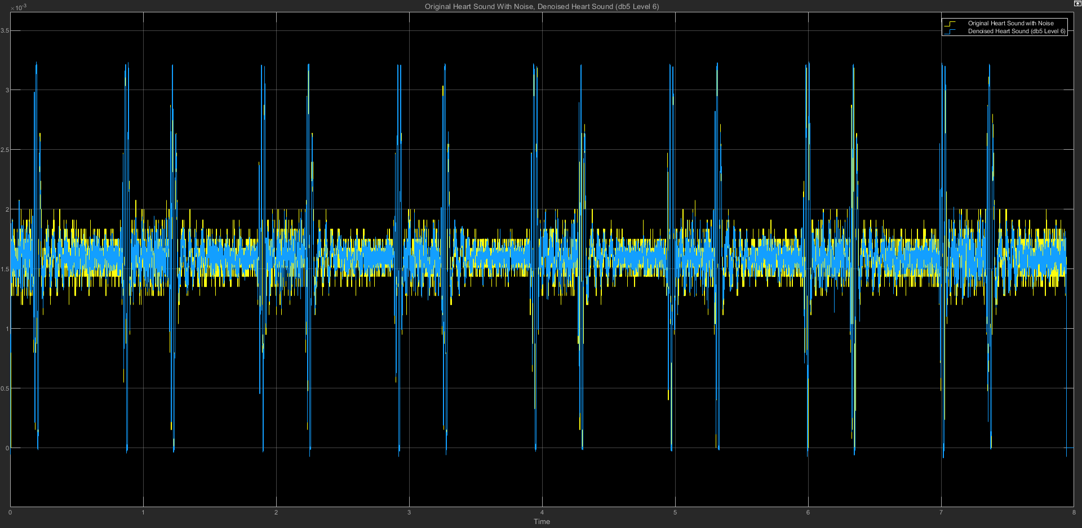



(c) db6 LEVEL 6 STATISTICS RESULT

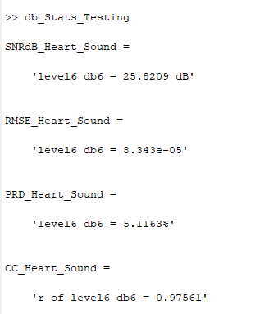

(d) db6 LEVEL 6 SCATTER PLOT RESULT

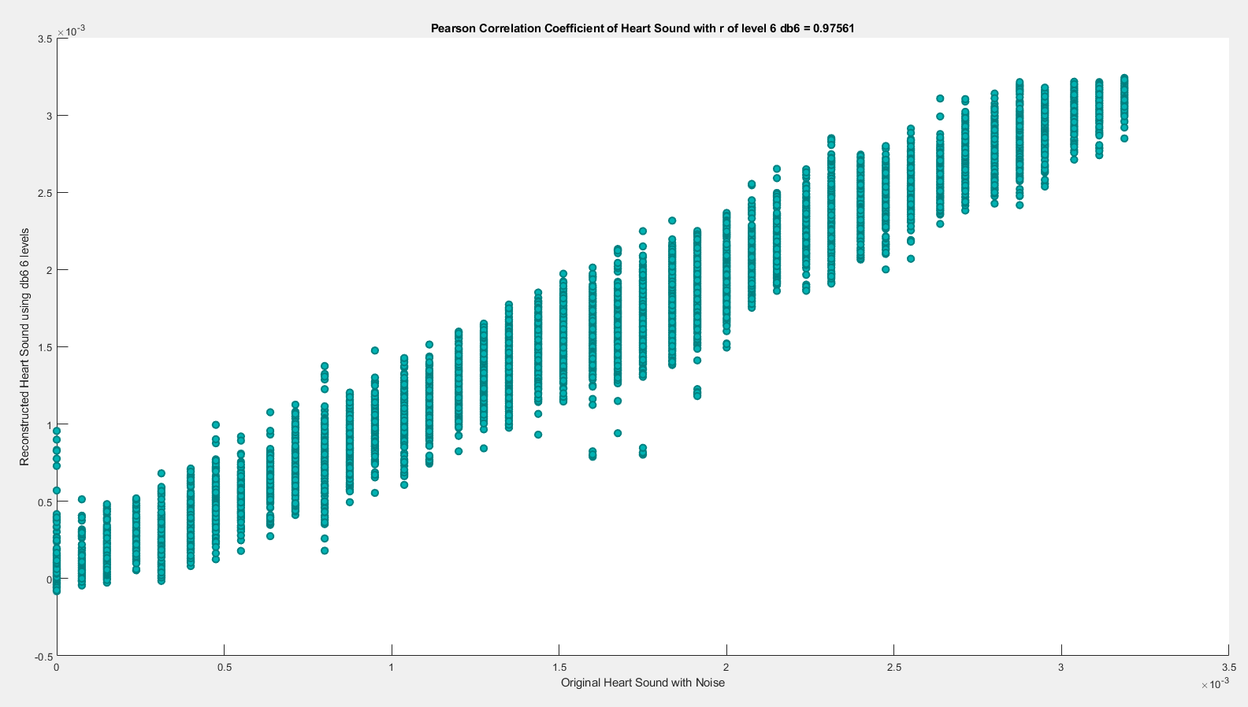

**(6) db6 LEVEL 7**

(a) db6 LEVEL 7 ARCHITECTURE

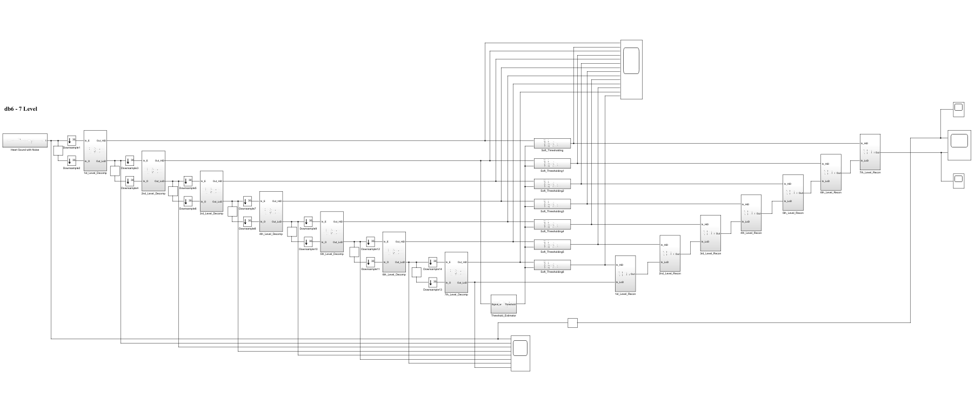

(b) db6 LEVEL 7 SIMULATION RESULT

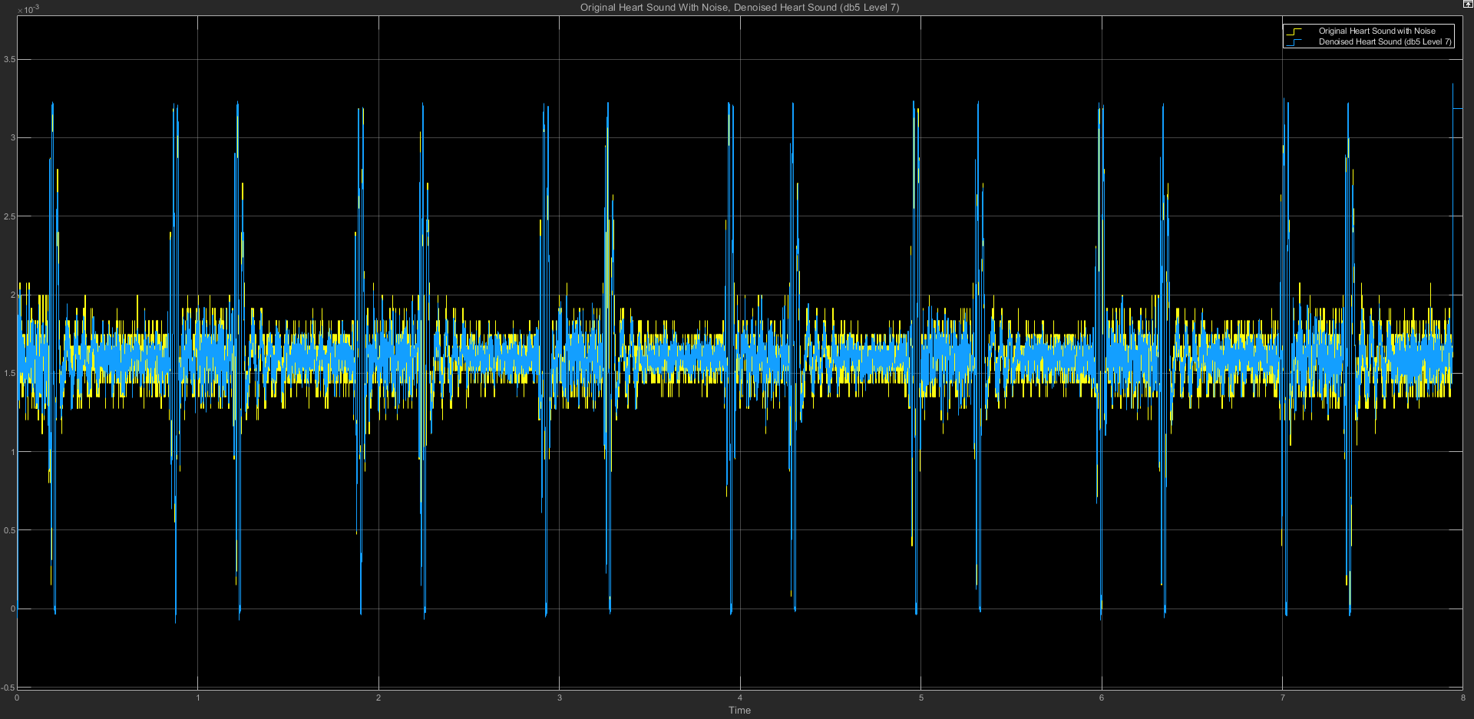

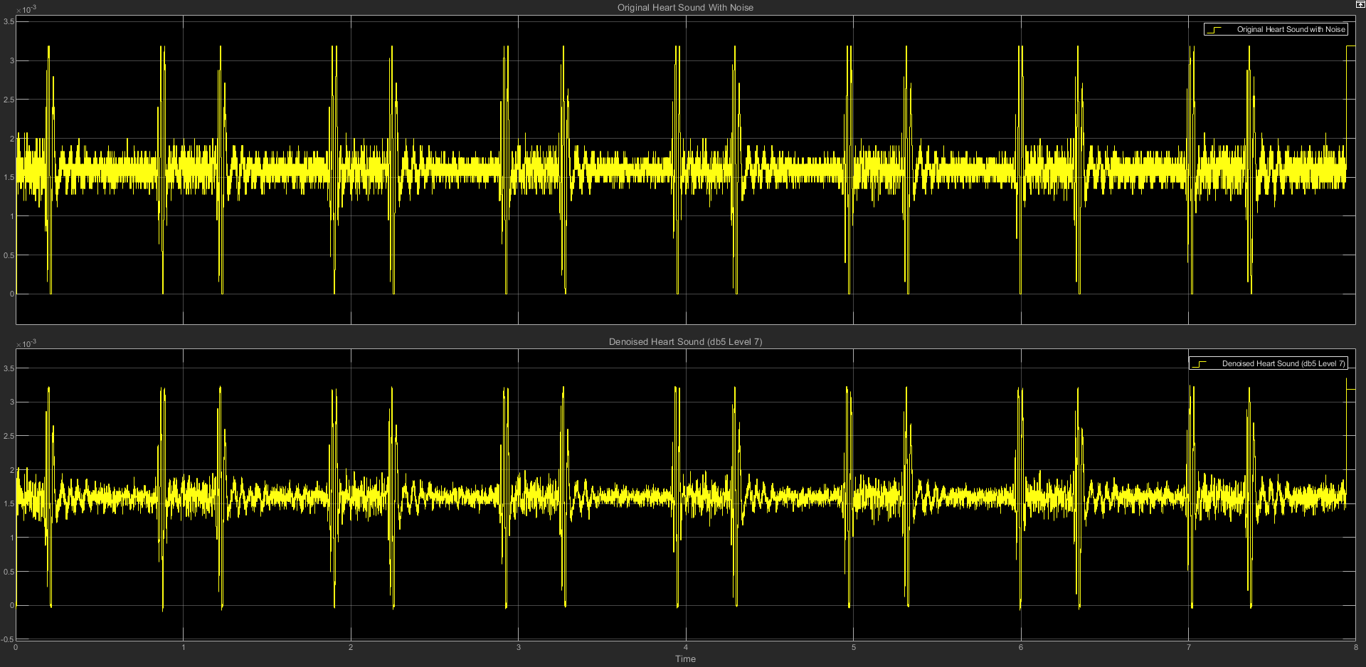

(c) db6 LEVEL 7 STATISTICS RESULT

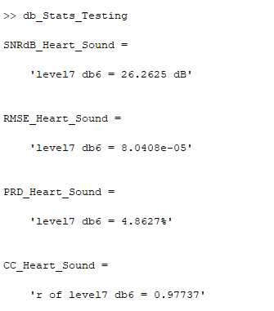

(d) db6 LEVEL 7 SCATTER PLOT RESULT

